

2008 MEETING OF THE
ASSOCIATION OF SOUTHEASTERN BIOLOGISTS

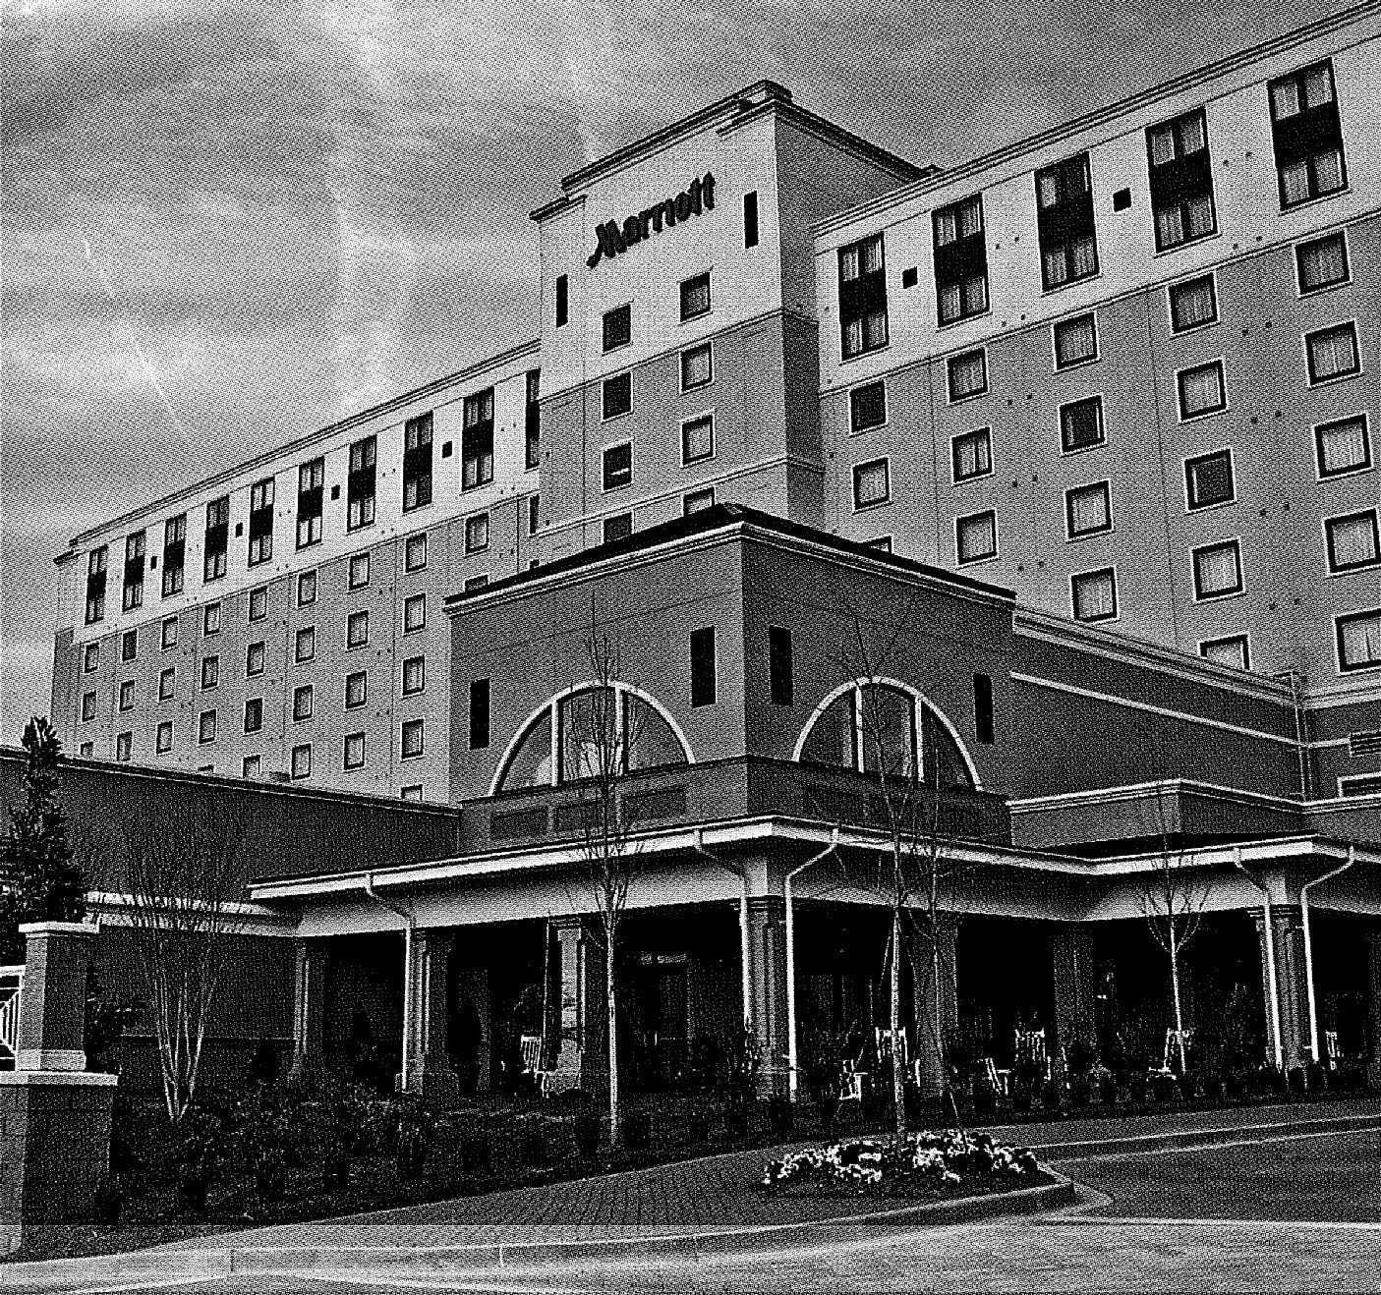

SPARTANBURG MARRIOTT AT RENAISSANCE PARK
SPARTANBURG, SC

APRIL 16-19, 2008

CALL FOR PAPERS
(this is the only call)

THE 69TH ANNUAL ASB MEETING

HOSTED BY:

FURMAN UNIVERSITY
and
WOFFORD COLLEGE



Please note the following deadlines
for our 69th annual meeting.
This will be the only call for papers!

15 OCTOBER Nominations for ASB officers and executive committee due to the Nominations Committee.

3 JANUARY Titles and abstracts of papers and posters, including those applying for awards, due to the Program Committee. This will be the only call for papers. They must reach the Program Committee by this date.

3 JANUARY–25 JANUARY
Submission materials for research awards due to respective research awards committees.

25 JANUARY Meritorious Teaching Award materials due to Meritorious Teaching Award Committee. Application for graduate student travel awards due to Graduate Student Travel Awards Committee.

LOCAL COMMITTEE ASSIGNMENTS
FOR THE 69TH ANNUAL MEETING
FURMAN UNIVERSITY, GREENVILLE, SC
AND
WOFFORD COLLEGE, SPARTANBURG, SC

Local Arrangements Co-Chairs: Joe Pollard (864) 294-3244
joe.pollard@furman.edu
Doug Rayner (864) 597-4624
raynerda@wofford.edu

Program Committee: Dennis Haney (864) 294-2050
dennis.haney@furman.edu
G.R. Davis (864) 597-4621
davisgr@wofford.edu

Field Trips: Greg Lewis (864) 294-3249
greg.lewis@furman.edu
Doug Rayner (864) 597-4624
raynerda@wofford.edu

Social Events: Victoria Turgeon (864) 294-3791
victoria.turgeon@furman.edu

Volunteer Coordinators: Min-Ken Liao (864) 294-3246
min-ken.liao@furman.edu
Lisa Thomas (864) 597-4620
thomaslp@wofford.edu

Tri-Beta Coordinators: Eli Hestermann (864) 294-3527 eli.hestermann@furman.edu
Stacey Hettes (864) 597-4659
hettessr@wofford.edu

Audiovisual Coordinator: Nicholas Schisler (864) 294-3243
nicholas.schisler@furman.edu

Silent Auction: Edna Steele (864) 596-9120
edna.steele@converse.edu

Meeting Coordinator: Scott Jewell (336) 421-0034
a2zconvention@yahoo.com

The Meeting Coordinator handles Commercial Exhibits & Workshops, Registration, Hotel Accommodations, and Transportation.
PAPER & POSTER SUBMISSION DOCUMENTS
FOR 2008 MEETING

DEADLINE: THURSDAY, 3 JANUARY 2008

Individuals presenting papers or posters are expected to be members of ASB or an affiliate society!

INSTRUCTIONS FOR SUBMITTING ABSTRACTS

Submit a single e-mail message with two attachments in MS Word document format to the appropriate address for posters or papers (see below). The two attachments should be titled, “Author Information” and “Abstract”. DO NOT submit author information or abstracts within the text of the e-mail message. Submit oral papers to ASBpapers@furman.edu and posters to ASBposters@furman.edu.

ATTACHMENT 1 (Titled “Author Information”)
Number and list the following information items:

1. AUTHOR(S)

2. INSTITUTION(S)

3. FIRST AUTHOR PHONE/FAX

4. FIRST AUTHOR E-MAIL

5. ABSTRACT TITLE

6. PRESENTATION TYPE: PAPER or POSTER

NOTE: All oral presentations must be in MS PowerPoint with a backup copy on a CD disk or USB memory drive. Slide projectors will not be available. Poster space is 46” x 46”. Bring your own pins or Velcro.

7. CHOOSE THE APPROPRIATE SECTION(S) TO WHICH YOUR PAPER OR POSTER SHOULD BE ASSIGNED. IF YOU CHOOSE MORE THAN ONE, RANK SECTIONS AS TO YOUR PREFERENCE (1 = MOST PREFERRED).

Animal Behavior | Animal Ecology
Animal Physiology | Aquatic, Wetland & Marine Mgmt.
Developmental Biology | Genetics, Cell & Molecular Biology
Herpetology | Ichthyology
Invertebrate Zoology & Entomology | Microbiology
Ornithology | Parasitology
Plant Biology | Plant Ecology
Plant Systematics | Teaching Biology

8. AWARDS: If you intend to apply for one of the following awards, you must indicate this to the Program Committee during the abstract submission so that talks can be scheduled appropriately. Students must be first author to be considered for student awards. Applicants must be present at the Awards Banquet to be considered for an ASB award.

For most awards, you MUST also submit an abstract to the award committee chairperson. Please see applicable rules for each award at www.asb.appstate.edu/2008_Meeting_Awards.php and in this issue. If you do not follow these instructions, you will not be considered for the award.

ASB Senior Research Award ($1,000). Sponsored by Associated Microscopes, Inc.
ASB Student Research Award ($1,000). Sponsored by Martin Microscope Company.
Brooks/Cole Student Research Award in Aquatic Biology ($200). Sponsored by Thomson Learning Brooks/Cole Publishing Company.
ASB Research Award in Microbiology ($500). Sponsored by Thomson Learning Brooks/Cole Publishing Company.
ASB Student Poster Award ($300). Sponsored by ASB.
Eugene P. Odum Award ($500). Sponsored by the SE Chapter of ESA.
Elsie Quarterman-Catherine Keever Award ($300). Sponsored by the SE Chapter of ESA.
NC Botanical Garden Award ($200). Sponsored by the NCBG.
SEASIH Student Travel Awards ($50). Sponsored by the SE Chapter of ASIH. See http://www.asih.org.
SEASIH Student Ichthyology Award ($100). Sponsored by the SE Chapter of ASIH. See http://www.asih.org.
SEASIH Student Herpetology Award ($100). Sponsored by the SE Chapter of ASIH. See http://www.asih.org.
SAC/SWS Student Travel Awards ($100). Sponsored by the SA Chapter of SWS.
BSA Student Plant Science Award ($100) plus travel expenses ($300). Sponsored by the SE Section of BSA.

ATTACHMENT 2 (Titled “Abstract”)
Please follow guidelines below.

The abstract must be in 9 point Arial (if your computer does not have Arial, use Times New Roman) with margins of 1 inch right and 2½ inches left. Text should be fully justified. Do not place hard returns at ends of lines; allow word wrapping. The abstract (not including the authors’ name(s), address(es) or title of the presentation) must not exceed 250 words. Single space all typing.

1. Indent author, institution, and title information 1 tab stop (1/2 inch). Type in the following order: AUTHOR’S NAME(S) all capitalized; last name first for first author; other authors’ names (if any), first names first. If two authors, separate names with “AND”. In the case of more than two authors, separate all but the last name with a comma and separate last two with “AND”. End with a period.

2. Institution(s) follow authors’ names directly. Maintain the same indentation as names and end with a dash (—). In case of two or more authors from different institutions, place all author names together first, followed by all institutions in the same order. If necessary, key the authors’ names to the institution with a superscript number.

3. Start the title immediately after the dash without a space. Capitalize first letter of first word, then only proper and scientific names as customary. Underline all of the title, and maintain the same indentation as the name and institution. End with a period. Leave one full blank line between title and abstract text.

4. Start text of abstract on a new line. Do not indent first line. Use one paragraph for entire text. Do not put any reference citations in the abstract. Justify both left and right margins. 250 word maximum.

5. Single space all typing. Put taxonomic names in italics.

EXAMPLES

RADENBAUGH, TODD A. United States Peace Corps, Jamaica—Major plant community types of Duncan Bay, Jamaica, West Indies.

There is an urgent need to record and describe the coastal ecosystems on the North coast of Jamaica before they are severely altered by human…………………
_______________________________________________________________________

DAVIS, JENNIFER¹ AND DWAYNE WISE². Shorter College¹ and Mississippi State University²—Causes and consequences of elevated levels of meiotic abnormalities in laboratory colonies of the crane fly Nephrotoma suturalis.

Progeny of wild-caught crane flies were compared to a laboratory colony of Nephrotoma suturalis for mean % chromosomal abnormalities, mean % survival, and parameters indicative of ……………

INSTRUCTIONS FOR SUBMITTING ORAL PRESENTATIONS

All oral presentations will be done using Microsoft PowerPoint only. Presenters should bring a backup copy on a CD or USB memory drive. Complete and final presentations must be submitted on CD to the audiovisual coordinator to be received by April 4. The first author’s name and truncated title should be written on the upper surface of the CD using an indelible marker.

Submit CD to be received by April 4 2008 to: Dr. Nicholas Schisler, Department of Biology, Furman University, 3300 Poinsett Hwy, Greenville, SC 29613.
ASB 2008 FIELD TRIPS

The upstate of South Carolina is adjacent to the Blue Ridge Escarpment, one of the richest botanical and zoological zones in the Southeast. Plan early to attend one of the Saturday trips!

The list of field trips below is tentative. More information will be available in the January issue of SE Biology.

- Botanical Diversity Field Trip, Wadakoe Mountain, Pickens County SC. 8:00 am - 2:00 pm. Trip leader: Patrick McMillan, Clemson University, host of SCETV’s “Expeditions.” Spectacular plant diversity and many botanical rarities, because of unusual geology and soils.

- Wildflowers Field Trip, Bridal Veil Falls, Translvania County, NC. 9:00 am - 1:00 pm. Trip leader: Doug Jensen, Converse College. An easy hike in an area with a great diversity of wildflowers, finishing at a spectacular waterfall.

- Herpetological Field Trip, Location TBA. Time TBA. Trip leaders: Wayne Van Devender, Appalachian State University, Ab Abercrombie, Wofford College. Reptiles and amphibians of the piedmont and Blue Ridge.

- Birding Field Trip, Cottonwood Trail, Spartanburg County, SC. Time TBA. Trip leaders: Lyle and Sarah Campbell, USC Upstate. Avifauna of the South Carolina piedmont.

- Aquatic Macroinvertebrates Field Trip, Croft State Natural Area, Spartanburg County, SC. 9:00 am - 12:00 pm. Trip leader: Jim Glover, SC Dept. of Health and Environmental Control. Characteristic macroinvertebrates of an upper piedmont stream, including identification, life history, and use of macroinvertebrates as indicators of water quality.

- Ichthyology Field Trip, Middle Saluda River, Jones Gap State Park, Greenville County, SC. Time TBA. Trip leader: Dan Rankin, SC Dept. of Natural Resources. Characteristic fish fauna of a beautiful Blue Ridge mountain stream and a downstream piedmont segment of the same stream.
ACTIVITIES FOR GUESTS

Guests who are not participating in the conference will find many interesting places to visit in the Greenville-Spartanburg area. In Spartanburg, the brand-new Chapman Cultural Center, including the Spartanburg County Museum of Art, is immediately next door to the convention hotel. The Hatcher Garden and Woodland Preserve is a horticultural oasis near the center of the city. Historic homes include the Seay House and the Thomas Price House. Also close to Spartanburg you can relive a pivotal battle of the American Revolution at Cowpens National Battlefield, which can easily be combined with a trip to one of the state’s largest outlet malls. Greenville also has many attractions, including the spectacular Liberty Bridge over the Reedy River Falls, as well as the Greenville Zoo. Stroll through downtown Greenville, which recently won the American Main Street Award from the National Trust for Historic Preservation, and enjoy a wide range of shops and restaurants. Car enthusiasts love the exhibition and tour at the BMW Zentrum, BMW's first plant outside Germany, located between Greenville and Spartanburg (near GSP airport). Golfers will find a huge range of public and semi-private courses throughout the upstate area.

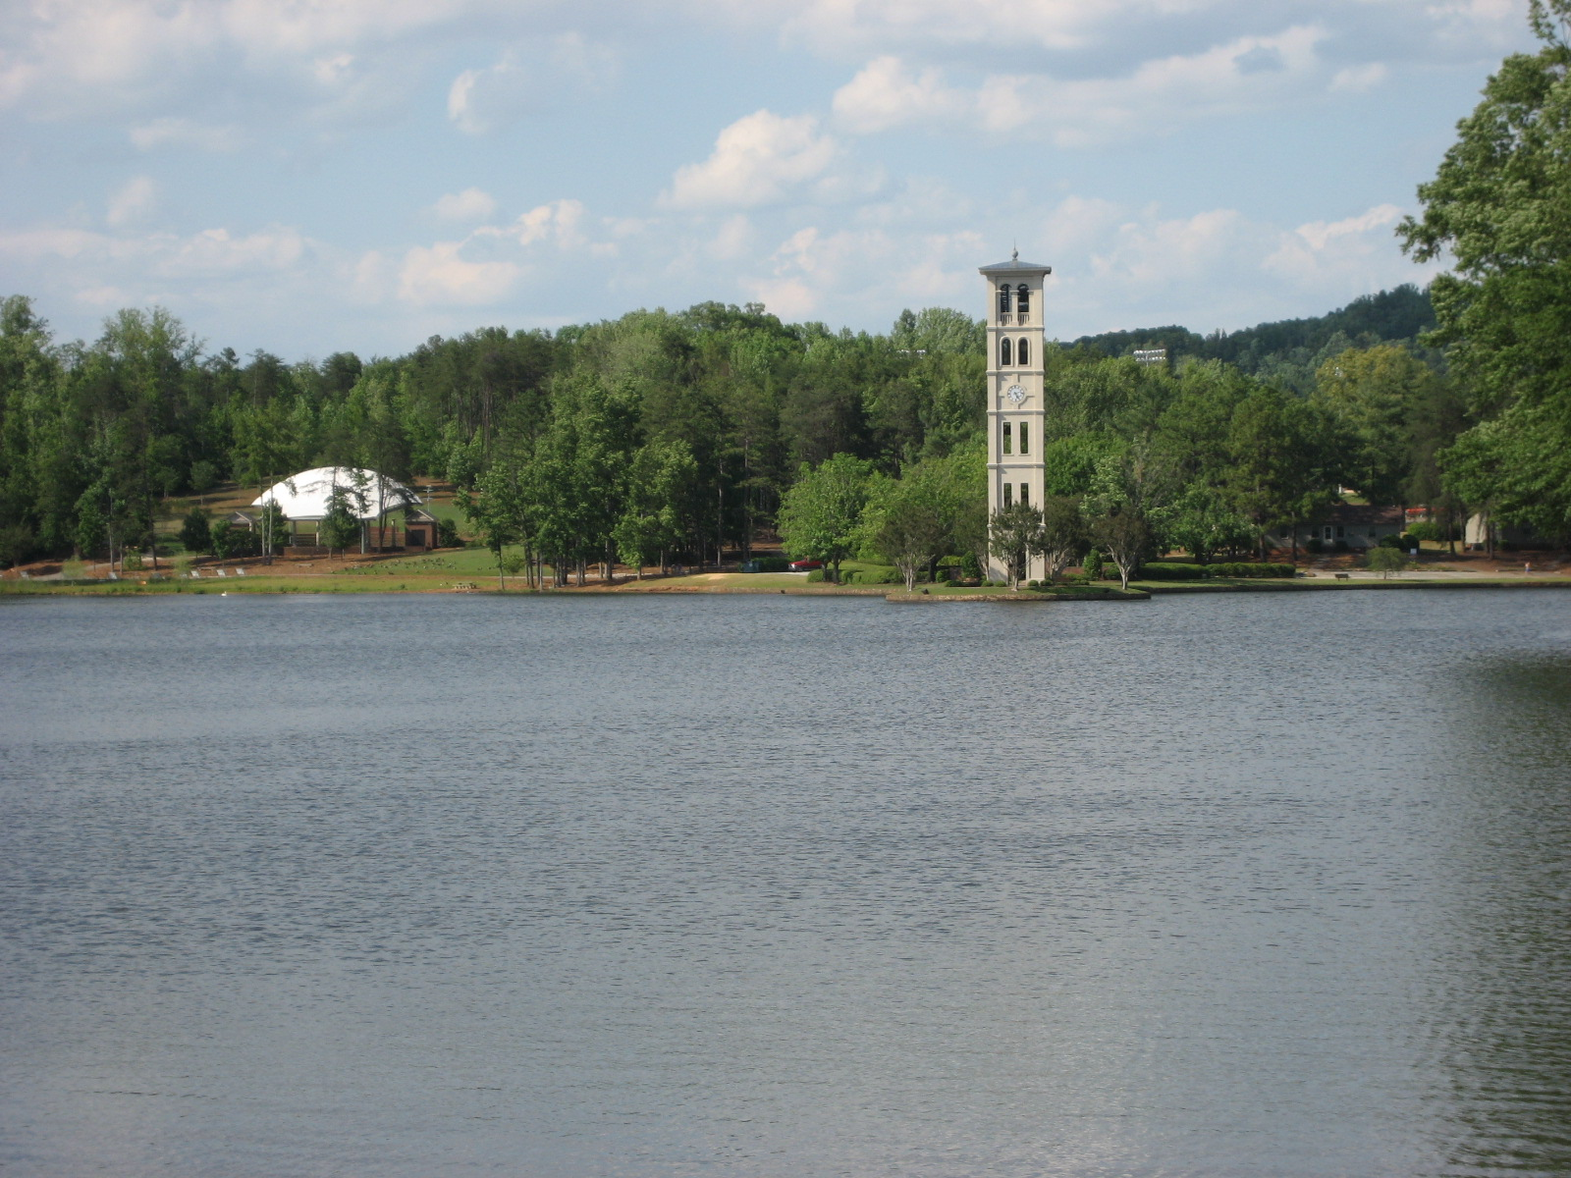
Lake and Bell Tower at Furman University

Announcing the ASB
Thursday Night Social
“Let the Good Times Roll………..”

ASB has a reputation for hosting an exciting and fun-filled Thursday Night Social. This year’s plans include all the excitement and fun, with a few new twists.
A multimedia musical extravaganza will be provided by E & M Entertainment. E & M excites every crowd with the most popular American hits and all genres of music, enhanced by giant screen music videos, dance lights, and a great sound system.
Don’t miss the casino games! Yes, we’ll have activities for those who want to sit back and enjoy the music from a gaming table. There will also be quiet corners for those whose main priority is to hang out with old friends.
Local micro-brews, great wines and a giant buffet of mouth-watering South Carolina flavors will ensure a most enjoyable and exciting evening.
Please note: ASB will provide transportation to/from satellite hotels for this event only! More details will be found in the January issue of SE Biology.

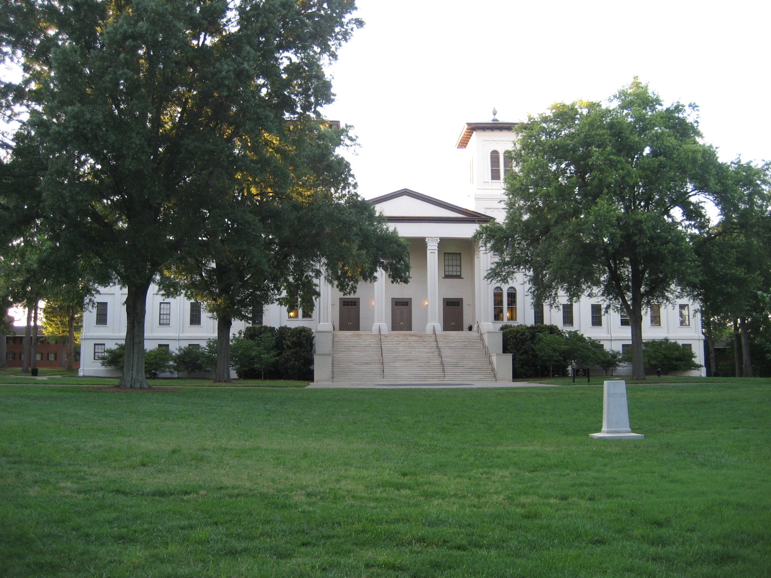
Historic Old Main Building at Wofford College
Silent Auction

_____Yes I would like to contribute to the Silent Auction to help with student travel to the Annual Meeting.
(100% of all proceeds to benefit student travel awards)

Partial List of Items Donated at the 2007 Annual Meeting in Columbia

Dissection Set
Corporate Gift Certificates
Heart Model
Dinner for Two
Two Nights Hotel Accommodations
Books
Charts
Gift Basket
Educational Charts
Microscope
IPod

Description of Item(s) to be donated ___________________________________________________________________________________________________________________________________________________________________________________________________________________________________________________________________________________________________________________________________________________________________________________________________________

Please check appropriate option:
____Please contact me at the conference to pick-up donation
____I will mail the donation to Scott Jewell, ASB Meeting Coordinator before March 15, 2008.

Signature Date phone

Title e-mail

Return form by March 15, 2008 to: Scott Jewell, ASB Meeting Coordinator, PO Box 1088, Mebane, NC 27302; A2Zconvention@yahoo.com, 336/213-7373 cell, 336/421-0034 office, 336/421-3425 fax.

Workshop Form
2008 Association of Southeastern Biologists
April 16-19, 2008 Spartanburg, SC

Workshop Description: All commercial workshops will be conducted during the meeting on a first-come first-served basis. Classroom style seating will be provided at no additional charge to the presenter. Each classroom will be set for a minimum of 50 participants. A screen will be provided for each room. LCD projectors and laptops will not be provided. One workshop per application please.

Company/Organization_____________________________________________________
(Please list company name as you wish it to appear on printed materials)
Presenter__________________________ Email Address:____________________________________
Contact Address:________________________________________________________________ _______________________________________________________________________
Telephone:_________________________________
Fax: ____________________________________ web site:______________________
Workshop Title:___________________________________________________________________
50 Word Workshop Description:_____________________________________________________________
_______________________________________________________________________
_______________________________________________________________________
_______________________________________________________________________
(Description will appear in Final Program of Southeastern Biology)

Please indicate which time slot you prefer below:

Pre-Conference Workshop: Wed 4pm-5:30pm _____

Thurs 8:30am-10am___ Thurs 10:30am-12noon___ Thurs 1:30pm-3pm___
Thurs 3:30pm-5pm___ Fri 8:30am-10am___

Deadline for workshop submission is 14 October 2007

Hold Harmless Clause
The workshop presenter assumes all responsibility and liability for losses, damages and claims arising out of injury to the presenter’s display, equipment and other property brought upon the premises of the convention facilities and shall indemnify and hold harmless the association agents, servants and employees as well as the ASB organization from any losses, damages and claims.

Upon acceptance by ASB, this signed application and Workshop Contract form becomes the contract for the 2008 ASB Annual Convention. Workshop presenter will be notified of their acceptance by letter no later than 15 Dec 2007.

Signature Date

Return form by October 14 2007 to: Scott Jewell, ASB Meeting Coordinator, PO Box 1088, Mebane, NC 27302; A2Zconvention@yahoo.com, 336/213-7373 cell, 336/421-0034 office, 336/421-3425 fax.

Industry Partners Form
2008 Association of Southeastern Biologists
April 16-19, 2008 Spartanburg, SC

__Yes I Would Like To Partner With ASB And Participate
In the Industry Partners Program!!
Send no money now, please complete form and return to address shown below

Company/Organization_____________________________________________________
(Please list company name as you wish it to appear on printed materials)
Representative:__________________________ Email ___________________________
Address:________________________________________________________________
City,State,Zip:____________________________________________________________
Telephone:_____________________________Fax:______________________________

*Special Recognition at the Thursday Night Social, Friday Night Awards Banquet, signage at the Convention Center and a listing in Final Program of Southeastern Biology!

Qty Item Amount

_____ Wed Night Cash Bar (4 Opportunities) $500/opportunity
_____ Coffee Breaks (8 Opportunities) $500/opportunity
_____ Cyber Café & Marketing Survey $750/opportunity
_____ Thurs Night Social (4 Opportunities) $900/opportunity
_____ Fri Night Banquet Cash Bar $850
_____ Yes I wish to present a workshop See Workshop Form
_____ 24 Hour Exhibit Hall Security $1,000
_____ ASB Executive Committee Breakfast $350
_____ Yes I would like to Donate an Item to the See Silent Auction Form
Silent Auction to help with Student Travel
_____ ASB Web Site Hot Link to
Your Company (12 months) $375
_____ Yes I would like an AD in all 4 See Advertising Form
2008 issues of Southeastern Biology, (circle choice)
¼ page=$200, ½ page=$325, full page=$425
_____ AD in Final On Site Program (circle choice) See Advertising Form
¼ page=$175, ½ page=$225, full page=$275

Signature Date

Title e-mail

Return Form With Check or Credit Card Information by January 1 2008 to: Scott Jewell, ASB Meeting Coordinator, PO Box 1088, Mebane, NC 27302; A2Zconvention@yahoo.com, 336/213-7373 cell, 336/421-0034 office, 336/421-3425 fax.

Advertise With The
Association of Southeastern Biologists

Reach Your Target Audience and Promote your Products and Services Throughout the Year!!

Advertise in Southeastern Biology!!

Advertise in Southeastern Biology and reach over 1,500 members from 40 states and 13 countries. ASB publishes four issues of Southeastern Biology per year and an on-site Program for the Annual Meeting. Choose either or both of these opportunities to increase your marketing exposure. Promote your products and services throughout the year!

Ad Sizes

¼ Page Ad 1½” x 1”

½ Page Ad 3” x 2”

Full Page Ad 7½” x 4 ¾”

Advertising Order Form

_____ Ad in all 4 issues of Southeastern Biology (circle choice)

¼ page = $200, ½ page = $325, full page = $425

_____ Ad in Final On Site Program (circle choice)

¼ page = $175, ½ page = $225, full page = $275

*All ads are black and white and must be submitted in pdf.

Signature Date

Title phone e-mail

___Visa __MasterCard __Discover

CC# _ _ _ _ _ _ _ _ _ _ _ _ _ _ _ _ Exp __/__ 3 digit code on back of credit card ___/___/___

Name As It Appears On Card__________________________

Credit Card Billing Address

*Last Name_____________________ *First Name____________________

*Company/Organization_____________________________________________

*Address_________________________________________________________________
*Line 2___________________________________________________________________
*City____________________________ *State________ *Postal Code_______________
*Phone ______________________

Office Use Only

Paid with check #_________ on Date_____________ Rec’d by:__________

Paid with credit card # _________________ on Date:_________ Rec’d by______
Confirmation Sent on Date:________________ via________________________

Return form with check or credit card information to: Scott Jewell, ASB Meeting Coordinator, PO Box 1088, Mebane, NC 27302; A2Zconvention@yahoo.com, 336/213-7373 cell, 336/421-0034 office, 336/421-3425 fax.

