On the Home Front: Greenville and World War II (5th Grade)
Melissa Summer

Objectives: Students will be able to...
- Critically analyze informational texts to deduct important facts;
- Examine images for information;
- Gather information from a variety of resources;
- Understand motives behind and constructions of propaganda; and
- Identify changes in Greenville's educational institutions, economy, social life, and war efforts during World War II.

Essential Question: How did World War II impact Greenville, South Carolina?

SC Curriculum Standards
SC-2007.ELA.5.2 | The student will read and comprehend a variety of informational texts in print and nonprint formats. Students in grade five read informational (expository/persuasive/argumentative) texts of the following types: essays, historical documents, informational trade books, textbooks, news and feature articles, magazine articles, advertisements, encyclopedia entries, reviews (e.g., book, movie, product), journals, and speeches. They also read directions, maps, time lines, graphs, tables, charts, schedules, recipes, and photos embedded in informational texts. In addition, they examine commercials, documentaries, and other forms of nonprint informational texts.
SC-2007.ELA.5.2.2 | Analyze informational texts to draw conclusions and make inferences.
SC-2007.ELA.5.2.6 | Understand that titles, print styles, chapter headings, captions, subheadings, and white space provide information to the reader.
SC-2007.ELA.5.2.7 | Use graphic features such as illustrations, graphs, charts, maps, diagrams, and graphic organizers as sources of information.
SC-2007.ELA.5.5.1 | Create informational pieces such as book reviews and newsletter articles that use language appropriate for the specific audience.
SC-2007.ELA.5.6 | The student will access and use information from a variety of sources.
SC-SS-05.5.4.4 | Explain the principal events related to the United States’ involvement in World War II—including the bombing of Pearl Harbor, the invasion in Normandy, Pacific island hopping, the bombing of Hiroshima and Nagasaki—and the role of key figures in this involvement such as Winston Churchill, Franklin D. Roosevelt, Joseph Stalin, and Adolf Hitler. (P, G, H)
SC-SS-05.5.4.5 | Summarize the political and social impact of World War II, including changes in women’s roles, in attitudes toward Japanese Americans, and in nation-state boundaries and governments. (P, E, H)

Background Information
As World War II gained momentum, Greenville saw drastic changes in its economy and social life. Economically, Greenville County witnessed the most changes during World War II since the Civil War. With its strong textile past, Greenville industries contributed to the war effort by making military necessities. Increased security ensured that vandalism would not impact these important textile industries. Agriculture experienced a brief surge in economic importance as farmers in the county were asked to produce more food for the war. Despite these contributions, rationing of food, sugar, cars, tires, and gas was required.
Social life changed dramatically during World War II in Greenville. As Congress passed the first peacetime draft in the history of the nation on September 16, 1940, young men left to fight in the war. More men in training came to the Greenville Air Force Base, founded in 1941 to train B-24, B-25, and B-26 aircrews. Those left behind supported the war by raising money with posters, banners, school drives, and performances. Families found ways to take their minds off the stress associated with wartime with regular social gatherings. Greenville had important connections to World War II. The first Greenvillian casualty from the bombing of Pearl Harbor was Vardry McBee's son Kirk, who was on the West Virginia when the Japanese bombed the ship. Lieutenant Colonel Paul Adams became the first black pilot from South Carolina.
During World War II, Furman students consisted mainly of women because men and professors left to fight in the war. President Plyler tried to get an Army Reserve Officers' Training Corps at Furman in 1940 to recruit and retain men, but this goal was not met due to shortages of officers. College education was vital to the war effort--they needed people with strong skills in science, medicine, and other high-skill areas. Students could defer the draft for a year to finish school or increase their class load to finish in three years instead of four. Summer school also carried heavier course loads, though shortages of tires and gasoline challenged the program. Soon, paper, coal, and electricity were also scarce, further complicating education during wartime. By 1942, enrollment decreased by 7.2%; the following year, it was down by 40%. Sports teams were cancelled due to shortages of men, though a football team still existed. To compensate for the missing men, Furman offered more housing and scholarships for women. Students at Furman contributed to the war effort by donating blood; conserving water, electricity, and fuel; donating clothes to Europeans impacted by the war; and making bandages. Due to travel restrictions to conserve fuel, holidays were cancelled and graduation was held earlier.
After the war ended, enrollment increased dramatically as veterans returned to school. Enrollment at Furman in 1943 was 658; in 1944, it was 756. In 1945, enrollment reached 1,100, and in the following year, it increased to 1,408. All the beds and classrooms were filled to capacity--even the 25 trailers on campus. In 1946, administrators began to consider a campus development plan, but it was expensive and materials were still scarce due to World War II. By 1947, however, the suggestion had been made to move Furman University to a new site to allow for expansion. The vote passed in August 1950, and the groundbreaking at Furman's current site occurred in October 1953.
After World War II, economic and social changes in Greenville as a whole continued. As small towns continued to grow, people moved from town centers to suburbs. Agriculture had already suffered a decline by 1946, whereas the textile industry continued to grow after World War II. Such industrial growth allowed the founding of a county-wide hospital system, an industrial park on the site of the Donaldson Air Force Base (formerly the Greenville Air Force Base until 1951) in 1963, and the Greenville Technical Education Center in 1962.
Additional information can be found in many sources, including the following resources from the library at Furman University:
- Greenville's Heritage (Judith T. Bainbridge)
- Greenville County: A Pictorial History (Choice McCoin)
- Furman University: Toward a New Identity, 1925-1975 (Alfred Sandlin Reid)
- Greenville: The History of the City and Country in the South Carolina Piedmont (Archie Vernon Huff, Jr.)
- History of the 339th College Training Detachment: Furman University, Greenville, SC, 1943-1944
- Wings over America: Army and Navy Publication, 1943
- The Greenville News

Primary Activity: Greenville and WWII Newspaper

Materials
- The Bonhomie, 1941. (Furman University yearbook)
- Threads of Victory: Upcountry South Carolina During WWII. (DVD documentary)
- Assorted WWII articles from The Greenville News. (Images from microfilm attached)
- Assorted photographs from Wings Over America: An Army & Navy Publication, 1943. (From Furman Special Collection; images attached)
- Greenville County, A Pictoral History by Choice McCoin, 1983. (Specific pages 119-134)
- Furman University: Toward a New Identity, 1925-1975 by Alfred Sandlin Reid, 1976. (Specific pages 115-117)
- Greenvillle: The History of the City and County in the South Carolina Piedmont by Archie Vernon Huff, Jr., 1995. (Specific pages 381, 388-389, 392-393)
- World War II: Mission Greenville (The teacher should print this document before class. It contains the four group task descriptions, each of which is followed by the articles and photographs that group needs to complete their assignments.)
- Computer software to make newspaper (Word or Publisher) or materials to make paper by hand (paper, markers, colored pencils, etc.)
- Newspaper rubrics to share with students

Instruction
To captivate students' interest in the topic. present the artifact: a Furman yearbook from 1941. Engage students in a conversation while flipping through pages. Critical questions may include, "What was life like in 1941?", "How is life different now?", "How are Greenville and Furman University different now?", and most importantly, "What happened in 1941? How do you think life in Greenville was impacted?" As a final hook, show the first excerpt from the documentary "Threads of Victory: Upcountry South Carolina During WWII" (beginning through 2:07).
Students will gather information in groups about various aspects of life during World War II in Greenville. The four groups are "Furman University: Collegiate Contributions," "Economic Contributions and Changes," "Life on the Home Front: Changes in Society," and "Greenville at War." Each group will be responsible for investigating a variety of resources related to their topic and then summarize their findings in an article for a class newspaper about Greenville and World War II. The tasks and resources within each group are as follows, though more specific details for group activities are listed in the "World War II: Mission Greenville" document which will be distributed to the students.
Furman University: Collegiate Contributions
Teacher's Guide to Questions:
- Students will infer what the most important information on the page is and then discuss how World War II impacted colleges like Furman, in this case regarding vacation travel.
- Students will analyze these pictures to see how army recruitment resources encouraged young men to enlist with positive images.
- Students will synthesize information about the 339th College Training Detachment and how it impacted Furman during its years there, imagine what life was like in the 339th C.T.D. and make personal connections based on the positive images in the pictures, and compare images of campus from Furman's 1941 yearbook with images from the 339th C.T.D. book from 1943-1944.
- Students will research the importance of a college education in the war effort, specifically the needs for people skilled with science and medicine, and how colleges helped students finish their education quickly so they could leave to fight. They will also realize how the war changed Furman's population, namely a substantial decrease in men and increase in women. They will also be able to put some names with faces in the Furman yearbook.
Economic Contributions and Changes
- Students will screen another excerpt from "Threads of Victory" (4:46-5:39) that discusses the textile mills and their contribution to the war though items such as bandages.
- A couple of students will read the newspaper article from December 12, 1941, to infer what the most important information on the page is based on headlines and then discuss Greenville's economic strength during the war (cotton and textiles).
- Students will analyze pictures and gather information from captions to learn that Greenville's industries began to produce military necessities and shifted from agricultural to industrial, the Greenville Air Force Base grew, and small towns grew as people moved to the suburbs.
- Students will read excerpts to discover that farmers grew more food for the war and Greenville citizens rationed items like food, cars, and gas to conserve for the war. They will also read about the decline of agriculture and the rise of textiles immediately after the war, and they will also study how the post-war growth of industries produced the county-wide hospital system, the industrial park, and Greenville Tech.
Life on the Home Front: Changes in Society
- Students will screen another excerpt from "Threads of Victory" (11:34-13:47) that discusses what life was like at home, specifically mentioning war bonds, rationing, and letter-writing.
- Students will read "What to Do in an Air Raid" to analyze why this article is in the newspaper and how it prepares Greenville citizens to deal with the war through self-protection tips.
- Students will analyze pictures and gather information from captions to learn that Greenville citizens raised money for the war effort with posters, banners, school drives, and performances. They will also see how some families endured through hard times through family reunions. Some information about community resources, such as the Little Theater and the bookmobile, were available for relief is included as well.
Greenville at War
- Students will screen another excerpt from "Threads of Victory" (19:08-19:58) that discusses Greenville's jubilant reaction to the end of World War II.
- Students will read "Japs Bomb U.S. Hawaiian Posts, Then Say War On" to analyze how headlines and photos in newspapers manipulate the audience. They will also discuss why less-advanced technology in the 1940s delayed news announcements.
- Student will read the newspaper article from December 17, 1941, to discover that the most important article on the page announces the death of Kirk McBee, Greenville's first casualty in World War II.
- Students will read the newspaper articles from August 7, 1945, and August 15, 1945, to experience authentic reports about the end of the war and how newspapers appealed to emotions through specifically-chosen wordings and photos.
- Students will analyze pictures and gather information from captions to learn about the Greenville Army Air Base, which trained B-24, B-25, and B-26 air crews early in the war; and Lieutenant Colonel Paul Adams, who attended Sterling High School in Greenville and was the first black pilot from South Carolina.
After all the activities within each group are completed, the group as a whole meets to address the impact of World War II in Greenville on their topic. The students will begin to draft their article for the class newspaper. The teacher should share the rubric with the students before they begin their assignment so they are aware of expectations.
When each group has completed their articles, the class newspaper shall be compiled. The "Life on the Home Front: Changes in Society" group will be the official editors of the newspaper. Students can present their findings as they share their articles in the newspaper with the entire class. Printing out copies of the newspaper for each child gives him or her a tangible finished project for the study and involves parents as well.

Assessment - Informal
The teacher will circulate as groups work, offer assistance as needed, and carry a checklist to ensure that students remain on-task during the lesson.

Assessment - Formal
The attached rubric will be used to assess the students' cumulative knowledge as evidenced with the class newspaper. Newspaper layout, graphics, organization of information, time management, and cooperative work will be considered.

Cross-Curricular Activities
This lesson integrates many subject areas:
Social studies: Students will draw upon their previous knowledge of the Greenville area. Students will also learn indirectly about the history of Furman University, an important presence in the community. They will also gain an appreciation for technology and its impact on communication. Students will try to gain more perspective with a semi-imaginative-entry activity when they have to think how they would react to certain situations or photographs.
Language arts: Students will read many first-hand accounts, such as newspaper articles, and infer their own meaning from these informational texts. Students will also examine the importance of visual presentation of information and its impact upon the viewer. They will practice their research and summarizing skills.
Writing: Students will be able to create their own newspaper from their gathered information.
Art: Students will use their creative talents to design an attractive layout for the newspaper. They will also analyze how visual presentation impacts an audience.
Critical thinking: Students will have to determine which information is the most important on pages from a newspaper. They will have to infer information from their readings. Students will also discover connections between the various groups to describe the overall impact World War II had on Greenville.

Attached: World War II: Mission Greenville materials
Assessment Rubric

Furman University: Collegiate Contributions

As a part of this group, your task will be to see how Furman University, like many college campuses, contributed to the war effort. Within your group, divide yourselves to compile research with the following activities:

- Read the article that you think is most significant on this page.
  - Which article did you pick? Why?
  - What did you learn about how and why World War II impacted college students?
- Examine the image of “College Training.”
  - How do they depict training on college campuses?
  - How do you feel looking at these pictures?
- Look at pictures from Wings over America.
  - Look at the picture and skim the information about the 339th College Training Detachment.
    - How did this training group impact Furman?
  - Look at the picture depicting “Life in the 339th C.T.D.”
    - How does life seem in the 339th College Training Detachment?
    - Do the pictures make you want to live this life? Why or why not?
- Compare the pictures from “The Buildings and Offices” to the pictures of campus in the Furman yearbook (pages 7-9).
    - Do the pictures look similar or different? How?
- Skim pages 115 to 117 from Furman University: Toward a New Identity, 1925-1975 by Alfred Reid.
  - Why was a college education important for the war effort?
  - How did the war impact Furman?
  - On page 115, some faculty members who left Furman to join the fighting are listed. Can you find their pictures in the Furman yearbook?

After your sub-groups have completed these activities, join together as a group to write an article for our class newspaper about how Furman contributed to World War II. Remember to grab the reader’s attention, include important information, and enhance your work with graphics.
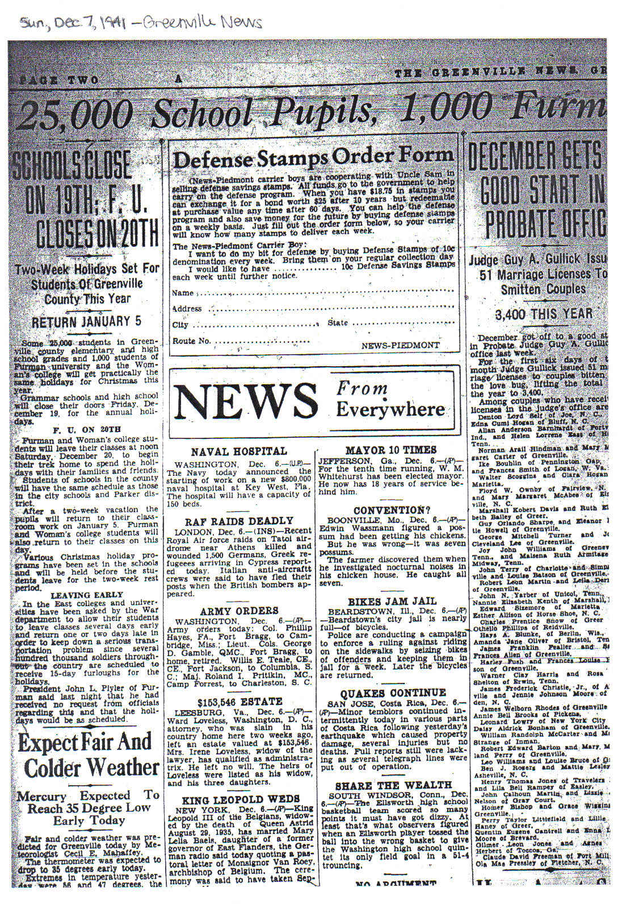
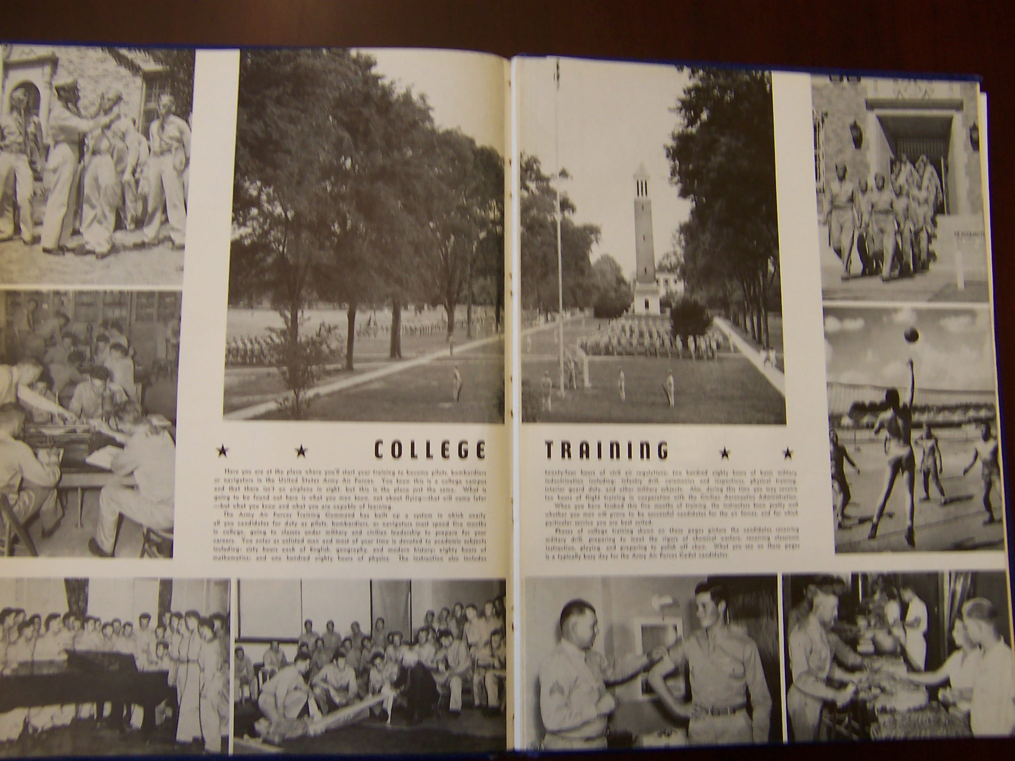
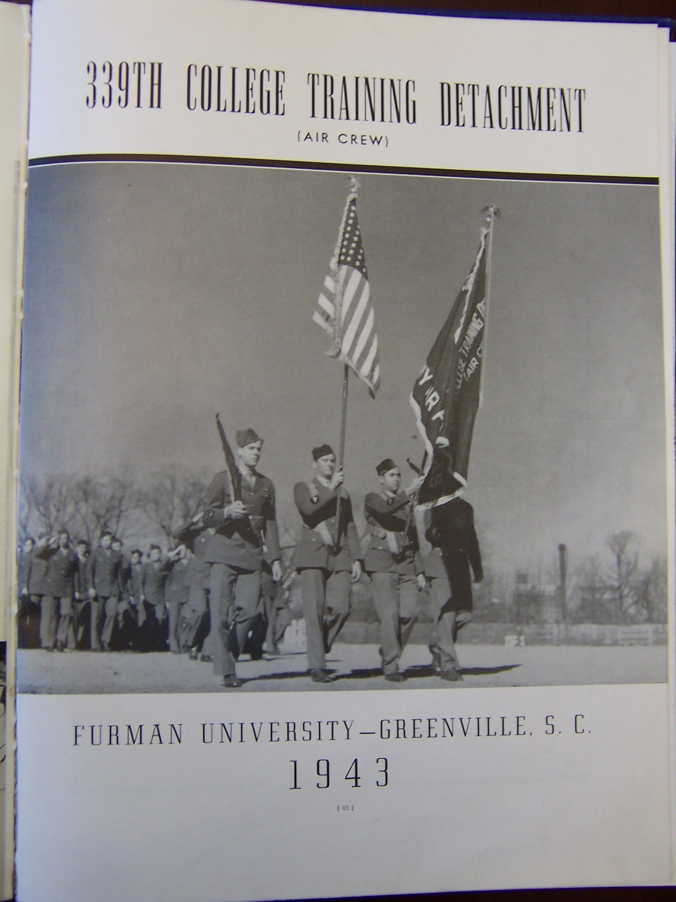
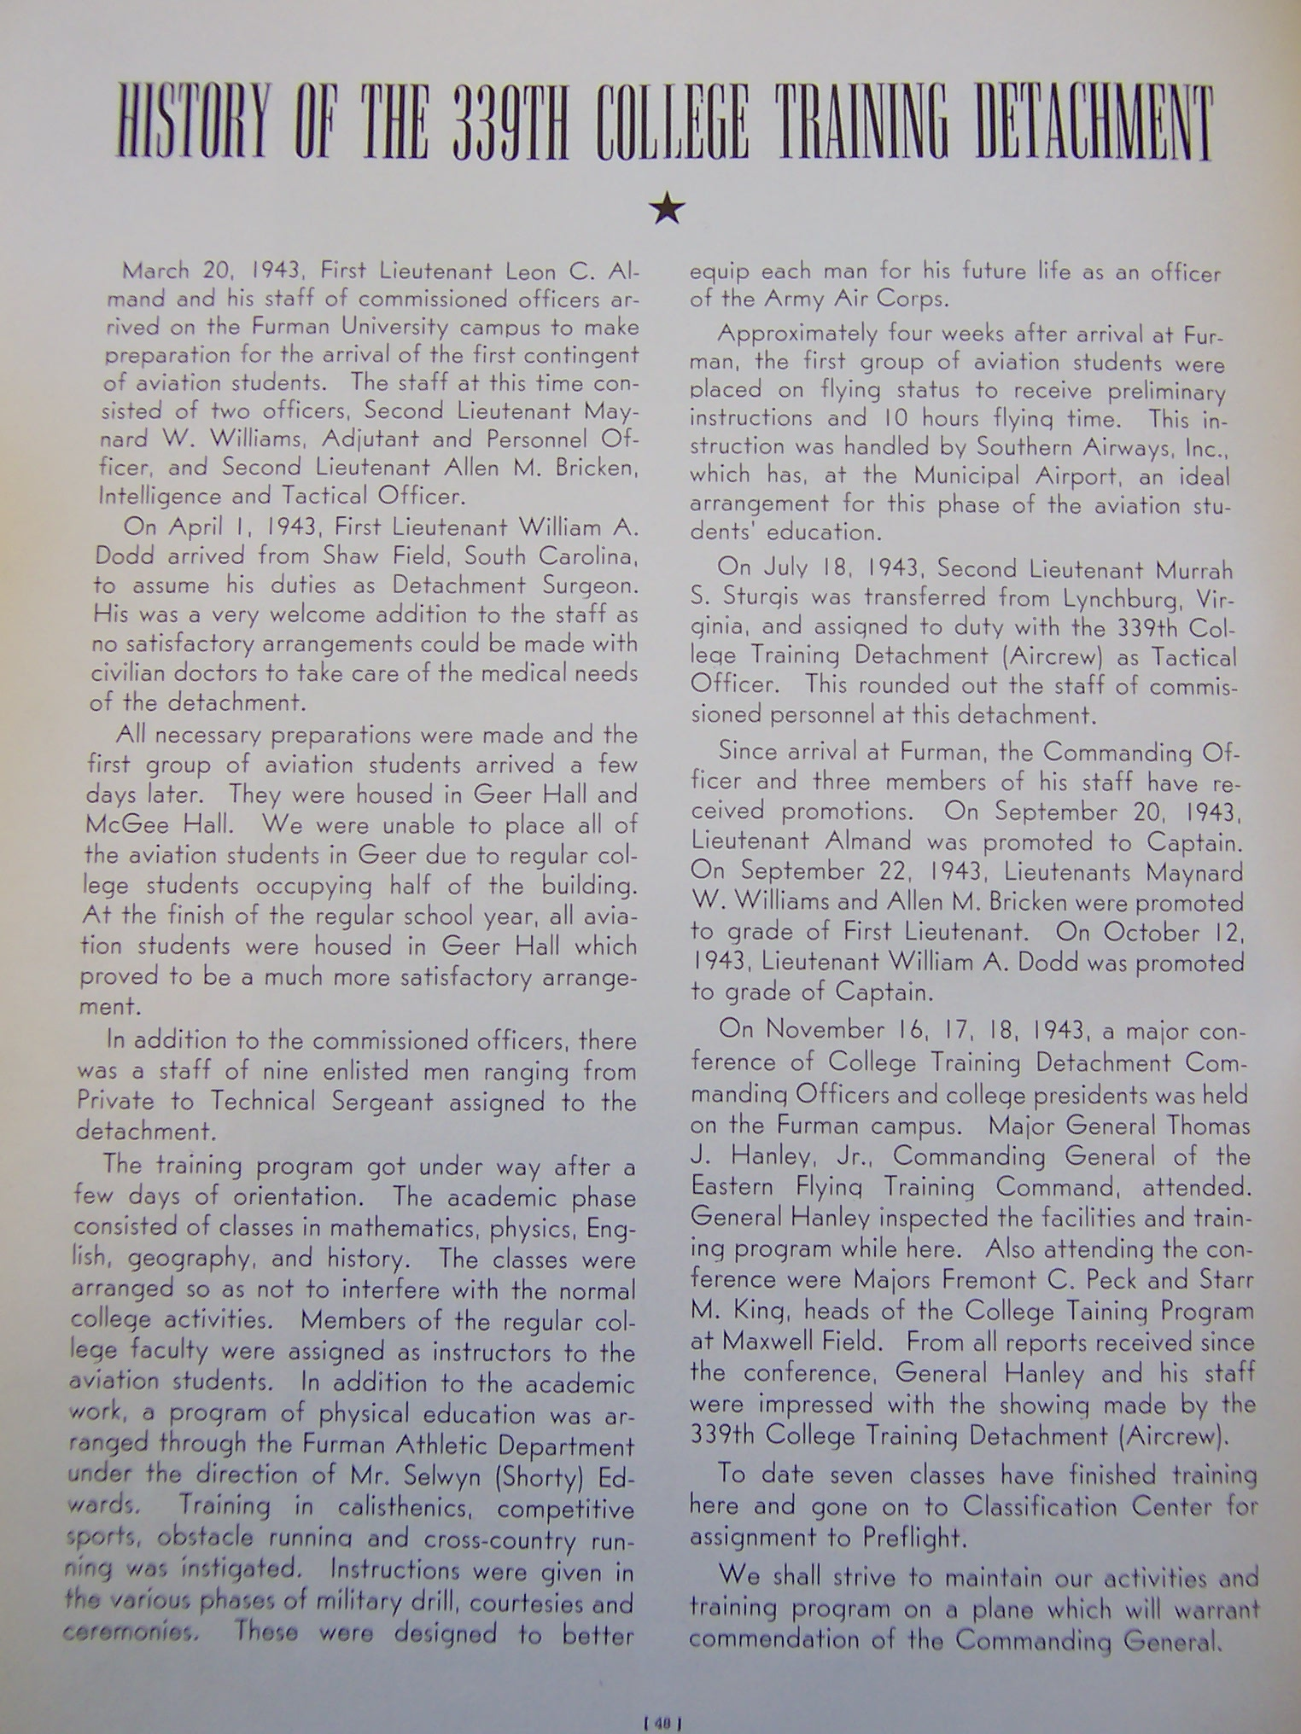
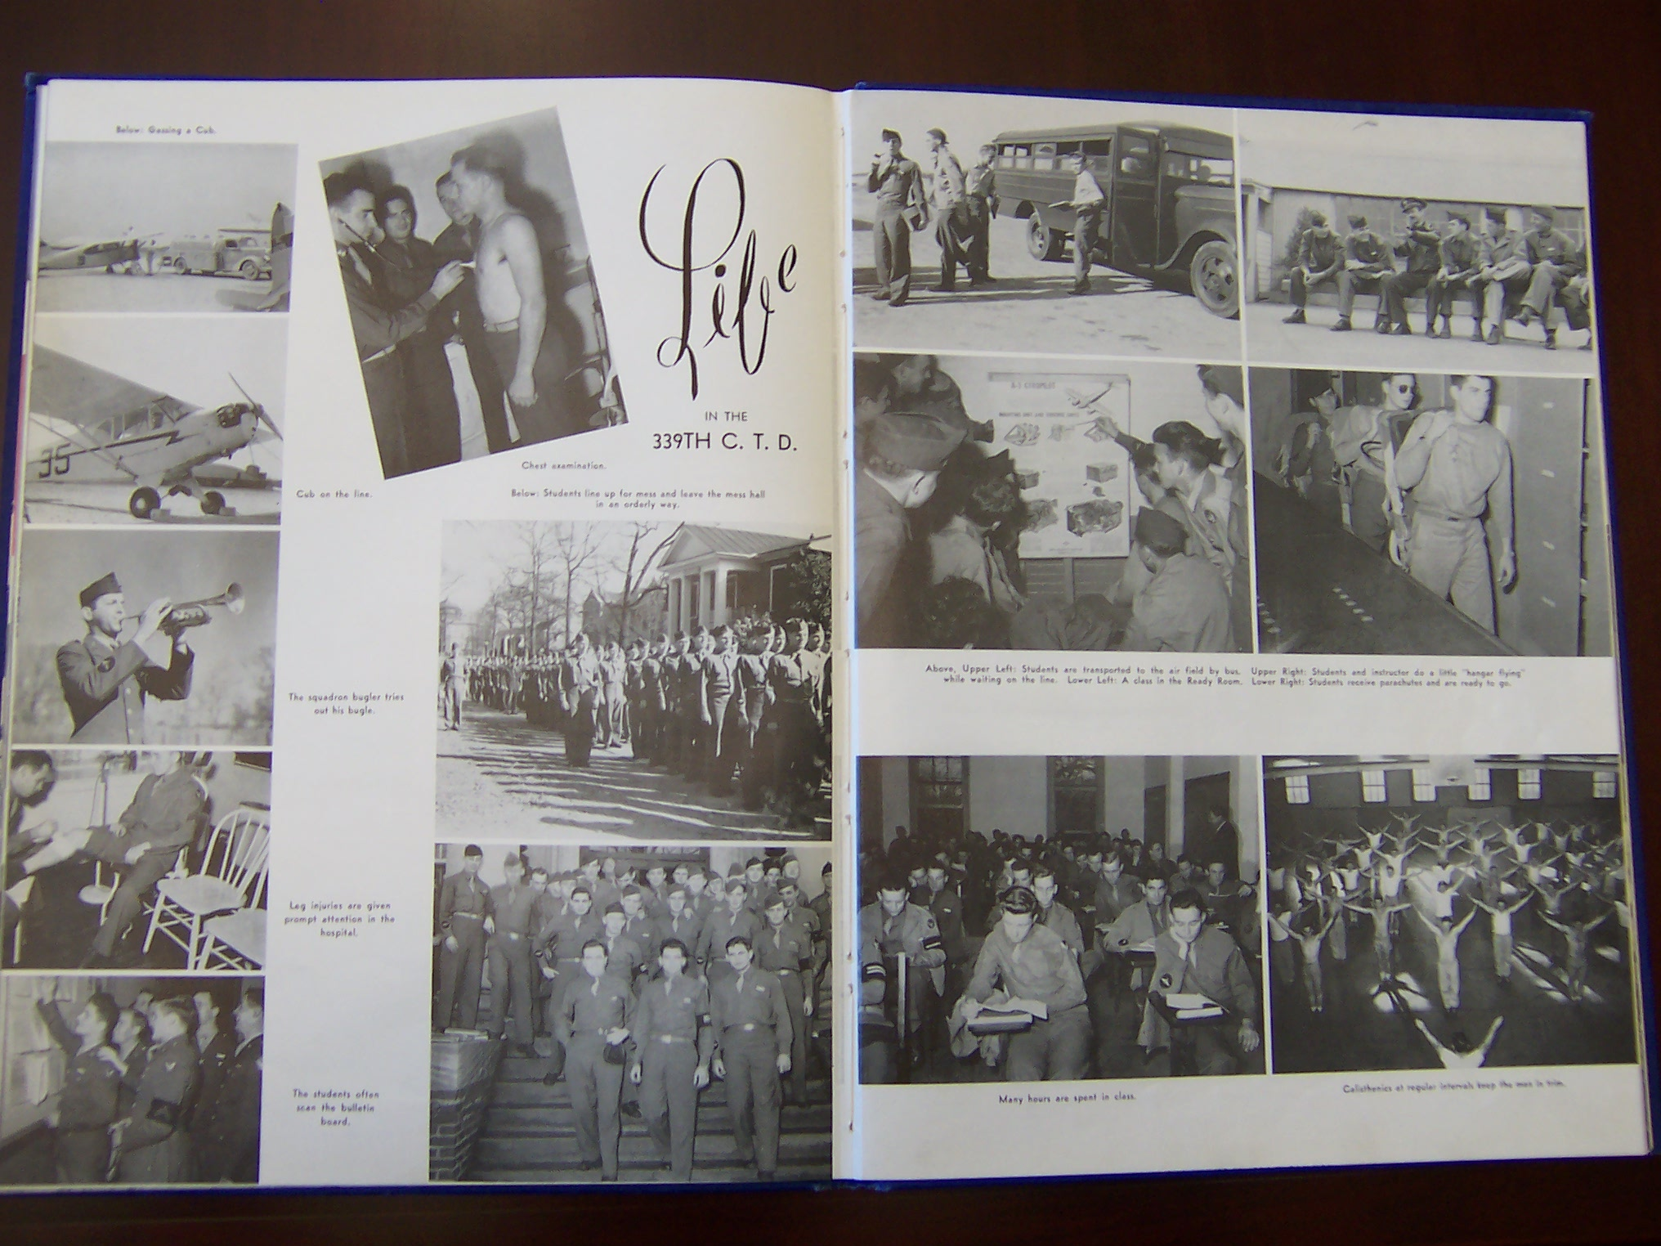
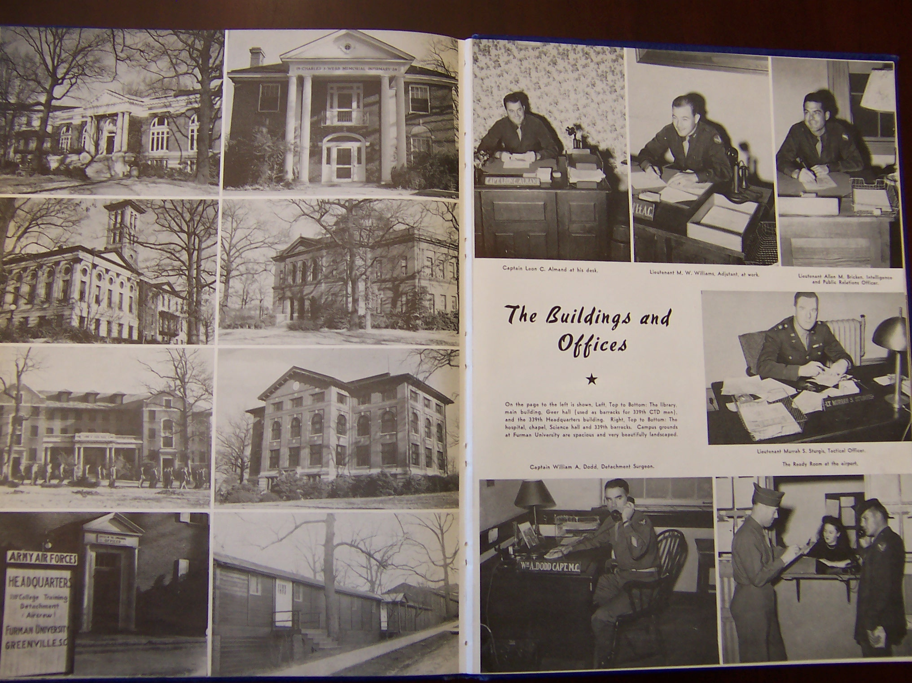
Economic Contributions and Changes

As a part of this group, you will be responsible for researching the impact of World War II on Greenville’s economy. Investigate your topic by dividing within your group to complete the following activities:

- Screen a portion of “Threads of Victory” (4:46-5:39).
- How did World War II impact the mills in Greenville?
- What were some war contributions from the mills?
- Skim the newspaper page provided.
- What is the most important headline or article? Why?
- What did you learn or infer about Greenville’s economy during World War II?
- Look at the pictures on page 119 in Greenville County, A Pictorial History by Choice McCoin.
- What did you learn about how Greenville’s economy changed before and during the war?
- In Greenville: The History of the City and County in the South Carolina Piedmont by Archie Huff, Jr., read the following selections and consider these questions:
- Skim page 381. What did farmers and Greenville residents do to help the economy during the war?
- Skim pages 388 and 389. How did Greenville’s economy change immediately after the war?
- Skim pages 392-393. What are some results of the post-war growth of industries?

After your sub-groups have completed these activities, join together as a group to write an article for our class newspaper about how the Greenville economy helped during the war and continued to grow after the war. Remember to grab the reader’s attention, include important information, and enhance your work with graphics.
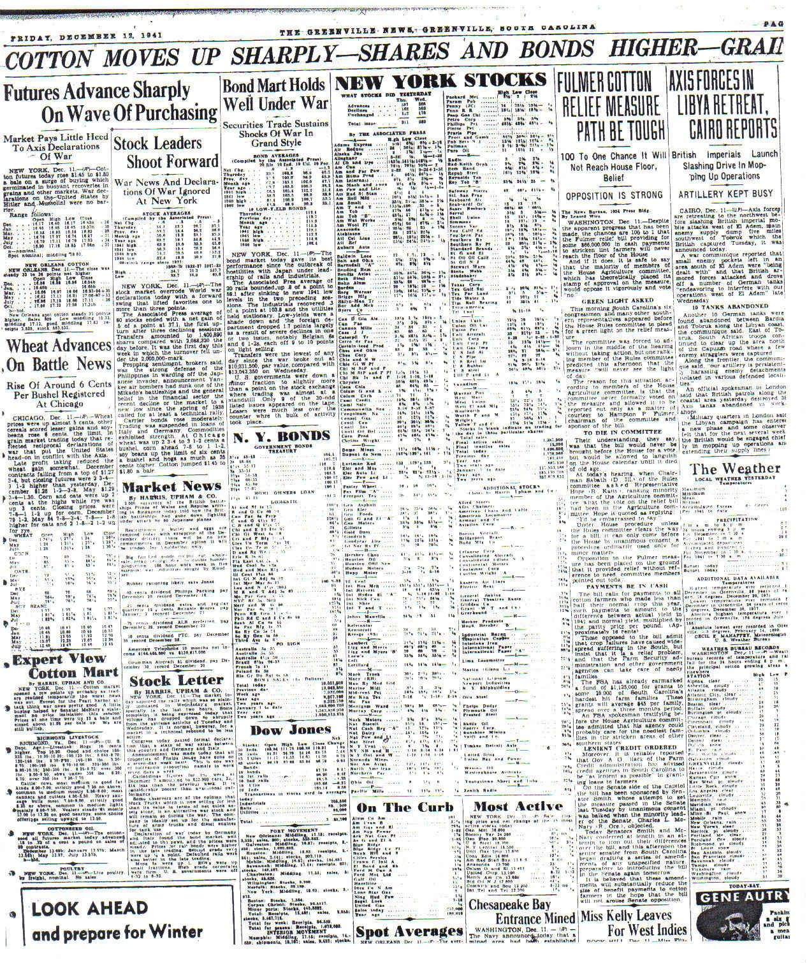
Life on the Home Front: Changes in Society

In this group, you will discover how World War II changed the lifestyles of the people who remained at home. Divide your group members to complete the following activities:

- Screen a portion of “Threads of Victory” (11:34-13:47).
- How did the people in Greenville support the war from home?
- Read the article “What to Do in an Air Raid.”
- Why would this article be in the newspaper?
- What does it say about how citizens of Greenville were dealing with the war?
- Look at the pictures on pages 128 through 133 in Greenville County, A Pictorial History by Choice McCoin.
- How did citizens of Greenville contribute to the war effort from home?
- How did life change in Greenville during the war?

After your sub-groups have completed these activities, join together as a group to write an article for our class newspaper about how life changed in Greenville during the war. Remember to grab the reader’s attention, include important information, and enhance your work with graphics.

Important: YOUR group will be the editors of our class newspaper! Decide as a group the layout for the newspaper. Make sure that all the other groups turn in their articles by the deadline. Each group should proofread their own articles, but work together to make sure that you check everyone’s work for mistakes
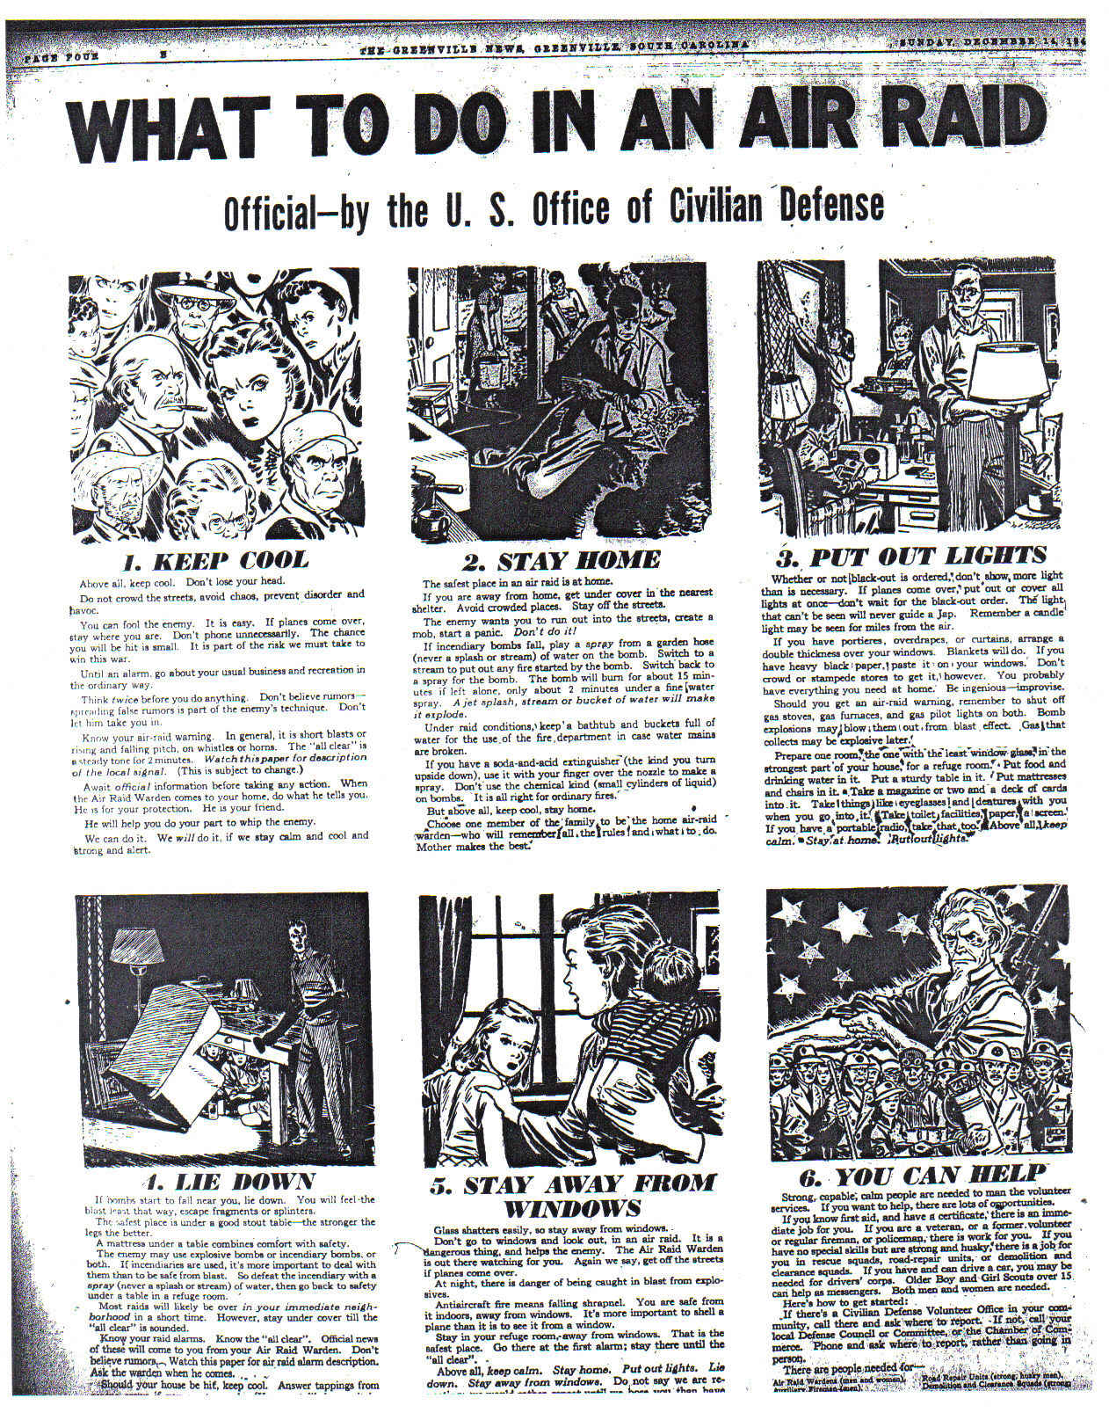
Greenville at War

Your group will research Greenville’s contributions to the war effort as a whole. Explore this topic by dividing group members to accomplish the following tasks:

- Screen a portion of “Threads of Victory” (19:08-19:58).
  - How did the people of Greenville react to the news about the war’s end?
- Skim “Japs Bomb U.S. Hawaiian Posts, Then Say War On.”
  - How do you think Greenville citizens felt when they read this newspaper?
  - When was this newspaper published? What is odd about this date and the events discussed? What did technology have to do with it?
- Skim the newspaper article from December 17, 1941.
  - What is the most important article or headline on the page?
  - How did the attacks on Pearl Harbor directly impact Greenville?
- Skim the newspaper articles from August 7, 1945, and August 15, 1945.
  - Why are these front pages important?
  - How do these headlines make you feel? How do you think the people of Greenville felt when they read these headlines?
- Look at the pictures on pages 119 through 128 in Greenville County, A Pictorial History by Choice McCoin.
  - What did you learn about some of Greenville’s significant events and leaders during the war?

After your sub-groups have completed these activities, join together as a group to write an article for our class newspaper about how Greenville reacted to the war and what important events and people during the war had connections with Greenville. Remember to grab the reader’s attention, include important information, and enhance your work with graphics.


