Community Ecology

I. Introduction
II. Multi-species Interactions within a Trophic Level
III. Multi-species interactions across Trophic Levels
IV. Succession
V. Biodiversity: Patterns and Processes
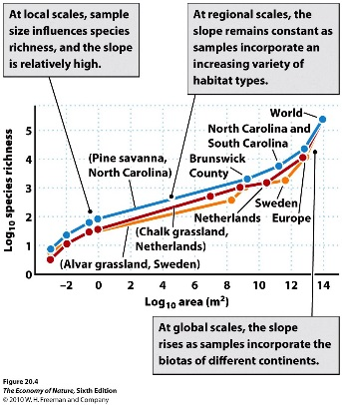
A. The Species-Area Relationship
1. The Pattern
Almost all organisms – across different taxonomic scales and physiologies, show this pattern. As sampling area increases, species diversity increases. Why?

2. The Theory of Island Biogeography
MacArthur and Wilson (1967) suggested that species diversity in a community might be an equilibrium between colonization (adds species) and extinction (subtracts species). The created a model which considered how these effects might play out on “islands” of isolated habitat, being populated from a source ‘mainland’ with a particular fixed species pool.
a. Islands Size Effects
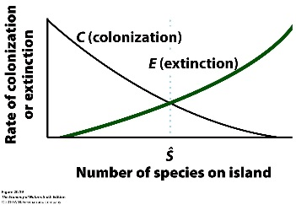
- The colonization rate to large islands should be higher than the colonization rate to small islands… as a combination of large islands being larger ‘targets’, and as having more habitats so that the colonists would have a better chance of establishing a population. This has been confirmed by sampling experiments, except among small islands (differing in size) which don’t have very different habitats.
- The extinction rate, however, should be higher on small islands. Small islands will have fewer resources and will house smaller populations which are more likely to bounce to zero randomly.
- Now, when we represent these functions in relation to species richness, things work like this: The colonization rate is a decreasing function of species richness… because as species richness increases on an island, the probability GOES DOWN that the next colonist from the mainland species pool will be a NEW one to the island. However, the extinction rate is an increasing function of diversity, because the more species there are, the more likely it is that one of them, by chance, will go extinct.
- So, if we combine the decreasing colonization functions and the increasing extinction functions for large and small islands, we see that the functions intercept at a higher richness value on large islands than on small islands… meaning that large islands have a higher EQUILIBRIUM species richness value than small islands. Species are being added and lost all the time, but the equilibrium richness is maintained and is higher on large islands.
b. Island Isolation Effects (Distance from Source Populations)
- MacArthur and Wilson realized that isolation could have similar effects, in that more distant islands would have lower colonization rates, and higher extinction rates, than close islands. The extinction rates would be higher because, once extinction occurs, a distant island would be far less likely to be recolonized again. In a sense, near islands might even maintain themselves just by migration – continually ‘rescued’ from extinction by migrants.
c. Empirical Tests
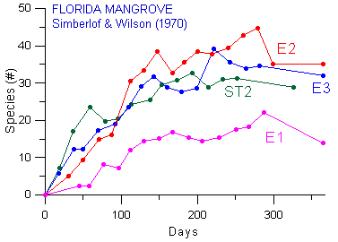
- Porcasi et al. (1999) – Catalina islands off California. Over 50 years, the number of bird species is fairly constant, yet there has been a significant change in the actual membership of these communities (turnover).
- Simberloff and Wilson (1970) manipulated mangrove islands in the Florida Keys… collecting all the isects by fumigation, and then looking at the pattern of recolonization. Islands tended to recover to richness values near the original levels, and yet there was continual turnover.

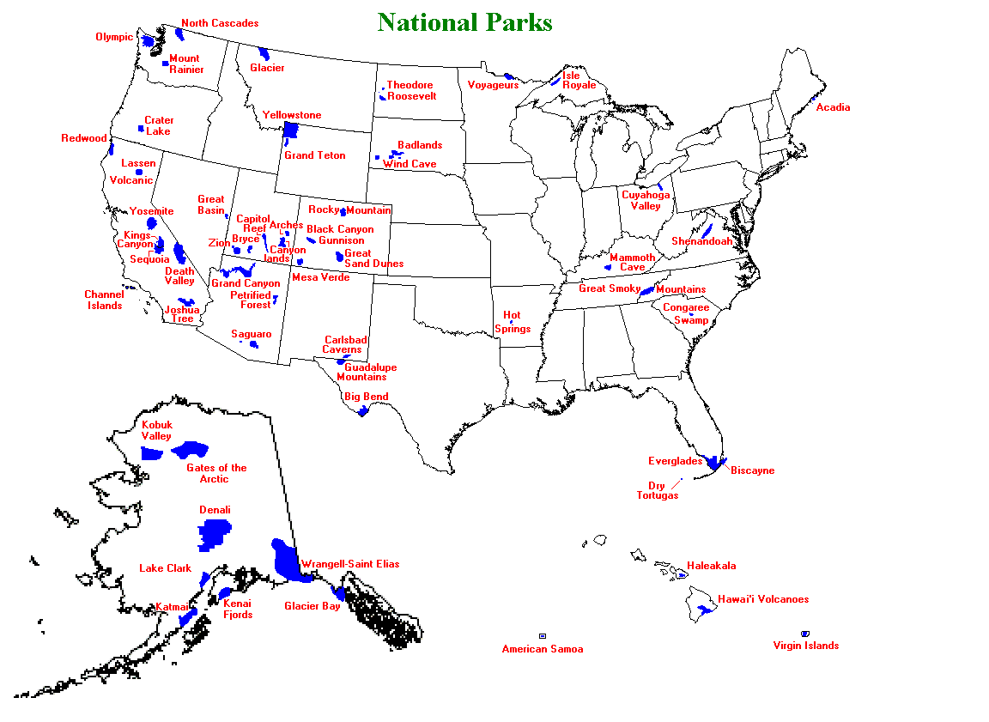
3. Why is this important? Fragmentation
This theory is one of the most important contributions to community ecology, because it is so easily genralizable to a variety of habitats at many scales. In fact, one might even consider continents to be islands with barriers to dispersal between them. Habtats are naturally subdivided – be they separated by rivers, land, or elevational change.
And of course, one of the most important effects that humans have had on natural landscapes is to reduce their size and subdivide them. So, simply as a consequence of the reduction in size of an area, we should expect local species extinctions and a reduction in species richness.

4. The SLOSS debate
So, in the ‘70’s, ecologist and conservationists became concerned with the rampant loss and fragmentation of tropical rainforests – and were concerned about the loss in diversity that these changes might cause. Several organizations from developed countries were established to help study and protect rainforests, including the Organization for Tropical Studies, which oversees the sites we visit in the “Tropical Ecology” course. In any case, the issue was this: given the reduction and fragmentation of habitat, how should we best maintain biological diversity? Should we save single large areas that should maintain the most species on that one island, or should we protect several small islands that may be maintaining different species and more, cumulatively, than the one big island? The answer turns on how the communities are structured with respect to ‘membership’ – not just how many species are present on islands, but who they are, and what the patterns in membership are as islands size increases. In short, the issue turns on the question of ‘nestedness’.

5. Nestedness
A B C D E
A
A B C
A B C D
A set of communities is said to be nested if the species found in low-diversity communities are also found within the set of species in high diversity communities. So, community sets are nested within one another as diversity increases, like a set of Russian dolls. Many communities are nested, for a variety of reasons similar to the species-area relationship, itself. Large islands are likely to have the habitats on small islands PLUS other habitats, so they should harbor the species on small islands PLUS other species. Extinction patterns should be non-random, too; small islands will lose the same species for biological reasons – so top predators will be lost from all small islands, and species sensitive to the same size-dependent disturbances will be lost from stressed habitats. So, even if you begin with unnested communities, the application of stress to these communities – caused by reduction in area or environmental stress – will cause a non-random loss of sensitive species and can cause the communities to decay to a nested subset of tolerant species.
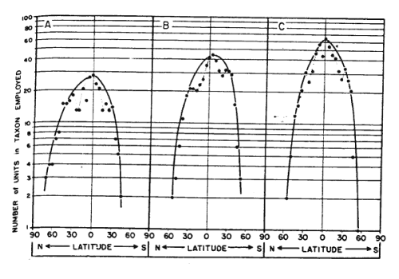
B. The Latitudinal trend in Diversity
1. The Pattern
- across all types of organisms (plants, animals, protists) that live in all types of habitats (terrestrial, marine, freshwater), we see that diversity increases from the poles to the tropics. This general pattern suggests that there might be a general determinant… but ecologists have found each prediction wanting in one regard or another.
- Also, these latitudinal patterns are often confounded (or moderated) by other large-scale climatic correlates. For example, although tree, amphibian, and reptile diversity does decline with increasing latitude across North America, there is also a very strong cline from east to west that correlates with differences in moisture availability.
2. Potential Causes
a. The energy-diversity hypothesis: The amount of energy/unit are also declines with increasing latitude, and many ecologists have suggested that this correlation with diversity might be causal – for several reasons. First, more energy into a system means more plant productivity. More plant production means more herbivore biomass can be supported, and more carnivore biomass, and more higher levels of a trophic pyramid. So, diversity may be greater because of this quantitative increase in the base of a food web, creating “bottom-up” effects on diversity. Tropical systems are indeed more productive, per unit area, than temperate or polar systems.
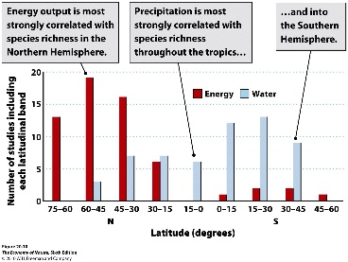
The relationship with energy is complicated a bit by plant demand for water. Indeed, diversity correlates more strongly with precipitation in the tropics and southern hemisphere; because energy is uniformly high anyway (tropics) and/or water becomes a more limiting variable (southern hemisphere). For this reason, some ecologist have tried to map diversity onto Potential Evapotranspiration (PET). However, these curves flatten out and are no more descriptive, really, because diversity tends to decline with the highest PET that occurs in deserts.
Energy and productivity may also increase diversity for qualitative reasons. The tropics not only have MORE productivity, they have more KINDS of productivity – more types of plants, allowing greater specialization by more types of animals. We tend to see this diversity evolving by sister species using slightly different resources. This should make sense; sister species are probably very similar, and so they would have to partition some important resources in order to coexist without competitive exclusion.
More species and longer food webs means more predators, and the possibility of maintaining that diversity by keystone, “top-down” effects.
Finally, another aspect of the energy-diversity hypothesis suggests that the rates of evolution, adaptation, divergence, and speciation might be higher in the tropics under increases energy irradiation. Increased radiations means more mutation (increasing diversity), and higher metabolism, faster development, and shorter generation times. So, in a given amount of time, tropical populations should have greater variation and more bouts of reproduction (read: more opportunities for “differential reproductive success” = SELECTION). So, with more selection, populations should adapt more quickly, diverge from sister populations more rapidly, and speciate more quickly, too – producing more species in the tropics.

Study Questions:
1. Give two reasons why colonization rate should increase with island area, and one reason why extinction rate should decline with islands area.
2. Describe the results of the surveys in the Catalina islands and the mangrove islands in the keys. What essential features of these studies provide support for the equilibrium theory of species richness?
3. Why is the theory about “islands” become so important to issue of conserving biodiversity? Provide a couple examples?
4. What is nestedness and how would it influence decisions about conserving “single large” or ‘several small” areas?
5. Describe three factors that can cause nestedness.
6. How can an initially unnested system “decay” to a nested set of communities? Provide an example.
7. There are several effects that “energy” might have on diversity. Explain “bottom-up” quantitative and qualitative effects, and also why these would produce top-down effects.
8. Explain the “evolutionary spped” hypothesis.

