Lecture 6: Darwin and the Birth of Modern Biology

I. The Birth of Science

A. Overview
The idea of observing a natural phenomenon, proposing a testable hypothesis of causality to explain that phenomenon, and then testing that hypothesis to determine its validity has NOT been a formal method of inquiry throughout human history. Although processes of "trial and error" in solving mechanical problems almost necessitate at least an unconscious 'scientific' process, explanations of how the world IS, or why it is THIS WAY, were promoted by philosophers long before the tool of science developed. A very brief overview of the birth of science, as it relates to the study and explanation of life, is therefore important and instructive for understanding why Darwin's ideas were both revolutionary and yet - in some sense - historically anticipated.

B. The Greeks
1. Hippocrates (450-377 bc): He valued observation and testing rather than pure logic - "cut-it-open-and-see" - Believed in use and disuse and inheritance of acquired traits; so accepted change within a "family". - Close to an embryological, evolutionary approach, and physicians today honor his philosophy of "first, do no harm" in the Hippocratic Oath.
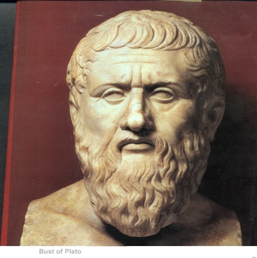
2. Plato (427-347 bc): Plato was trained in the Pythagorean school, and was more truly a pure philosopher rather than a 'naturalist', per se. As such, he was more impressed by generalizations rather than the vagarities and variation of individual experience; indeed, those variations that are so important to a true understanding of biology.
UNIVERSAL PHILOSOPHY (four dogmas)
- Essentialism: (essences perfect; material world is an imperfect reflection of these perfect essences/'ideals' (eidos). Cave analogy; triangle example.
- Universal Harmony: essences form a perfect whole - can’t change
- Demi-Urge: creative force that made the essences
- Soul: non-corporeal "spark of life" in living systems; maximized in humans.
- became the bedrock of western civilization for 2000 years! Ernst Mayr, one of the most important biologists of the 20th century, states: "It took more than 2000 years for biology, under the influence of Darwin, to escape the paralyzing grip of essentialism...the rise of modern biology is, in part, the emancipation from Platonic thinking".
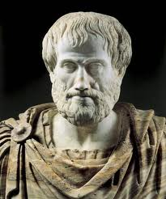
3. Aristotle (384-322 bc): Aristotle was the first great philosopher interested in biology. He described 100’s of species and fossils, and he wrote books on anatomy, reproductive biology, and life histories. He was Plato's student and Alexander the Great's tutor. He was more of an empiricist than Plato, using observation (and not reason, alone), to answer some questions about the natural world. Indeed, he is credited with describing the first formal rules of deductive and inductive logic. He believed that knowledge could be discovered from observations (induction), but he did not include an experimental component to his methodology - rather, the evaluation of alternative, "induced" hypotheses was by logical deductive reasoning, alone. He affirmed the Platonic ideals of a harmonious, static whole, with fixed species created by an "unmoved mover" in an array from simple to complex in a great chain of being (Scala naturae) of increasing perfection.
4. Summary: There is a rather schizoid biological inheritance from the greeks. On one hand, Aristotle and Galen provide much correct (an erroneous) factual knowledge about the natural world, and Aristotle's contributions in logic are the foundations of the scientific method. However, the Platonic essentialism that dominated a philosophy of nature would inhibit consideration of evolutionary ideas, and the emphasis on reason as the ultimate arbiter of truth hindered an experimental approach.
C. The Persians (latinized name used in the west)
1. Ibn al-Haytham (Alhazen) (965-1040): Born in Basra (now in Iraq), he is credited with presenting the first formal process of observation, hypothesis, experimental test using quantification and math, and conclusion. In his major work,Book on Optics (1021), he describes his experiments that falsified the notion that sight is caused by particles that radiate from the eye (as argued by Ptolemy) or radiate from the object (as argued by Aristotle).
2. al-Biruni (973-1048): Born in what is now Uzbekistan, al-Biruni applied a scientific method to new fields, basically inventing the disciplines of comparative sociology (in the study and comparison of cultures) and experimental psychology. His contributions to astronomy are even more profound, as he considered the hypothesis that the earth travels in an ellipse around the sun and spins on its axis daily, and he measured the radius of the Earth 600 years before a correct estimate would be made in the west. His most valuable contributions to the progress of science were his emphatic reliance on precise quantification and repeated observations. He believed that error caused by instrumentation or human error could be compensated for by taking the average of repeated observations.
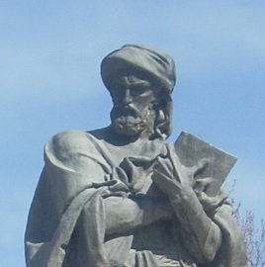
3. Ibn Sena (Avicenna) (980-1037): Also born in what is now Uzbekistan, Avicenna was a contemporary of al-Biruni and is considered one of the greatest philosophers in history. Although he was closer to Aristotle than al-Biruni, he still felt that Aristotle's philosophy of induction needed the critical element of experimentation to test the conclusions. Avicenna is primarily known for building on the works of Hippocrates, Galen, and Aristotle, making contributions to medicine that were used throughout Europe in the Middle Ages.
4. Summary: The Persians were the first to explicitly describe and study natural phenomena in the language of mathematics. Building on aristotelian ideas of induction and hypothesis formation, the Persians added the critical concept of empirical, quantitative, replicated experimentation to test hypotheses. This is the scientific method.

D. The Middle Ages (476-1400)
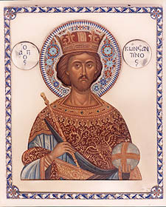
1. Constantine the Great (reign 306-337 - First Holy Roman Emperor) - His conversion to Christianity signalled a change in the west from the polytheism of ancient Greece and Rome to monotheism; and the tenets of a single, perfect, static creation meshed well with the dominant Platonic philosophy of essentialism.
2. Thomas Aquinas (1225-1274) - Aquinas presented the most formal logical argument for the existence of God, largely using the teleological argument of design. Events or objects that move towards a goal (have a purpose) a primary cause; Aristotle's "unmoved mover" is Thomas's Christian God. Thomas professed a "natural theology", which suggested that one could come to know more of God by studying "His works" (nature).
3. Summary: The unification of political, religious, and economic power in the Roman-Catholic Church created a monolithic cultural authority that was resistant to alternative views. The Church claimed its inerrant authority from an inerrant Bible, so facts or ideas in conflict with the Bible were at least wrong, and at most heretical; alternative sources of truth and authority (like scientific investigations) were implicit challenges to the power of the church. During this period, however, several western philosopher-theologians like Aquinas and Robert Grosseteste (~1168-1253; translator of Aristotle) and Roger Bacon (1220-1292) read translations of muslim philosophers and exposed the west to the power of Aristotelian logic and experimentation.

E. The Renaissance (1400 to 1700)
1. Cultural Climate: The political and cultural tumult of the Protestant Reformation, the formation of the Church of England, and the development of a merchant class and trade, undermined the hegemony of the Roman-Catholic Church and placed a greater premium on knowledge of mechanics and the physical world. At the same time, the voyages of discovery of Dias (1488) - who rounds the Cape without burning up - and Columbus 1492) revealed new species and lands not described in the Bible. The Roman Inquisitions begun in the 16th century were attempts to maintain control over heretics and their ideas. On February 16, 1600, Italian philospher Giordano Bruno was burned at the stake for heresy - probably due to his persistent promotion of logic, reason, and empiricism as a source of truth, rather than religious authority. His support for the copernican system may also have played a role. Protestants were equally adamant in their beliefs, and John Calvin had Michael Servetus burned at the stake for heresy in 1553.
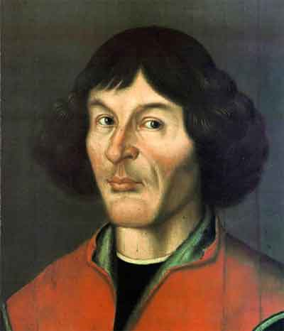
2. 1543: The publication of two works had a profound impact. Nicolaus Copernicus's De revolutionibus orbium coelestium (On the Revolutions of the Heavenly Spheres) described the heliocentric model of the solar system, opposing the terracentric view supported by both the authority of the ancients (Ptolemy and Aristotle) and the Bible. Interestingly, Copernicus still depended on philosophical preferences over observation - he imagined that the planets travelled in circles, not ellipses, because the circle was a more perfect form. Likewise, Andreas Vesalius's De humani corporis fabrica (On the Fabric of the Human body) was published in 1543. Profitting from the renaissance developments in art and printing, Vesalius was able to include exquisite drawings of dissected cadavers. Through this empirical approach to human anatomy, many errors of the ancients (Galen, in particular) were revealed. In short, as Francis Bacon (1561-1626) concluded, knowledge is incomplete; it is not all found in the Bible or the ancient texts, and new knowledge is discovereable by the process of empirical hypothesis testing.
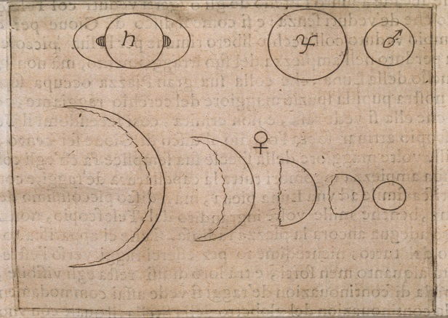
3. Kepler (1571-1630) and Galileo (1564-1642) were the first great natural philosophers in the west to emphasize and use a mathematical, experimental approach to answer questions about the physical world. Galileo's observations of the moons orbiting Jupiter, and the full phases of Venus (impossible to explain with a Ptolemaic model of the solar system), provide empirical support for the copernican model. Galileo, however, was still wedded to the philosophical imperative that the orbits were perfect circles. Kepler attacked this view with voluminous data collected by he and his mentor, Tycho Brahe. By using elliptical orbits, Kepler was able to fashion the most precise predictive models of planetary orbits available. Galileo was a devout Catholic, but he famously said that the Bible tells a person "how to go to heaven, not how the heavens go". In this, and in his goad to "Measure what is measurable, and make measurable what is not so", he personifies the quantitative scientist. In his Dialogue Concerning the Two Chief World Systems (1632), he publicized the debate over these worldviews. The Roman-Catholic church brought him to trial for heresy, and he was ultimately forced to recant his support for the Copernican model before the Commissary-General of the Inquisition in Rome during 1633. He was ultimately placed under house arrest (confined to his home in Arcetri) for the remainder of his life.
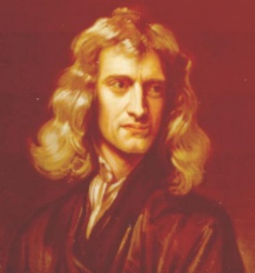
4. Newton (1642-1727): In Newton's Philosophiae Naturalis Principia Mathematica (1687) we see the fulfillment of the scientific method - the formation of testable general theory. Newton constructed a general theoretical model of gravity and motion that became classical mechanics. This theory explained the motion of earthly objects (apples and projectiles falling) and the elliptical path of heavenly bodies. We see the culmination of Aristotle's imperative for both inductive and deductive reasoning - from specific observations one constructs a general hypothesis (inductive reasoning). Now, you use deduction to create a prediction that follows from that hypothesis (IF... THEN...). And of course, you subject your prediction to an experimental test in which falsification is possible. Although other natural philosophers (the term "scientist" was not coined until the 1830's) had been held in high regard by some nations, kings, or patrons, Newton was knighted - signifying the complete cultural acceptance of this new way of examining the physical world.
5. Summary: During this period we see the development and application of the scientific method in the west. The "scientific revolution" had a curious effect on the study of life. Science emancipated physics, astronomy, and chemistry from theology by describing constant, natural, predictive laws and by describing the unchanging nature of elements (alchemy disproven). This confirmed the Platonic views of an unchanging universe created in perfection and left to run like a 'clockwork'. But what about our little corner of the universe? Was the Earth also static from 'the beginning", and just how long ago was that, anyway? Anglican Bishop James Ussher (1581-1656) applied logical rigor to the History of the Earth as revealed in the Bible and counted back the generations, determining that creation began at noon, October 23, 4004 b.c. (For a great book about calendars, read Stephen J. Gould's Questioning the Millenium). Thomas Burnet (~1635-1715) wrote The Sacred Theory of the Earth (1680), an account of earth's history as a literal account of Genesis 1. So, both concluded that the Earth was young, and most natural philosphers also concluded that the species were fixed since their creation.

F. The Enlightment (1700’S)
1. Cultural Climate: The 1700's were a tumultuous century in Europe, punctuated by the industrial revolution, the American Revolution, and the French Revolution. Ideologies were shaken to their foundations, and the promise offered by science and reason and industrial power challenged ideas of socieconomic stasis and authoritarian rule.
2. Natural Theology - Following on the thinking of Aquinas, there was a resurgence of Natural Theology to explicitly consider the theological import and relvance of the new observations made by science. The fundamental assumption was that God made things for a purpose, and that we might understand God's purpose if we more fully describe the creation and its operation. The most explicit reconstruction of these ideas was by theologian William Paley's Natural Theology: or, Evidences of the Existence and Attributes of the Deity, Collected from the Appearances of Nature (1802). Here he provides his teleological argument for the existence of God, using the allegory of the "watchmaker".
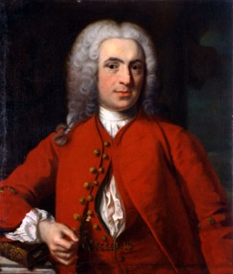
a. Carl Linne (1707-1778) - "Linneaus" (he latinized his own name) was the "great cataloguer", and he published the first edition of Systema Naturae in 1735. It wasn't until 1753, however, in Species Plantarum (Plant Species), that he formalized his prcedure for using two names to identify a species - the latin binomen (like Homo sapiens). The first name is the GENUS, and the second is called the 'specific epithet' that describes this species and distinguishes it from other similar species placed in the same genus. Linnaeus also grouped these genera (plural of 'genus') into orders, classes, and kingdoms based on additional morphological similarities. In plants, he relied on similarities in the reproductive structures, as many naturalists accepted that species are kinds that reproduce only with themselves. In the 10th edition of Systema Naturae (1758), he applied this system to all animals, too. The oldest scientific species names used today date from these two works. By the way, the word 'species' is both the singular and plural. There is no 'specie'. FYI. : )
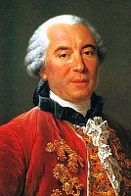
b. Georges Louis Leclerc, Comte de Buffon (1707-1788) Buffon pulbished the first volume of his encyclopedic Histoire Naturelle in 1749. Ernst Mayr considered Buffon to be the foremost biologist of the 18th century, and Mayr wrote "it makes no difference which of the authors of the second half of the 18th century one reads - their discussions are, in the last analysis, merely commentaries on Buffon’s work. Except for Darwin and Aristotle, there has been no other student of organisms who has had as far-reaching an influence." He opposed the notion oif classification; if the species were separately created, then of what use was any classification system? He was aware of possibility of evolution but rejects it:
"Not only the ass and the horse, but also man, the apes, the quadrupeds, and all the animals might be regarded as constituting but a single family... If it were admitted that the ass is of the family of the horse, and different from the horse only because it has varied from the original form, one could equally well say that the ape is of the family of man, that he is a degenerate man, that man and ape have a common origin; that, in fact, all the families, among plants as well as animals, have come from a single stock, and that all the animals are descended from a single animal, from which have sprung in the course of time, as a result of progress or of degeneration, all the other races of animals. For if it were once shown that we are justified in establishing these families; if it were granted that among animals and plants there has been (I do say several species) but even a single one, which has been produced in the course of direct decent from another species; if, for example, it were true that the ass is but a degeneration from the horse - then there would no longer be any limit to the power of nature, and we should not be wrong in supposing that, with sufficient time, she has been able from a single being to derive all the other organized beings. But this is by no means a proper representation of nature. We are assured by the authority of revelation that all animals have participated equally in the grace of direct Creation and that the first pair of every species issued forth fully formed from the hands of the Creator." Histoire Naturelle (1753)
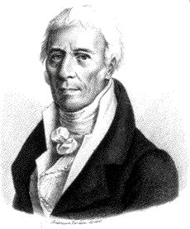
c. Jean Baptiste Pierre Antoine de Monet, Chevalier de Lamarck (1744-1829) - Initially a botanist and tutor to Buffon's son, he became an expert in invertebrates and the mollusc fossils of the Paris Basin. through this work, his initial belief in the fixity of species changed. In his culminating work Philosophie Zoologique (1809), he suggested that species change over time, climbing the Scala Naturae from simple forms to complex. The simplest forms were continuously produced by spontaneous generation, and species did not go extinct - they evolved into more complex forms over long periods of time. In addition to this vertical progression, they could also diverge as a consequence of responding to the environment and passing on the traits they acquired as a result of the action of this environment. Structures that were used in an environment would be elaborated (use and disuse), and then these newly elaborated structures were passed on to offspring (inheritance of acquired traits). Lamarck's evolutionary ideas explained the new observations of fossil diversity and apparent extinction. In Lamarck's mind, extinctions were theologically impossible, because he believed in a complete, harmonious creation by a benevolent creator. Why would a benevolent, purposeful creator let creations go extinct, and wouldn't the loss of some species render the perfection of the initial creation imperfect? For Lamarck, species changing into other species preserved the whole of creation. "May it not be possible that the fossils in question belong to species still existing, but which have changed since that time and have been converted into that similar species that we now actually find?" Lamarck is rightly regarded as the first "biologist" (he was the first to use the term) to propose a true evolutionary hypothesis, and a testable, naturalistic mechanism to explain it. Unfortunately, the mechanism was wrong.
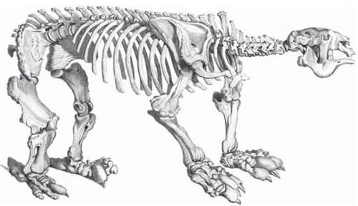
d. Georges Cuvier (1769-1832) - Cuvier was also an intellectual giant in France, and was Lamarck's nemesis. A great anatomist, Cuvier founded the comparative approach in anatomy and also founded vertebrate paleontology. Unlike Lamarck, he believed that extinctions occurred; and he supported this contention by showing that the great mammals of the past (mammoths, giant ground sloths, etc.) had no modern living forms (Cuvier concluded that elephants and mammoths were different species, and mammoths were truly extinct.) In contrast to Lamarck's ideas of gradually changing species responding to their environment, Cuvier promoted the notion that there were period cataclysms ('revolutions') that killed off local faunas and required repopulation from elsewhere. This idea became known as 'catastrophism', and stood in opposition to the 'uniformitarianism' of gradual change espoused by Lamarck and others. Cuvier also tore down the notion of the scala naturae, replacing it with four 'embranchments' of life disconnected from eachother. Finally, Cuvier said that the intermediates predicted by Lamarck's gradualistic evolutionary model did not exist, and he reminded the scientific community that spontaneous generation had been refuted (for insects, at least) since the experiments of Francesco Redi in 1668! He was a true essentialist, seeing discontinuity through time and through taxa. Cuvier outlived Lamarck and continued to lambast him and his ideas. Evolutionary ideas fell into disfavor as a consequence.

II. Darwin's Contributions
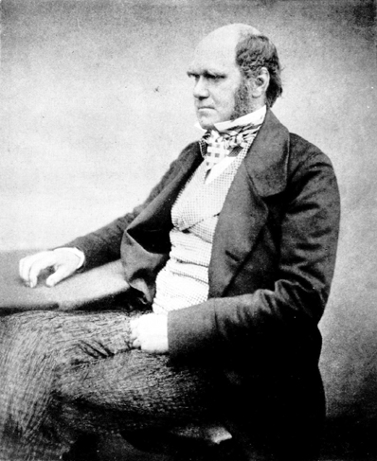
A. Overview: One of the great ironies of science is that the two greatest contributions in biology - the theory of evolution and the mechanistic principles of heredity - were described independently of one another within a ten year period. It is ironic because genetics (heredity) and evolution are so critically and intimately related...heredity describes how genetic information is passed from parent to offspring. This creates relatedness patterns within families, within species among populations, and among species. These relationships are a focus of evolutionary studies. The publications marking their official, orthodox ‘births’ were published only six years apart: Origin of Species (1859), and Experiments in Plant Hybridization (1865), yet it was nearly 80 years before these ideas were placed in their proper context within the Modern Synthetic Theory of evolution.

1. Darwin's Life
- born Feb 12, 1809, into a wealthy and distinguished family
- graduated Cambridge intending to join the clergy and study nature as a natural theologian
- 1831-36: Naturalist aboard the H.M.S. Beagle
- 1859 - Publishes "The Origin of Species", which he revises through six editions during his life
- dies April 19, 1882; interred in Westminster Abbey at the feet of Newton.

2. The Origin of Species (1859)
Darwin did three things in this book:
a. He summarized the evidence for evolution (common descent) as an historical fact
b. He proposed mechanistic theories explaining ‘how’ evolution might occur (Natural Selection, use and disuse)
c. He addressed the major problems with his ideas; notably the ideas of apparent design (Paley), the discontinuity of the fossil record (Cuvier), and the source of observed variation.

B. His Argument - Evidence for Common Descent as Historical Fact
1. Geology
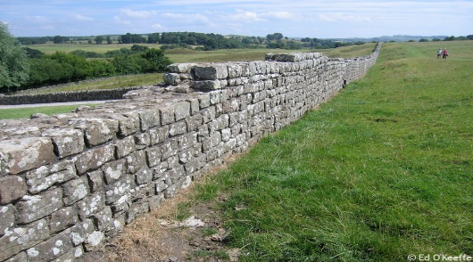
a. James Hutton (1726-1797): Hutton was the first great british geologist. He compared Hadrian's wall - which looks new but was 1600 years old (122 AD) - with natural rock outcrops that were strongly weathered. Hutton concluded that the natural outcrops must be 100's of times older. He also examined an important formation at Siccar Point, where one series of nearly vertical strata is overlain by another series of horizontal strata. This is now called an 'unconformity', and Hutton explained it as follows. Based on Steno's laws of superposition, the bottom vertical sediments must have been laid down first, and they must have been laid down horizontally. Ages must have passed between each deposit, as each turned to rock. Then, uplifts must have occurred to bend them into a vertical aspect. Long periods of erosion must take place to wear that uplift flat, followed by the long intervals of time needed to deposit the second horizontal series. Also, if erosion and deposition acted slowly (as current observations show), then it must have taken a really long time to erode mountains or build up marine deposits (White Cliffs of Dover). He concluded that this slow, 'uniformitarian' cycle of deposition, uplift, erosion, and deposition meant that the Earth was unfathomably old. Indeed, the cycle may mean that it's age might not be discoverable. In short, Hutton concludes, the Earth has "no vestige of a beginning, no prospect of an end."
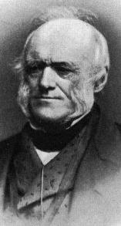
b. Charles Lyell (1797-1895): Lyell promoted Hutton's ideas of a great age to the Earth and uniform rates of change - making inferences based on the assumption of constant rates of physical processes. Small changes, accumulating over a long time, could have big effects. Lyell's three volume work Principles of Geology (1830-33) opened Darwin's eyes as he read them on the H.M.S. Beagle. Geology opened "deep time".... the Earth was at least 100's of thousands of years old, and natural processes working slowly, gradually, and cumulatively through time could affect large changes. Lyell was Darwin's contemporary and personal friend, although he was distressed by Darwin's evolutionary ideas.
2. Paleontology
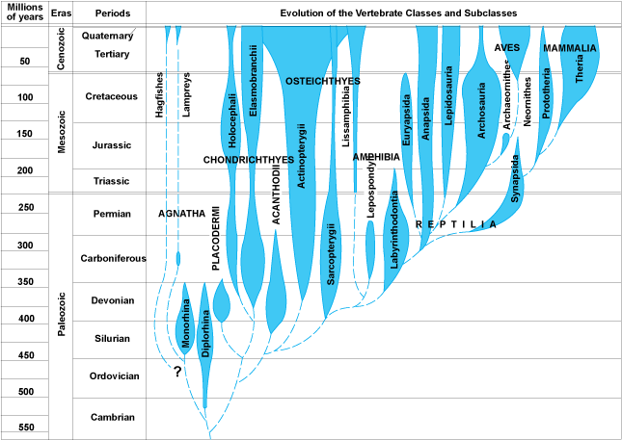
Paleontology provided a variety of interesting patterns. First, there were extinct forms that were different from the species alive today. Although some earlier natural philosophers suggested that the creatures might still exist in some unexplored corner of the globe, that was a less satisfying hypothesis in the mid-1800's... most areas of the globe had been visited by Europeans. Also, the idea of extinction was repugnant to some people on theological grounds. If God had created a perfect world, then extinction renders that creation imperfect. Also, if species could go extinct since the creation, could species also come into existence since the creation? Just how dynamic was this system?
Darwin was impressed by two major patterns in the fossil record.
1. The major groups of animals accumulate in an orderly manner'. Everything is not represented at the beginning. In vertebrates, for instance, the fishes appear first, and exist throughout the rest of the record. Amphibians appear next, followed by reptiles, mammals, and birds. So it is not everything at the beginning, and it is not a replacement. Where did mammals come from? Spontaneous generation had been refuted, so Darwin knew that mammals had to come from other pre-existing animals. But the only completely terrestrial vertebrates before mammals were reptiles.
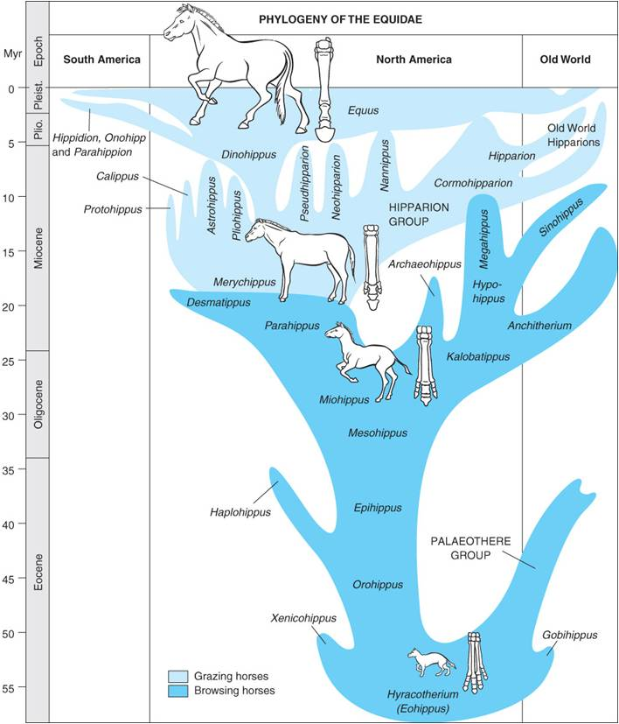
2. A second major pattern occurred within some lineages of similar organisms. Within some lineages, we seen orderly change in the size or characteristics of species in a geological sequence. For instance, consider the morphological patterns in a particular taxon (horses). Fossils in a stratigraphic sequence are similar, but often have traits that form a continuum...like the progressive loss of digits on the horse limb. And, with each innovation, there are often radiations - a "spurt" in the number of species that show this new trait. And finally, these species in recent strat are more similar to living ('extant') species than the species found in deeper, older strata. So, many of these transitional sequences terminate in living representatives.
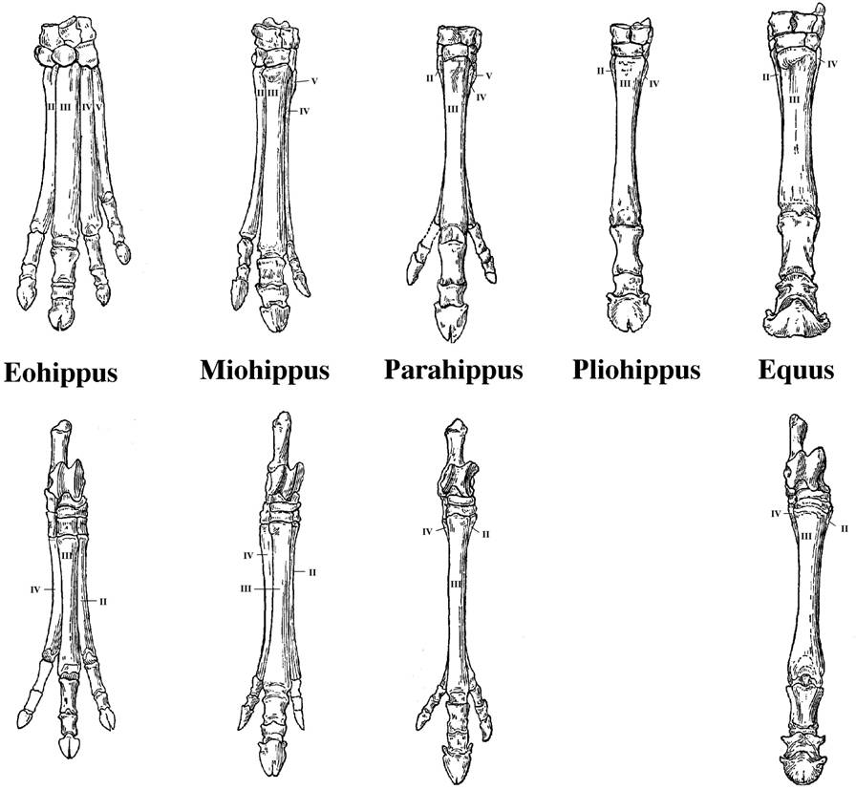
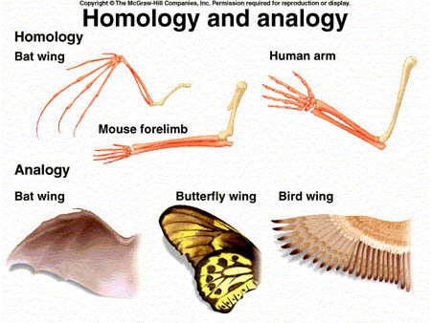
3. Comparative Anatomy
a. Homologous Structures
Although having a different outward "look" and although used for different purposes, they have an underlying similarity in structure - forelimbs of vertebrates all have one long upper arm bone, two lower arm bones, a bunch of wrist bones, and five digits. Darwin saw the similarity in structure as important. An engineer builds different things for different purposes - cars, boats, and airplanes are structurally DIFFERENT. Here, however, it seemed as if one basic structure was modified for different uses. Darwin knew why siblings in a family were similar - they had the same parents (ancestors). He reasoned that these structural similarities in different species might be due to the same principle - common ancestry. Also, he observed a correlation: Different uses correlated with different environments. Could this correlation be causal?
b. Analogous Structures
Organisms in the same environment often have a similar outward structure or body plan. For example, flying animals all have an aerodynamic wing that is wider at the front than at the rear. However, the wings of differnt animals are differnt in underlying structure. Bats have fingers that support the membraneous wing, whereas birds lack fingers and the body of the wing consists of feathers. Insect wings don't involve the limbs at all (even though they have 6!). Again, Darwin observed this correlation with the environment: similar use (and outward structure) in similar environments. Could this correlation be causal?
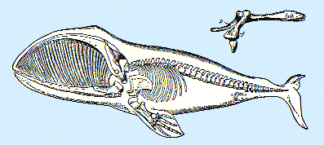
c. Vestigial Organs
These are organs that have no function in one organism (where they are 'vestigial') but they do function in other organisms. So, some whales have hip bones, but no legs. Why do they have these bones? Darwin was struck by the IMPERFECTIONS in nature, as much as the adaptations. Why do men have nipples? Why do we have muscles that wiggle our ears? Why do we have strong muscles in the front of our stomach, which are not "load-bearing", and weak muscles at the base of our abdomen (which rupture in a hernia)? This is a reasonable relationship in a quadraped, but not in a biped. Why do we have tail bones, but no external tail? Again, these are NOT well-designed features. In fact, attributing these imperfect designs to a perfect creator could be interpreted as heretical. However, when we see them working in OTHER species, it suggests that maybe we inherited them from common ancestors where they DID serve a function. As a scientist, Darwin was trying to explain ALL the data (adaptations and imperfections), he was not simply bringing forward only the data that supported a preferred position (design).
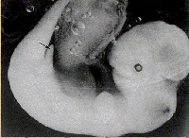
d. Embryology
Embryology reveals homologies and vestigial structures in both the anatomy of embryos and the process of their development. For Darwin, the notion that very different vertebrates, such as fish, amphibians, reptiles, birds, and mammals, would develop from very similar initial forms was inexplicable from a 'separate creation' perspective. For example, why do whale embryos (like the one pictured to the right) have hind limb buds? Why do all vertebrates have folds of tissue in the neck, when only fish develop them into functional gill slits in the adult? Some anomalies like the recurrent laryngeal nerves of mammals (described in your book) are explicable in a developmental, comparative, evolutionary context. Although no modern evolutionary biologist propounds the notion that an organism "traces their evolutionary history" as they develop from an egg (this was Haeckel's post-Darwinian idea that "ontogeny recapitulates phylogeny"), and Haeckel's drawings grossly exaggerated the similarities among vertebrate embryos, embryos are far more similar to one another than adults, and embryos are more similar to other embryos than they are to their own adult form. As we will see when we look at modern contributions from genetics and developmental biology, the similarities in development are even more dramatic than anatomy alone suggests.
4. Biogeography
a. Community convergence
Under similar environmental conditions, we find different species filling similar ecological niches. Outward 'form' correlates with ecological niche (role) across entire communities. So, in Australia, marsupials fill the role of dog-like predator, cat-like predator, burrowing animal, ant-eater, etc. These same roles are filled by outwardly similar placental mammals in South America. However, the similarity between a wolf (placental) and a Thylacine (marsupial - the 'tasmanian wolf') are strictly ANALOGIES. Their underlying structure shows them to be quite different - a wolf is more similar to a ground hog (both placentals) in underlying structure than to a thylacine.
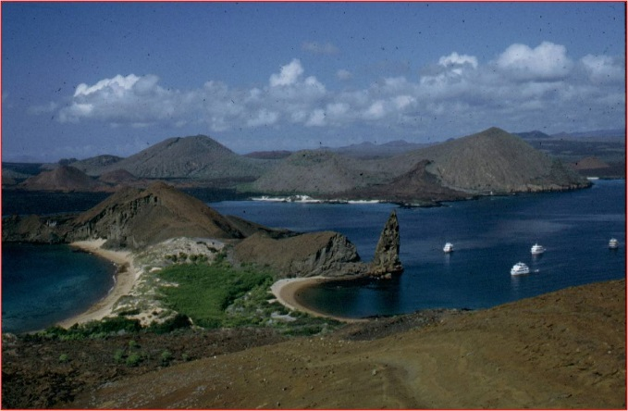
b. Islands Faunas
Islands often have fewer species than a mainland - even a patch of mainland the same size. As such, the patterns and interactions are often simpler to describe and understand. For both Darwin and Alfred Russel Wallace (the other independent author of the theory of evolution by natural selection), the study of islands was critical in to the development of their ideas.
1. Distance correlates with the uniqueness of the inhabitants: the animals on the Fauklands are the same species as on the mainland, but the Galapagos fauna is composed of unique species, found nowhere else:
"The natural history of these islands is eminently curious, and well deserves attention. Most of the organic productions are aboriginal creations, found nowhere else; there is even a difference between the inhabitants of the different islands; yet all show a marked relationship with those of America, though separated from that continent by an open space of ocean, between 500 and 600 miles in width. The archipelago is a little world within itself, or rather a satellite attached to America, whence it has derived a few stray colonists, and has received the general character of its indigenous productions. Considering the small size of the islands, we feel the more astonished at the number of their aboriginal beings, and at their confined range. Seeing every height crowned with its crater, and the boundaries of most of the lava- streams still distinct, we are led to believe that within a period geologically recent the unbroken ocean was here spread out. Hence, both in space and time, we seem to be brought somewhat near to that great fact -- that mystery of mysteries -- the first appearance of new beings on this earth." The Voyage of the Beagle - Darwin (1839).

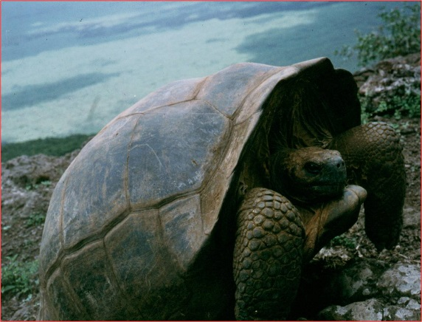
2. The Galapagos fauna:
- It was related to american fauna, yet different: the types of animals are new world animals.... there are iguanas like the green iguana of Central and South America, but the iguanas are different species. So, darwin describe it as " a world within itself, or rather, a satellite of the Americas" .... it was different, but more like the American fauna than any other...(no chameleons, for instance, which are old world lizards...)
- It was dominated by dispersive forms. This is critical. The communities are dominated by reptiles, birds, and marine mammals. All of these organisms could MIGRATE to the islands from the mainland. (Terrestrial mammals don't migrate as well as terrestrial reptiles over open ocean. Throw a reptile in cold salty water, and: 1) its metabolism slows down (its cold), so 2) its demand for food and water decline; and 3) its scales protect it against water loss... which is why reptiles do well in the desert, too. Throw a mammal in cold salt water, and it's going to have a VERY tought time: 1) the temperature gradient between its warm body and the cold ocean is very large - in order to maintain its high body temperature against this gradient, it's metabolism has to INCREASE (to produce more heat to compensate for the heat lost to the environment). This increased metabolic demand will INCREASE the need for food and water... that's probably in pretty short supply in the open ocean; and 2) water is lost quickly from the skin to the salty ocean once the fur is wet... so, mammals are more likely to starve or die of exposure than reptiles.
- So, the islands are dominated by dispersive forms, and this suggests they came from America. But if they came from America, WHY ARE THEY DIFFERENT SPECIES THAN THOSE IN AMERICA? They must have changed since their arrival.
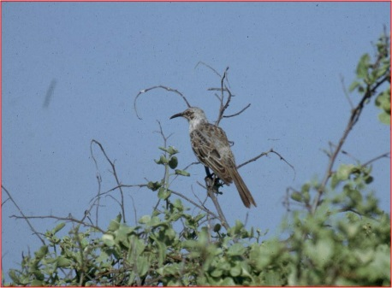
- There are even differences between species on different islands. On the 14 species of finches - "Seeing this gradation and diversity of structure in one small, intimately related group of birds, one might really fancy that from an original paucity of birds in this archipelago, one species had been taken and modified for different ends." The Voyage of the Beagle - Darwin (1839) VIDEO
- Galapagos Mockingbirds Darwin thought he had one, very variable species. He sent specimens to John Gould, the premiere ornithologist in England at the time. On Darwin's return to England, he found out that Gould recognized the mockingbird specimens as belonging to 4 separate species. This made Darwin consider that maybe the variation WITHIN a species could be continuous with the variation BETWEEN species.... maybe varieties within a species could gradually become so different from one another that they would eventually become different species. VIDEO
5. Argument For Evolution as a Historical Fact:
Premise 1: Species that are alive today are different from those that have lived previously.
Premise 2: Spontaneous Generation is refuted, so organisms only come from other organisms.
Conclusion 1: Thus, the organisms alive today must have come from those pre-existing, yet different, species.
Conclusion 2: There must have been change through time (evolution).
Conclusion 3: The fossil record, vestigial organs, and homologies are all suggestive of descent from common ancestors.
Below, the figure from The Origin of Species that shows Darwin's idea of descent from common ancestors.
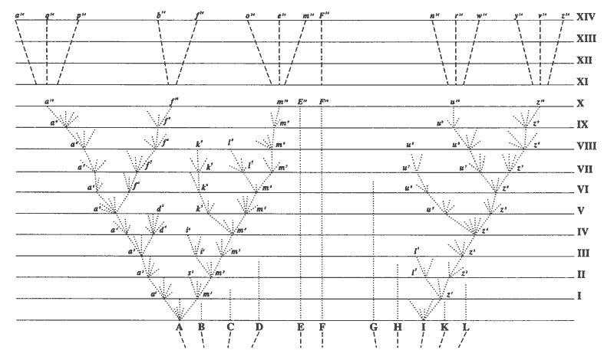
So, if species do change over time (evolve), the next question is "How?" How does this change occur?

C. His Mechanistic Hypothesis of How Evolution Occurs - Natural Selection
1. Transitional Observations
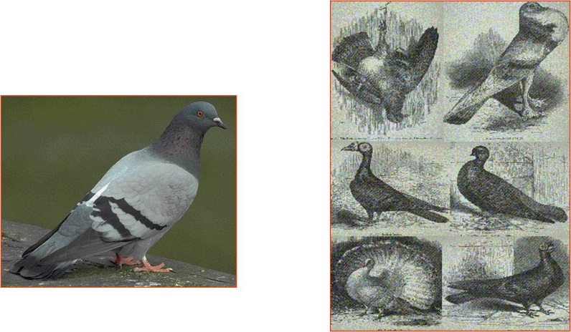
a. Domesticated animals:
As a result of selective breeding, humans have taken certain species and modified them tremendously. So, from an ancestral population of wolves, we have created chihuahuas and St. Bernards. Now, there were never any Chihuahua sized wolves running around - we created this variability by progressively breeding smaller dogs with one another. Now, we have two groups, Chihuahuas and St. Bernards, that can't easily be bred together. So, we have created separate biological groups, that could be called different species. Darwin was aware of many 'breeds' of pigeons, too. These were called varieties, almost assuredly descended from a common ancestral population of rock doves (left). The KEY to the production of new varieties by humans is that humans only allowed certain organisms to breed. So, only particular traits were passed to the next generation. Darwin wondered if there was a mechanism that could do the SAME thing in nature (only allow certain organisms in a population to breed), and thereby explain the natural changes seen in the fossil record (radiational patterns of multiple species in one strata necessarily coming from fewer species in earlier strata). and implied by island faunas. Just because man does it purposefully, by design and with aforethought, doesn't mean that nature can't do it WITHOUT purpose. We put water in the freezer to PURPOSEFULLY make ice cubes... but water freezes naturally, as well - without a purpose, but with the same NATURAL CAUSE (loss of heat).
b. Reading Malthus:
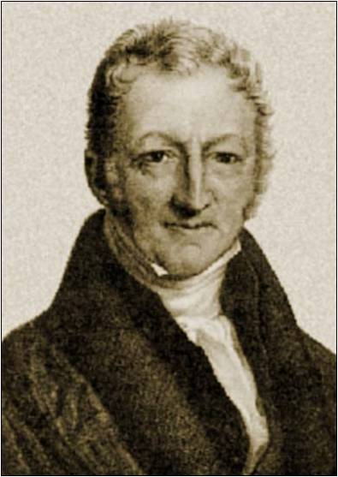
In 1838, Darwin read a book published in 1798 by Thomas Malthus called Essay on the Principle of Population. Malthus was a british aristocrat who was concerned that the british aristocracy might be overthrown like the French had been 10 years before (1788). He realized that all populations have the capacity to grow exponentially, but that resources are finite. As such, there will eventually be a "struggle for existence" (Darwin's words). Malthus was worried that the british population would continue to grow, and that poverty and famine would lead to revolution.
Darwin read Malthus, and wrote in his autobiography:
“In October 1838, that is, fifteen months after I had begun my systematic enquiry, I happened to read for amusement Malthus on Population and being well prepared to appreciate the struggle for existence which everywhere goes on from long-continued observation of the habits of animals and plants, it at once struck me that under these circumstances favourable variations would tend to be preserved, and unfavourable ones to be destroyed. The result of this would be the formation of new species. Here, then, I had at last got a theory by which to work; but I was so anxious to avoid prejudice, that I determined not for some time to write even the briefest sketch of it. In June 1842 I first allowed myself the satisfaction of writing a very brief abstract of my theory in pencil in 35 pages; and this was enlarged during the summer of 1844 into one of 230 pages, which I had fairly copied out and still possess.” - The Autobiography of Charles Darwin 1809-1882 (Barlow 1958).
- If there are limited resources of food, shelter, and mates, and if organisms in a population vary, then as a consequence of this variability, some will be more likely to gain the resources than others, and will thus be more likely to mate. So, the environment will 'select' which animals in a population will mate (the ones best able to acquire the limiting resources)... and these traits that work to gain resources in this environment will be passed on at high frequency to the next generation.
2. Natural Selection: (Know this. Understand it. You WILL be asked to outline NS in this very form.)
P1: Populations over-reproduce (Malthus)
P2: resources are finite (Malthus)
C1: Eventually, a population will grow until it becomes limited by its resources. At that time, their will be a "struggle for existence" and most offspring produced will die. (Malthus)
P3: Individuals in a population vary, and some of this variation is heritable (Darwin - observations and animal/plant breeding)
C2: Variations will not have the same probability of survival and reproduction in a particular environment; those well-suited to the environment will be more likely to survive and reproduce than others, passing on the genes for these adapted traits. There will be "Differential Reproductive Success" (Observations, breeding).
C3: Over time, adaptive traits will accumulate and the characteristics in a population will change. This is lineage evolution. (Like change in horse toes in a sequence of fossil species, or like the change in the chihuahua lineage from the ancestral wolves).
Corollary: Two sub-populations, separated in different environments, would be selected for different traits and may subsequently lose the capacity to interbreed. At this point, they are different biological species. This is Speciation and Radiational Evolution. (like the production of different Finches, mockingbirds, etc. on different islands in the galapagos, and like the radiation of St. Bernards AND chihuahua's, which diverged from one another over time).
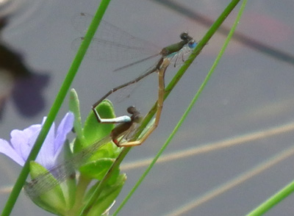
Darwin here provides a natural explanation for why purposeful structures and behaviors occurs in nature. Through some process unknown to him, variation arises in natural populations. These varieties differ in terms of functional efficiency in a common environment; so some improving an organisms probability of surviving and mating than others. Organisms with these beneficial traits will leave more offspring, and the frequencies of these beneficial characteristics will increase through time - much as humans select for smaller and smaller dogs. He ends The Origin of Species (1859) like this:
"It is interesting to contemplate an entangled bank, clothed with many plants of many kinds, with birds singing on the bushes, with various insects flitting about, and with worms crawling through the damp earth, and to reflect that these elaborately constructed forms, so different from each other, and dependent on each other in so complex a manner, have all been produced by laws acting around us. These laws, taken in the largest sense, being Growth with Reproduction; Inheritance which is almost implied by reproduction; Variability from the indirect and direct action of the external conditions of life, and from use and disuse; a Ratio of Increase so high as to lead to a Struggle for Life, and as a consequence to Natural Selection, entailing Divergence of Character and the Extinction of less-improved forms. Thus, from the war of nature, from famine and death, the most exalted object which we are capable of conceiving, namely, the production of the higher animals, directly follows. There is grandeur in this view of life, with its several powers, having been originally breathed into a few forms or into one; and that, whilst this planet has gone cycling on according to the fixed law of gravity, from so simple a beginning endless forms most beautiful and most wonderful have been, and are being, evolved". - The Origin of Species (Darwin 1859).
D. Darwin's Dilemmas
Chapter Six in "The Origin of Species" is entitled: Difficulties on Theory
Darwin starts the chapter by writing:
"Long before having arrived at this part of my work, a crowd of difficulties will have occurred to the reader. Some of them are so grave that to this day I can never reflect on them without being staggered; but, to the best of my judgment, the greater number are only apparent, and those that are real are not, I think, fatal to my theory."
These dilemmas are:
1. How can we explain the existence of complex characteristics composed of mutually dependent parts?
- Paley's "watchmaker analogy" (1798) and the eye - the argument of design. Some elements of nature seem so complex, and composed of mutually dependent parts, that it does not seem possible that they could arise by sequential innovations. For instance, for Paley, half an eye won't work. For modern Intelligent Design proponents, the cell is called "irreducibly complex" - suggesting that it can't come from any simpler precursor - everything has to be there. (Of course, for philosophical reasons, this is about as unscientific as it gets. The idea that something is simply "too complex" to understand thwarts curiosity and stifles TRUE scientific inquiry, which is fundamentally reductionistic - as we have discussed.)
- Darwin's Solution:
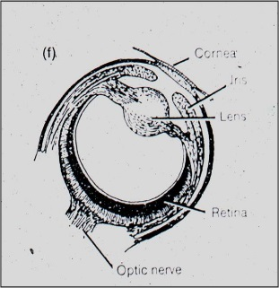
"To suppose that the eye, with all its inimitable contrivances for adjusting the focus to different distances, for admitting different amounts of light, and for the correction of spherical and chromatic aberration, could have been formed by natural selection, seems, I freely confess, absurd in the highest possible degree. Yet reason tells me, that if numerous gradations from a perfect and complex eye to one very imperfect and simple, each grade being useful to its possessor, can be shown to exist; if further, the eye does vary ever so slightly, and the variations be inherited, which is certainly the case; and if any variation or modification in the organ be ever useful to an animal under changing conditions of life, then the difficulty of believing that a perfect and complex eye could be formed by natural selection, though insuperable by our imagination, can hardly be considered real." - The Origin of Species (Darwin 1859).
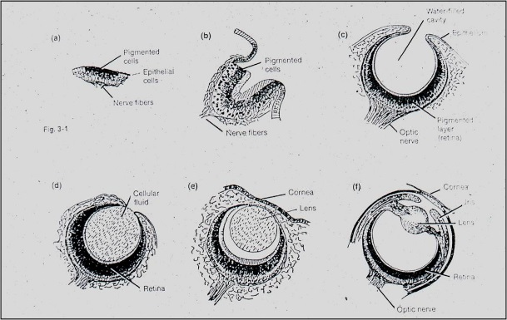
Well, Darwin then describes the photoreceptive organs in molluscs. They range from a sheet of receptive cells (a naked retina) to a cupped retina, to a lensless pinhole eye, to an eye with a lens, to a camera eye. If this sequence exists today, it is possible that this sequence could have existed through time, as a sequential evolutionary series in eye evolution. Half an eye CAN work, if the half you evolve first is the retina. The following videos from David Attenborough and Richard Dawkins are particularly good at describing the likely evolutionary scenario.

2. Where are all the intermediates?
“…why, if species have descended from other species by insensibly fine gradations, do we not everywhere see innumerable transitional forms? Why is not all nature in confusion instead of the species being, as we see them, well defined? … as by this theory innumerable transitional forms must have existed, why do we not find them embedded in countless numbers in the crust of the earth?” The Origin of Species (Darwin 1859).
Darwin was well aware that his uniformitarian hypothesis would require populations to change continuously and gradually through time. And although Lamarck's work on molluscs showed this type of change, most other lineages were best described as discontinuous and incomplete. And of course, and most importantly, the hypothesis of common ancestry predicts the existence of transitional species, representing the first evolutionary steps in the evolution of a major new group. No transitional fossils had been discovered by 1859.
There was another set of 'intermediates' that Darwin's hypothesis predicted - internediates between existing species. In other words, what would prevent the intermediates in a temporal sequence to leave descendants of their intermediate forms, thus making a continuous sequence of LIVING species between sister taxa? This continuity would make resolving one species from another almost impossible ("nature in confusion"). Darwin addressed this issue first. He said that selection, itself, would solve this issue. A more efficient descendant, with new adaptive traits, would competitively eliminate less adapted, ancestral forms:
“As natural selection acts solely by the preservation of profitable modifications, each new form will tend in a fully-stocked country to take the place of, and finally to exterminate, its own less improved parent or other less-favoured forms with which it comes into competition. Thus extinction and natural selection will, as we have seen, go hand in hand. Hence, if we look at each species as descended from some other unknown form, both the parent and all the transitional varieties will generally have been exterminated by the very process of formation and perfection of the new form.” – The Origin of Species (Darwin 1859)
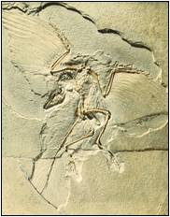
With respect to intermediate and transitional fossils, Darwin suggested that the fossil record was incomplete. Fossilization was a very rare event, and thus it would be very unlikely for a representative of each species in a lineage to have a representative preserved. However, he hope that, in time, a more complete picture (and some truly transitional fossils) would be discovered. In 1861, he was pleased by the discovery of Archeopteryx lithographica in Bavaria. When previous fossils of this species had been unearthed, they were classified as reptiles because they had teeth, fingers, and a long bony tail. But, when this fossil (and 9 others since) were pulled from the very fine sedimentary deposits of Bavaria, the impression of feathers were seen. So, here is an organism with a very odd combination of traits - a lizard skeleton covered by feathers.
- IMPORTANT: Now, the existence of this odd animal is not the only thing that bears on evolution. Obviously, evolution does predict the existence of intermediates. But even more so, it also predicts WHEN in the fossil record this species should have lived. For instance, If Archeopteryx is a transitional species, it has to be after reptiles appear in the fossil record, and before true birds. It can't just be anywhere and be a transitional species between these groups. Well, it is just where evolutionary theory predicts it should be; after other reptiles and before all true birds. We will see lots of intermediates later in the course, when we look at post-Darwinian developments.
3. How is heritable variation produced?
Darwin's genius was seeing the importance of heritable variation; it would lead to differential reproductive success and evolutionary change. However, he did not understand how this variation was produced (mutation and recombination) or inherited (meiosis and heredity). He knew how important this was for his theory, and he was a real scientific student of hybridization experiments. One of the most difficult chapters in The Origin of Species is his extensive summary of patterns of hybridization across the animal and plant kingdoms. It is obvious that he hoped to find patterns in comparing these disparate studies that would reveal a mechanism of heredity. Unfortunately, they did not. As such, Darwin relied on those old Lamarckian ideas of "inheritance of acquired traits" (described as the effects of the 'external conditions of life') and "use and disuse":
"These laws, taken in the largest sense, being Growth with Reproduction; Inheritance which is almost implied by reproduction; Variability from the indirect and direct action of the external conditions of life, and from use and disuse; a Ratio of Increase so high as to lead to a Struggle for Life, and as a consequence to Natural Selection…". - The Origin of Species (Darwin 1859).
Darwin proposed the existence of particulate 'gemmules' that were present in every cell of the body. Changes in the body changed these gemmules somehow, and before mating these gemmules migrated to the reproductive tissue for transmission to the next generation - explaining how acquired traits could be inherited. He even did experiment to test his idea, which he falsified. Yet, he had no other ideas. He died not appreciating the insights that had been made by Mendel in Austria in 1865.
E. A Summary of Darwinian Evolution:
Darwin's view of evolution can be summarized as follows:
Source of variation: UNKNOWN
but variation is observable
Causes of Evolutionary Change: (factors that cause change in natural populations): Natural Selection
Study Questions:
1. What is Platonic essentialism (or 'idealism') and how did it hinder the consideration of evolutionary ideas?
2. What contributions did Aristotle make to the construction of a scientific method? Where did he fall short?
3. What three critical contributions did ancient Persians make to the development of the scientific method?
4. How did knowledge from Persia make its way to the west, and why was the use of these experimental methods delayed?
5. What contributions did Copernicus, Kepler, Galileo, and Newton make to our understanding of the solar system? Frame these in the context of the scientific method.
6. What counter-intuitive effect did the renaissance have on the development of modern (evolutionary) biology?
7. Contrast the positions of Linnaeus and Buffon.
8. Contrast the positions of Lamarck and Cuvier.
9. What is the principle of Natural Theology, as professed by Aquinas and Paley?
10. How are evolution and genetics related?
11. What where the three things Darwin did in Origin of Species?
12. What is "uniformitarianism" and how was it important to the development of Darwin's ideas?
13. What observations did Hutton make, and what did he conclude from these observations?
14. What two patterns occur in the fossil record that impress Darwin regarding the hypothesis of evolution and common descent?
15. What are homologous structures? What correlations occurs with the environment?
16. What are analogous structures? What correlation occurs with the environment?
17. What are vestigial structures, and why were they so important to Darwin's refutation of Paley?
18. How did Darwin explain the existence of 'convergent communities"?
19. The Galapagos are dominated by many unique species of reptiles, birds, and marine mammals. What did this non-random assemblage suggest to Darwin about their origin, and how was evolution implied?
20. Why were the mockingbirds so critical to Darwin's ideas about the production of new species?
21. Outline Darwin's argument of the fact of evolution.
22. How did Darwin use the comparative method and observations of 'artificial selection' to produce the theory of 'natural selection'?
23. How were Malthus's observations and conclusion rlevant to the development of Darwin's theory?
24. Outline the theory of natural selection as an argument, with three premises, 3 conclusions, and a corollary.
25. How did Darwin solve Paley's dilemma regarding the stepwise evolution of a 'camera' eye?
26. How did Darwin explain the absence of LIVING intermediate forms?
27. How did Darwin explain the absence of EXTINCT intermediate forms?
28. How did Darwin believe that variation was produced in natural populations?
29. Outline Darwin's model of evolution, listing 'sources of variation' and 'causes of evolutionary change'.

