Lecture 2: Molecules and Membranes
The oldest fossils date to 3.5-3.8 bya. How did life originate? “Reductionism” would suggest that the components of life—molecules—would have had to form first. Let’s meet them, and then see how they form.
I. Biologically Important Molecules
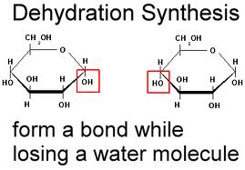
A. Water
B. Carbohydrates
1. Structure:
- monomer - monosaccharide (simple sugar) - C_{n}H_{2n}O_{n} (glucose, galactose, fructose are 6 carbon sugars; ribose, ribulose, deoxyribose are 5 carbon sugars)
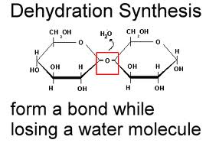
- disaccharides: sucrose (glucose + fructose); maltose - (2 glucose)
- polymer - polysaccharide - chain of sugars
starch, glycogen, chitin, cellulose
- monomers are linked together into polymers using dehydration synthesis - a removal of a water molecule (dehydration) and the synthesis of a bond. This requires energy and is catalyzed by enzymes in living systems.
2. Function:
a. energy storage:
- all large biomolecules have lots of bonds and thus store lots of energy. But, the larger the molecule, the more time it takes to harvest all the energy by metabolic breakdown (catabolism). So, polysaccarides serve better as 'longer-term' energy storage than monosaccharides, whereas monosaccarides, because they can be metabolized more quickly, serve better as a short term energy supply. (starch in plants andglycogen in the liver of animals are longer term storage molecules; glucose is the short-term energy molecule in all of life)
b. Structural:
- cellulose is just a long chain of glucose. And decomposers break down wood to create the sugars they will use for metabolic energy.
- chitin is the primary component of exoskeletons in arthropods.
C. Proteins
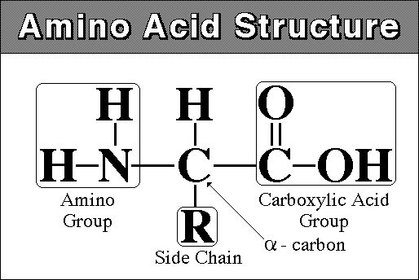
1. Structure:
monomer - amino acid - amine (NH₂) group at one end and carboxyl group (COOH) at other
there are 20 different amino acids that are found in living systems.
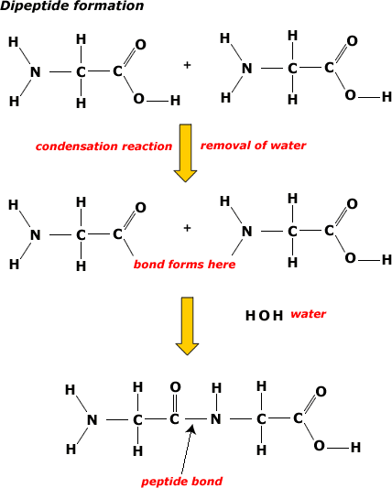
polymer - polypeptide - 100 to 300 amino acids long. The AA's are linked by dehydration synthesis reactions into a long linear chain. Because there are 20 Amino Acids ("letters") that can be used in their construction, proteins can have a limitless number of different combinations (like letters in different combinations make different "words"). This variety in form means variety in function.
Sometimes, single proteins are not functional on their own - they must be combined with other proteins to forma a protein with a quaternary structure. Hemoglobin, with 2 alpha and 2 beta globular polypeptides, is one example. collagen is another, composed of several helical polypeptides.
2. Function:
a. Energy Storage: (all biomolecules can be broken down for energy harvest. Typically, since proteins are doing something else, too, they are broken down last so that the organism can maintain this function that the protein performs for as long as possible).
b. Structural:
after water, animals are largely proteinaceous
collagen, elastin, muscle proteins, etc.
c. Metabolic:
all biological reactions are catalyzed. Most biological catalysts are proteinaceous ENZYMES
d. transport:
cell membrane - there are proteins that assist transport across the membrane
organism - hemoglobin, for instance, transport oxygen
e. Immunity:
antibodies are proteins.

D. Fats and Lipids:
1. Structure:
monomer - fatty acid - long carbon chain with a carboxyl group (COOH)
- can be saturated (with H - no double bonds between C's) or unsaturated (a double bond)
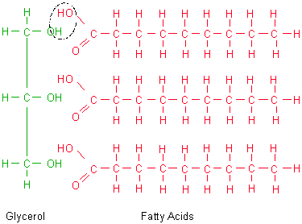
- animal fats are usually saturated, and are solid at room temp. Plant and fish fats are usually unsaturated, and are liquid at room temp and are called 'oils'. By saturating a plant fat, it can be made solid - hydrogenated fat or oil. (changing peanut oil into peanut butter, or vegetable oil into "crisco"). During this process, trans-fats are also created. These are unsaturated fats with a trans (not cis) conformation. Trans-fats have been associated with atherosclerosis
polymer - fat (triglyceride)
- three fatty acids attached by dehydration synthesis to a glycerol molecule
- phospholipid: glycerol with 2 fatty acids and a phosphate (PO₄) group. The PO₄ is negatively charged (thus, polar), while the fatty acids are non-polar. This accounts for how these molecules orient in aqueous solutions, forming membranes. A "choline" groups is typically attached to the phosphate.
2. Function:
a. Energy storage: saturated fats are very dense - the fatty acids fit together, in parallel, very snugly. So, to store the most energy in the smallest space, fats are the preferred medium.
b. Cell membranes - barrier to water soluble materials. The non-polar lipid "bilayer" is a barrier to water soluble materials (that are ionic or polar). So, ionic and polar compounds can't just flow into the cell; the cell can regulate how much of what gets in and out.
c. Insulation
d. Hormones - derived from fats, lipid soluble, slip right theough cell membranes into cells, so they can function at very low concentrations.

E. Nucleic Acids (DNA/RNA) - we will cover this in more detail later

II. The Formation of Biologically Important Molecules
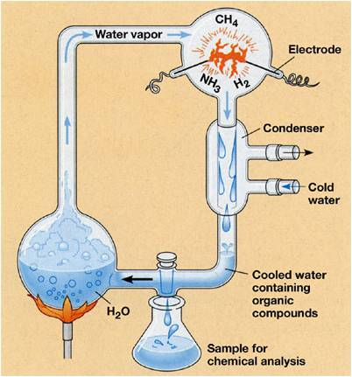
Life is complex, and is composed of complex subunits. Reductionism and probability imply that complex cells probably did not form spontaneously with all of their structures and functions intact. Rather, naturalistic, reductionistic models hypothesize that subunits would have to form first and then come together. At the most fundamental level, we might expect monomers to form, and then polymers, and then cell-like structures.
A. The source of biologically important monomers
In the 1920's, Alexander Oparin and J. B. S. Haldane independently hypothesized that biologically important monomers like amino acids and sugars might form spontaneously if a mixture of volcanic gases were bombarded with energy in a reducing environment. Curiously, this hypothesis was not effectively tested until 1953, when Stanley Miller and Harold Urey sent electric charges through gaeous mixtures of H₂O, CH₄, NH₃, CO, and H₂. In their closed system, the gases were condensed and dissolved solutes accumulated in solution. After a week of running the experiment, they found several amino acids in solution; confirming the Oparin and Haldane hypothesis that biologically important monomers could form spontaneously. Although scientists challenged the appropriateness of their gas mixture (volcanic gases contain other gases, too) and the constantly high application of electric discharge, more recent experiments using a wide variety of volcanic gases and other sources of energy also produced a wide variety of amino acids and all other biologically important molecules including nitrogenous bases, ribose, deoxyribose, fatty acids, phospholipids, and a variety of other sugars and other organic molecules. Although Miller and Urey surmised that the initial source of energy might be lightening strikes at the surface of the earth, other scientists have considered other locations for the synthesis of biologically important molecules. Günter Wächtershäuser (1990) suggested that hydrothermal vents might be a likely spot, where rich mixtures of volcanic gases are released under high heat and pressure directly to the surrounding water.
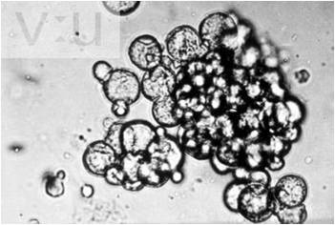
B. Formation of Polymers
Polymerization of all biologically important molecules works by the simple process of dehydration synthesis, and it didn't take long for scientists to polymerize amino acids spontaneously. In the 1960's, shortly after the Miller-Urey experiments, Sidney W. Fox discovered that amino acids would polymerize into small spheres composed of proteins - 'proteinoids microspheres' at fairly low temperatures (70ºC) if phosphoric acid was present as a catalyst. He found similar microspheres in volcanic lava on Hawaii, and suggested that this might be a spontaneous process by which proteins could have formed. These microspheres are differentially permeable, and they also bud (split into two spheres) when they enlarge. Fox thought these could have been the first 'membranes', creating a unique chemical environment in which other reactions could occur. In the 1960's Cairns-Smith demonstrated that clay particles could act as a polymerization template. The specific charge characteristics on a clay surface would bind a non-random (but not explicitly sequence specific) series of amino acids, and drying at warm temps would cause polymerization. In 2004, Szostak showed that RNA nucleotides could polymerize on clay surfaces, as well. Again, proponents of a hydrothermal vent origin of life argue that these types of polymerization reactions would be quite possible (and more stable) under the conditions at these vents.
C. Acquiring the Characteristics of Life
A soup of biologically important molecules is not a living cell. Once again, we are confronted by a seemingly impossible process of creating complexity from simple parts. As daunting as this questions sounds, scientists have made considerable progress in shedding light on how this process might have happened. In short, there are three basic functions that a cell must perform:
1) it must be a bounded system that, as a consequence of differential permeability, can become different from its environment;
2) it must acquire matter/energy and harvest energy through metabolic process;
3) it must have a genetic system that can co-ordinate this metabolic activity and also replicate. Surprisingly, there are very good hypotheses about how each of these steps might have occurred. However, there is still little agreement on the order in which these steps would have occurred. So, we will present these steps separately, but no order is implied.
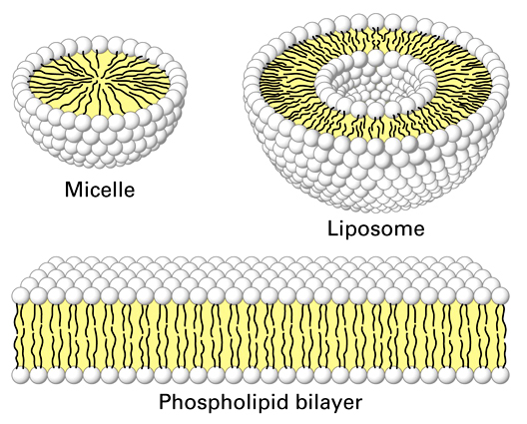
III. Membranes

- Evolution:
When Hydrogen cyanide and formaldehyde are added to Miller Urey experiments, phospholipids form spontaneously. In a turbid environment, wave action will cause these films to ball-up as single-layer micelles and as phospholipid bilayers. As you know, these bilayers form the semi-permeable membrane found in all living cells. So, the formation of a membrane is the easiest and most well-understood piece of the puzzle.

B. Structure
All living cells are bounded by a membrane composed of a phosopholipid bilayer. Proteins are present on and within each layer, and some also cross all the way through the membrane.
- phospholipids have hydrophobic fatty acid tails and hydrophilic phosphate group "heads" (charged). In an aqueous solution, phospholipids will form micelles (single layer spheres) and bilayers (two layer spheres and films) as a function of the hydrophobic and hydrophilic nature of these molecules. These spatial orientations surround the hydrophobic fatty acid 'tails' with the hydrophilic phosphate 'heads' that interact with the polar water molecules in the solution. When arranged as a bilayer, they separate the internal aqueous solution of the cell from the external aqueous environment. Because the principle boundary is the hydrophobic, non-polar layers of fatty acids, the bilayer is permeable to lipid-soluble materials but not water soluble (polar and ionic) materials unless they are very small. These bilayers are also very dynamic or "fluid"... the phospholipids are moving laterally all the time, like the lipids in a soap bubble.
- Proteins are present on both inner and outer surfaces, and also extending through the lipid bilayer. They are important in transporting things across the membrane.

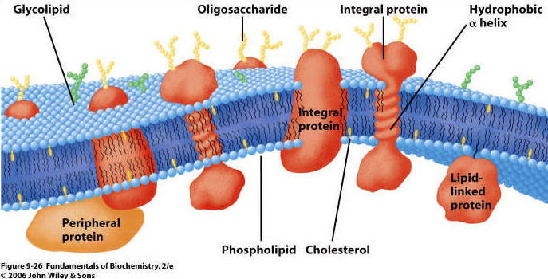

C. Membrane Function
1. Semi-permeable barrier: If a substance dissolves in water, then it is polar or ionic (amino acids, sugars, nucleic acids). So, it does not cross the non-polar lipid bilayer . Lipid-soluble materials cross membrane rapidly (fats, steroids, CO₂, O₂). So, a lipid layer is a great barrier for separating two aqueous solutions and the dissolved solutes they contain (those inside and outside the cell).
2. Transport: matter does cross the membrane. However, unless it is a small or non-polar molecule, it cannot cross the lipid bilayer "on its own". Rather, crossing the membrane must be assisted by a protein. These proteins may be rather unselective "tubes", or they may be specific for the transport of a particular class of molecules. By using proteins as 'gates' the cell gains control over the composition of its cytoplasm. There are three ways that material can cross a membrane:
a. Diffusion: As a consequence of the random movement of molecules, molecules will disperse from areas of high concentration and move to areas of lower concentration. So, when you uncork a bottle of perfume, the molecules diffuse through the room from high concentration at the bottle to low concentration in the rest of the room. Molecules may cross membranes as they move in this manner, moving from areas of high concentration on one side of the membrane to areas of lower concentration on the other. With respect to the lipid bilayer in living membranes, non-polar molecules and some small molecules can diffuse directly through the lipid bilayer. The movement of CO₂ and O₂ across the membrane happens by diffusion. Every molecule moves by diffusion in response to its own concentration gradient.
The movement of water across a membrane, in response to its water potential, is called osmosis (video). Although water is polar, it is also a small molecule. So, it can cross the lipid bilayer directly, or through specialized protein channels called 'aquaporins'. Water potential is a bit more complicated than just 'concentration', although it includes this idea. The higher the concentration of dissolved solutes, the lower the 'concentration' of water and the lower the water potential. These solutes may be one or many things, so water potential is a function of total solute concentration. So, water will osmose across a membrane from an area of low solute concentration (high water potential) to an area of high solute concentration (low water potential), or in other words, from a dilute solution to a concentrated solution. Another component of water potential is water pressure: water will also cross a membrane due to pressure exerted by an outside force or the force of its own mass responding to gravity. So water can be pushed across a membrane.
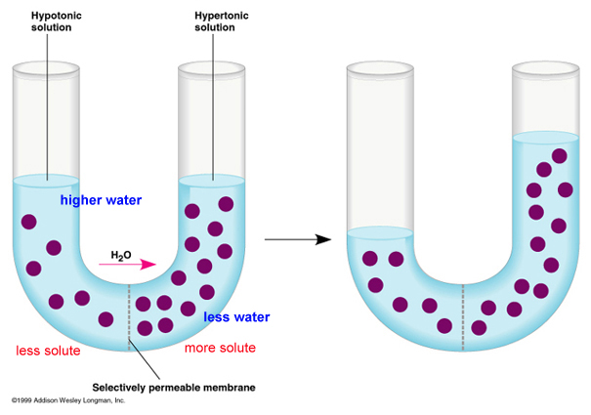
Consider the figure, below. The purple circles are dissolved solutes. SO! In the first figure at left, total solute concentration is HIGH on the right side of the u-tube, so water potential is LOW. Water will move across the membrane from the dilute solution on the left (high water potential) to the concentrated solution on the right (low water potential), and the water level will rise (figure on the right). Eventually, in this rigid vertical system, the tendancy of the water to move left to right in response to solute concentration is balanced by the tendancy of water to move right to left - "leaking" back across the membrane - in response to the greater water pressure. An equilibrium is reached where there is no NET flow. In a rigid plant cell (with a cell wall), the influx of water creates "hydrostatic pressure" and makes the cell rigid or 'turgid'. The loss of water (from evapotranspiration or osmosis out of the cells to a saltier environment) reduces this turgidity - or 'turgor pressure' - and the plant tissue wilts (gets 'floppy'). In an animal cell bounded only by a thin membrane, the influx of water can create a pressure large enough to rupture the cell. We will deal with these concepts more in lab.

b. Faciliated Diffusion: Large polar molecules cannot diffuse across the lipid bilayer. However, they can cross the membrane 'passively' from high to low concentration, through integrated proteins channels. Some of these channels are rather unspecialized 'tubes', while other channels are rather specific and will only permit the transport of certain classes of molecules. In any case, this is the way that large polar molecules cross the membrane in response to their concentration gradient (high to low). video.
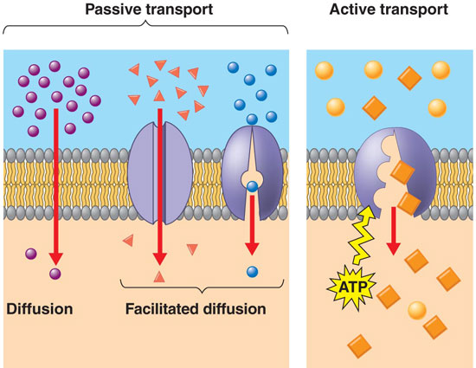
c. Active Transport: If material only crossed the membrane by some form of diffusion, then the cell's cytoplasm would come to be very similar to the surrounding environment. They cell would be unable to raise or lower the concentration of material above the concentration in the environment. In order for cells to be differnt from the environment (in the concetration of some stuff), another mechanism is needed. This is 'active transport'. In active transport, a cell uses energy to 'pump' material across the membrane - against the concentration gradient (from low to high). So, although sugars might be in higher concetration within the cell than outside it, and although sugars may be "leaking" from the cell by diffusion, the cell can pump sugar against the concentration gradient and accumulate it in the cell. Likewise, a cell can pump toxins or waste OUT of the cell, even if the concentration outside of the cell is already high. THIS TAKES ENERGY - LIKE ROLLING A BALL UPHILL, AGAINST THE 'GRADIENT' OR SLOPE. An important active transport mechanism is the "sodium-potassium" pump. In this process, both ions are pumped against their concentration gradient, using energy (breaking ATP) to change the conformation of the transport protein. video
3. Signal Transduction:
Cells respond to their environment, and the membrane, as the point of contact between a cell and the environment is instrumental in this response. Chemicals binds to the membrane surface, usually at a protein. This changes the shape of the protein, often causing it to release something that was bound to it on the inside of the cell. This chemical can then stimulate something to happen inside the cell. It can even stimulate particular genes to turn on and off, and thus can stimulate the cell to make new proteins. So, hormones made in one organ of your body (like testosterone or estrogen) can flow through your bloodstream and stimulate responses in other organs of your body. In the cases of testosterone and estrogen, stimulating the development of the changes associated with puberty.

Study Questions:
1) What is the basic structure of simple sugar?
2) How do simple sugars polymerize into polysaccharides?
3) Name three biologically important carbohydrates and describe how they are used.
4) Draw the structure of an amino acid.
5) How do amino acids join to form a polypeptide?
6) Why can proteins have such variable structures and functions?
7) List four important functions that proteins perform in living systems.
8) Draw the basic structure of a fatty acid.
9) What is the difference between saturated and unsaturated and hydrogenated fatty acids?
10) How does a triglyceride form?
11) What is the major function of fats, and why?
12) Draw a phospholipid. Why do they form droplets in water? Explain in terms of the chemical properties of the fatty acid tails and the phosphate head.
13) Why is the Miller-Urey experiment (and others that followed) important?
14) How could biologically important polymers form?
15) How could membranes evolve?
16) Describe diffusion, facilitated diffusion, and active transport.
17) How would a cell get rid of a small polar molecule that is in high concentration inside the cell but low concentration outside the cell?
18) Cells are very different in the concentration of dissolved materials than the environment. By which process does a cell become different from the environment? What does this require?

