BIO 102: Biology and the Environment
Lecture 1: The Living Planet
I. Our Solar System
A. Formation of our Solar System
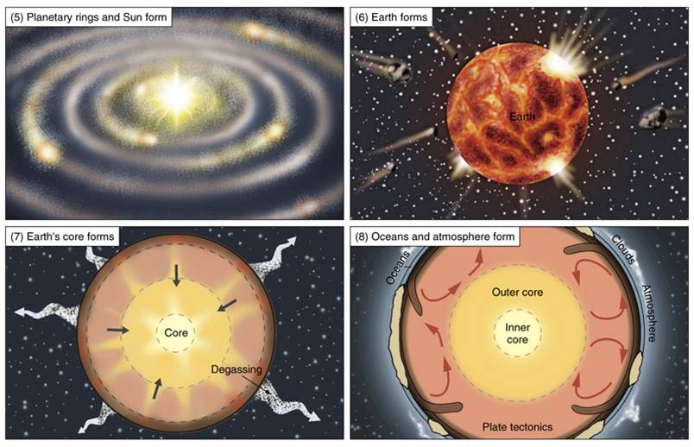
The standard working model (theory) of earth formation goes like this. Our solar system probably formed as a gas nebula began to condense and spin, perhaps because the explosion of a nearby supernova caused the gas cloud to collapse on itself. As this gas cloud collapsed and began to rotate, the center continued to collapse, form a strong gravitational field, heat up, and ultimately radiate light and energy (sun). Under this gravitational field, the rest of the spinning gas cloud flattened into a protoplanetary disk. The debris orbiting the sun at the same distances collided and formed larger bodies called 'planetissimals', which continued to collide and accrete. As these objects became larger, their masses and gravitational fields increased and they swept more material up as they orbited the sun - eventually resulting in a few large bodies at different distances (planets). Temperatures were too hot near the sun for volatile molecules (like water) to condense, so only matter with higher melting points - like metals, condensed to form the inner, rocky planets. Volatile molecules could condense farther from the sun, creating the huge gas giants of the outer solar system. The gravitational fields of Jupiter and Saturn were so large that they disturbed the formation of any large bodies nearby - so the planetissimals in the asteroid belt between Mars and Jupiter failed to form planets or were ripped apart by gravitational forces of Saturn and Jupiter.
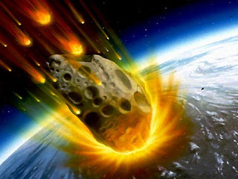
The gravitational effects of the large planets on the asteroid belt would also have disturbed asteroid from their orbits, causing them to crash with one another and sending them ricocheting in towards the inner planets (and the other way, out of the solar system). This meteor bombardment would have brought water (condensed on these distant meteorites) to Earth. However, this constant bombardment also may have incinerated any early life. Interestingly, the earliest fossils date to 3.5 billion years ago (by), about the time that the period of heavy bombardment stopped. The oldest minerals on Earth, and the oldest rocks from the moon and meteorites, are 4.4-4.5 by; giving a reliable age to the final accretionary period and the formation of the planets.
The Earth's own gravitational field pulled the heavy elements (nickel iron) towards the core. As they moved, frictional heat was produced that warmed and vaporized lighter material in the Earth's crust, which moved towards the surface and was released during periods of intense volcanic activity. This"degassing" (release of lighter elements) formed the atmosphere, and created a density gradient from the dense core to the lighter silicates in the Earth's crust, to the lightest, gaseous molecules in the atmosphere.
B. The Early Atmosphere
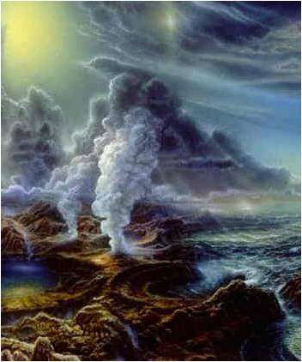
These volcanic gases are carbon dioxide (CO₂), and water vapor (H₂O), Hydrogen gas (H₂), Nitrogen gas (N₂), Hydrogen sulphide (H₂S), and trace amounts of methane (CH₄), ammonia (NH₃), and HCl. Any free hydrogen or helium gas would have been too light to have been held by the Earth's gravitational field at the time, and was lost to space. The gases released by volcanoes would have been held as the first permanent atmosphere. Because the process of vulcanization and the burning of rock is thought to be the same today as it was throughout Earth history, we can determine the composition of volcanic gases today and have a pretty good idea of the composition of the early atmosphere. By about 4.4 by, geologists surmise that the earth may have cooled to the point that water vapor would condense; raining down to fill the ocean basins. However, through the period of heavy bombardment by meteorites, it is likely that much of Earth's surface waters were repeatedly vaporized by the energy of these impacts. After the period of bombardment, the ocean basins filled for good.
II. The Earth and its Neighbors
A. Size and Temperature:
The Earth is a very special place. Although some parts of it look like Mars, the Earth, Mars, and Venus are very different. In this section, we will discuss the two major reason why. But first we will compare them to see how they differ:

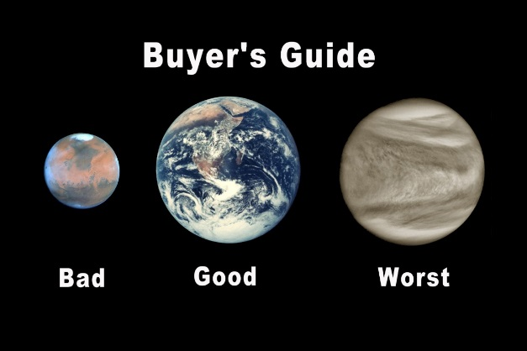
Mars is the fourth planet from the sun (Earth is third) and second smallest planet in the solar system; only Mercury is smaller. It is likely that the growth of Jupiter prohibited planetissimals from accreting onto Mars or condensing into a larger separate planet—they continue to orbit as the unconsolidated ‘asteroid belt’ between the orbits of Mars and Jupiter. Mars is about ½ the size of earth in radius and equatorial circumference. Its “day” is about 24 hrs, but it takes 1.88 earth years to orbit the sun. Although Earth temperatures range between -88 and 58ºC (136ºF), Mars ranges from -153 to 20ºC (68ºF). All surface water is bound up in a polar ice cap, although erosional landscapes suggest that liquid water did flow over the surface in the past. Venus is the second planet from the sun and is only slightly smaller (95%) than the Earth. It spins slowly (and backwards), taking 117 earth days to complete one rotation, and only spins a bit more than once per year (225 Earth days). Surface temperatures reach 462ºC (~900ºF). Venus is constantly clothed in clouds because most compounds vaporize at these temps; the clouds force a “runaway greenhouse effect” that traps heat. All water exists as water vapor. Earth, of course, is very different in being covered (71%) by liquid water.
B. Atmospheric Composition:
All three planets (and Mercury) are “rocky”, as opposed to the gas giants in the outer solar system. Mars and Venus have very similar atmospheres, composed largely of CO₂ with a small amount of N₂. In contrast, Earth has little CO₂. The reduction in this quantity makes the proportional representation of N2 increase dramatically. And of course, there is O₂ in the Earth’s atmosphere, which is all but absent in the atmospheres of the other planets.

 | Earth | Venus | Mars
CO₂ | 0.035% | 96% | 95%
N₂ | 77% | 3.5% | 2.7%
H₂O | 1% | 0.01% | 0.007%
Ar | 0.93% | 0.007% | 1.6%
O₂ | 21% | trace | trace

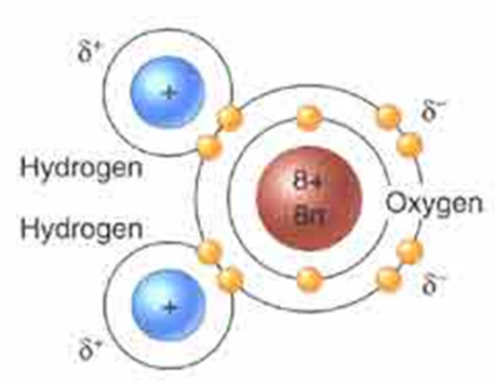
III. Why these Differences?
A. The Effects of Liquid Water
- Water’s molecular structure
Water has numerous properties that affect the Earth (and life). Water is composed of one oxygen atom, with 8 protons, and 8 neutrons in the nucleus, orbited by 8 electrons. There are 2 electrons orbiting in the first “shell” and 6 in the second. The second and third shells can hold 8, and atoms are most stable if the outer shell is full. So, oxygen will interact with other atoms and share electrons to “fill” its outer shell. This sharing of electrons between atoms is called a “covalent bond”. One oxygen atom will form single covalent bonds with two hydrogen atoms, each that has only one electron in its first shell. By sharing pairs of electrons, each atom fills its outer shell and is stable.
However, since the nucleus of the oxygen atom (with 8 positively charged protons) attracts the negative electrons more than the one proton in the hydrogen atom, the electron pairs are not shared evenly; they are held more closely to the oxygen, so it is slightly negative… the hydrogens have their negativity pulled away from their proton, revealing a part of its positive charge. So, there is a ‘polarity’ to a water molecule – a positively charged end and a negatively charged end. This is a critical property: WATER IS POLAR.

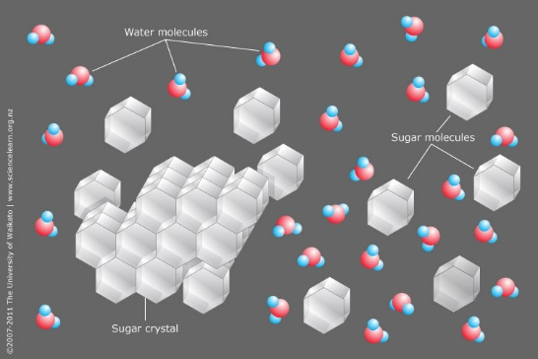
- Water is called the “universal solvent” - Charged compounds (polar or ionic) dissolve in water
Many materials have charges, sometimes for the same reason that water does. Sugar molecules are partially charged, like water, and so sugar molecules can become separated from themselves in water, binding to water instead of one another. This is what “dissolving” means.

Some material (atom or compound) have an unequal number of protons and electrons, and thus have a “complete” charge of -1 or +1, depending on whether the surplus is an electron or proton. They can have larger charges (like +3), too. Since they are charged, they can also attract and interact with water molecules and thus become separated (dissolve).
Table salt (sodium chloride) is a typical example of an “ionic compound”, composed of Na+ and Cl- atoms that are attracted to one another because of their opposite charges. The atoms attract and form a relationship – an ionic bond. The ions (charged atom or compound) form because one atom gives an electron to the other atom and they both satisfy their stability of having their outer electron shell full:

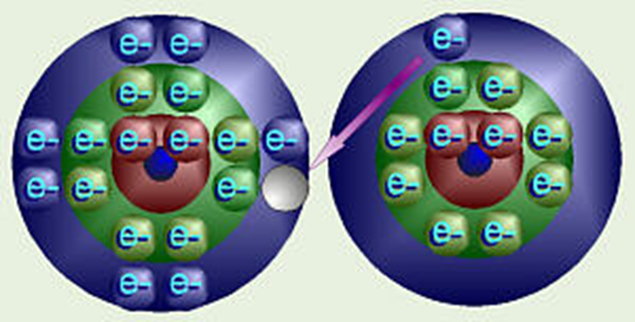

Chlorine (Cl): 17P, 17e Sodium (Na): 11P, 11

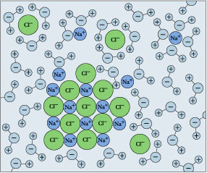
Typically, these oppositely charged ions attract one another in a lattice/crystal. But placed in water, the ions become separated and attracted to water…. Dissolving.

- Water Dissociates
This is important because ROCKS are often composed of charged particles, either minerals or ions. So, rock dissolves in water. Water also erodes rock, breaking pieces off mechanically and putting them in suspension and carrying them to other places. These physical and chemical processes of rock breakdown are called “weathering”. Water gets rocks moving and puts ions in solution where they can react with other chemicals.
One way that water dissolves rock is by “cation displacement”, and it is a consequence of another property of water called “dissociation”. Think of the electrons shared between the large oxygen nucleus and each small hydrogen nucleus (1 proton) as a “bed sheet” of electronegativity. When the larger oxygen nucleus rolls itself up in the sheet, it pulls the sheet partial off the hydrogen nucleus, revealing a portion of the proton’s positive charge. Sometimes, the oxygen pulls the sheet completely away from the hydrogen; now they aren’t sharing the electron-pair at all; the hydrogen nucleus is ‘naked’ – just 1 proton – existing as an independent H+ ion. The oxygen (and the other hydrogen) now have an extra electron and are a negatively charged hydroxide ion. The water molecule has “dissociated” into H+ and OH- ions. Now, of course, these oppositely charged ions are attracted to one another and they will re-associate. Water molecules are constantly splitting and rejoining in solution. In pure water, 1 in 10,000,000 (10 million) water molecules is dissociated at any one time. This equals a concentration of 1 x 10⁻⁷, and the negative of the exponent that describes the concentration of free H+ ions is an important characteristic of a liquid… it is called the pH (sort of the “percent Hydrogen”). In this case, pure water has a pH = 7.0. Hydrogen ions are very reactive. So, fluids with high concentrations of free H ions (low pH) are very reactive. Consider what happens between Cl (with 17 P and 17 e) and Hydrogen (1 p, 1 e). They share a pair of electrons and fill their outermost shells, making HCl (Hydrochloric acid). But, since the Cl is SO MUCH BIGGER (twice the pull of oxygen’s 8 protons), it rips the electron pair away from Hydrogen more frequently. In fact, the concentration of dissociated HCl molecules in solution, and thus the concentration of free H+ ions, is not 1 in 10 million like with water, it is 1 in 100! This is represented in exponential notation as 1 x 10⁻², and we say that HCl has a pH = 2.0.
The most abundant minerals in the Earth’s crust are feldspars – they make up 60% of the Earth’s crust. Chemically, they are KAlSi₃O₈, NaAlSi₃O₈, and CaAl₂Si₂O₈. K, Na, and Ca are positively changed ions. In the presence of water, the dissociated H+ ions ‘displace’ these other cations (positive ions), which are soluble in water because of their charge. Indeed, some minerals like olivine completely dissolve.
Mg₂SiO₄ + 4 H⁺ + 4 OH⁻ ⇌ 2 Mg²⁺ + 4 OH⁻ + H₄SiO₄
All three products are soluble in water. So, water can dissolve rocks, by donating electrons. What effect do you think a more acidic solution—that can donate more electrons—would have on these rocks?

- Carbon dioxide reacts with water to form carbonic acid (H₂CO₃).
CO₂ is soluble in water, and it combines with water to form carbonic acid (H₂CO₃). Acids dissociate, giving up their H+ ions, as we know. Carbonic acids in the soil are much more important in dissolving rock, as they have a pH of 5.6 (more acidic – a higher tendancy to give up H+).
There is another very important series of reactions that involve carbonic acids in solution. When they dissociate, they form bicarbonate and carbonate. The carbonate reacts with Ca⁺² in solution, forming “calcium carbonate” which settles out of the water as limestone, or precipitates when the water evaporates. This is the “abiogenic” (without life) that limestone forms. Most limestone forms biogenically, though, as we will see.
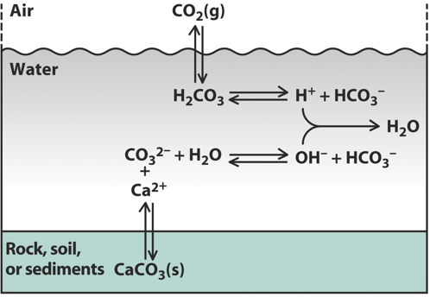

LOOK AT THIS DIAGRAM. WHA IS IN THE AIR? WHERE DOES IT GO? WHY IS EARTH’S ATMOSPHERE DIFFERENT FROM MARS AND VENUS?
- The Earth’s crust is recycled by tectonic activity
Mars is too small to generate the internal heat necessary for plate tectonics. Plate tectonics recirculates the Earth’s crust, taking some carbon from the atmosphere, that has been deposited in sediments, deep into the mantle. Venus is large enough to generate tectonic activity, but the crust is so hot that it “melts” and heals rather than forming plates that can be forced under one another, as on Earth. So it melts and crusts up, but doesn’t form plates. So, as a consequence of liquid water on Earth, CO2 in the atmosphere is dissolved, where it reacts with water and calcium and precipitates as limestone, which can be transported by plate tectonics deep into the Earth.
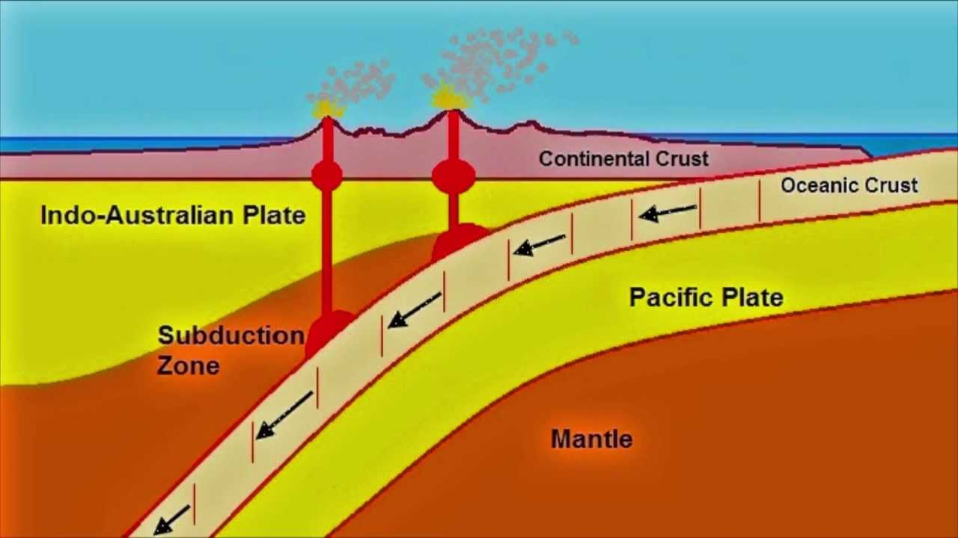

Ocean Crust has limestone deposits that are subducting, and are transferred deep into the mantle. Volcanoes return some of the carbon to the atmosphere, but there is a net transfer to the lithosphere.

C. The Effects of Life
1. Biogenic Limestone Formation
Many marine organisms, including some types of photosynthetic algae (Coccolithophores), Molluscs (clams, oysters, mussels, snails), and corals absorb Ca⁺² and carbonate CO₃⁻² and form calcium carbonate to make their shells. When they die, these shells fall to the bottom of the ocean, accumulate, and under pressure are turned to limestone. Under enough pressure and heat, they metamorphose into marble. 10% of the Earth’s rock is limestone, and most of this was produced organically (biologically). As CO₂ is converted to limestone, more CO₂ dissolves in water. So, life sucks CO₂ out of the air and into the oceans, converting it to limestone.
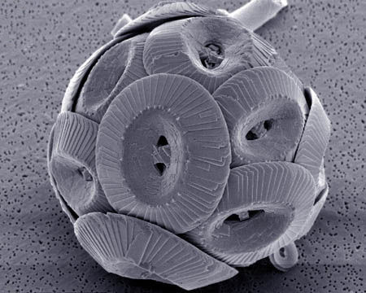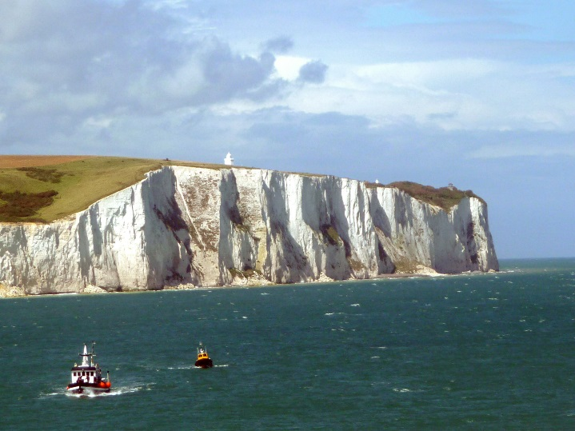

2. Photosynthesis
As we will learn in more detail later, photosynthesis typically consists of two major reactions: the “light dependent” and “light independent” reactions. In the light dependent reactions, organisms transform radiant energy of sunlight, carried by photons, into chemical energy in chemical bonds, carried by electrons. So, in sunlight, photosynthetic organisms trap convert light energy into chemical bonds…typically by binding a phosphate (PO₄) to adenosine diphosphate (ADP) to make ATP (adenosine triphosphate). To get the electrons that carry this radiant energy, the organisms split water molecules… the freed oxygen atoms from 2 water molecules unite, to forma molecule of oxygen gas (O₂). So, photosynthetic organisms split water to harvest electrons, and oxygen gas is released as a waste product. All of the oxygen gas in our atmosphere (21%!!!) was produced by this process.
In the light independent reactions, the chemical energy now present in the new bonds in ATP is converted into a more stable bond between carbon atoms. So, ATP is “broken” and the energy released is used to make bonds between carbon atoms. Where does the carbon come from? CO₂.
So, photosynthetic organisms use the ATP made in the light dependent reactions to link 6 CO₂ molecules together, making a glucose molecule that has six carbons. Photosynthesis contributes to the two major differences between the Earth’s atmosphere and those of Mars and Venus: it produces the O₂ and sucks CO₂ out of the atmosphere and makes glucose.
3. The Biosphere and the Carbon Cycle
Photosynthetic organisms use this energy trapped in glucose to make other organic (carbon-based) molecules… like lipids, proteins, and DNA. Other organisms eat these “producers” to make their own molecules, and they grow and get bigger. So, LOTS of carbon that would otherwise be in the atmosphere is now present in LIVING, carbon-based life forms! There is more carbon in living systems, now, than in the atmosphere. And when they die, sometimes they are trapped under sediments and fossilized. Over the long history of the Earth, lots of living things and their carbon have been converted to coal and other fossil fuels.
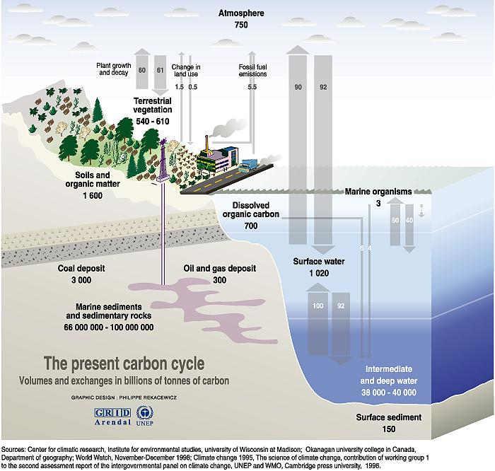

Conclusion: The Earth is a LIVING PLANET. Life doesn’t just live on Earth. It has transformed Earth, and it continues to maintain these odd conditions. Recent human activity is changing these relationships that have evolved over billions of years, as we will see.

Study Questions:
1. How did the solar system form?
2. How old is the earth, and what is the evience we have for this conclusion?
3. What are the compositions of the atmospheres on Earth, Venus, and Mars with respect to CO₂, O₂, and N₂?
4. What was the composition of the early atmosphere on Earth like? What is the evidence we have for this conclusion?
5. Draw the structure of a water molecule, showing all electrons for the atoms. Denote shared electron pairs.
6. What is a polar covalent bond?
7.Why does water’s polarity make it a good solvent?
8. What is an ionic bond?
9. What does it mean to say that water “dissociates”, and what does it mean to say that pure water has a pH = 7.0?
10. What effect does water have on rock, and how does it exert this effect?
11. What effect does water have on CO₂ in the atmosphere? Explain the formation of limestone abiogenically.
12. Describe the two major effects that life has had on the atmospheric composition of the Earth.
13. So, in conclusion, explain where the CO₂ in Earth’s atmosphere has gone.

