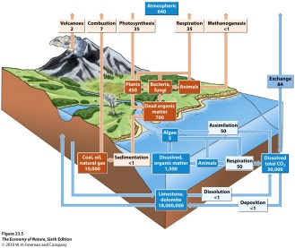
C. The Carbon Cycle
1. Overview: As we mentioned at the beginning of the term, most of the carbon that was in the atmosphere has been transferred to the lithosphere – which is now the primary reservoir for C on the planet. It is followed by dissolved CO2, dissolved organic matter, and then old dead stuff (fossil fuels, dead organic material). The living biosphere is a measureable reservoir, with about the same amount as the atmosphere.
2. Effects of Life: Exchange CO2 with atmosphere; and in marine systems, detritus and limestone can be stored in sedimentary deposits and stored long term, rather than being respired back to the atmosphere. Colonization of land by land plants caused a dramatic reduction in atmospheric CO2, particularly when this productivity was fossilized in coal swamps of the Carboniferous (300 mya).
3. Effects of humans: Deforestation reduces flux FROM atmosphere, and burning fossil fuels increase flux TO atmosphere; adding a net of 8 GT/year (~ 25% that respired by all terrestrial life).
$. Climate Change: The climate is changing, as measured by increasing global temperature, reduced ice and glaciers, increased sea levels, increased storms, and increased fires. These all correlate with increased CO2. CO2 has been increasing since the industrial revolution, as the result of human burning of fossil fuels. While this is fundamentally a correlation in one replicate system (earth), the causal linkages between burning fossil fuel > production of CO2 > increasing CO2 in atmosphere > increasing greenhouse effect > increased temperature > and increased melting, sea level, storms, and fires are firm.

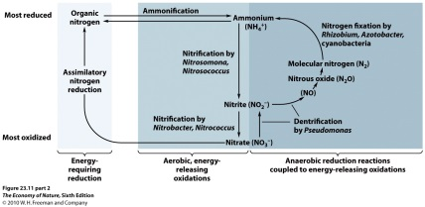
D. The Nitrogen Cycle
1. Overview: The major reservoir for N is the atmosphere, with about 10x more than the lithosphere.
2. Effects of Life: Fixation makes Nitrogen biologically available as ammonium and them nitrites and nitrates. Denitrification comverts nitrates to atmospheric nitrogen again.
3. Effects of Humans: Industrial fixation adds a significant amount, increasing eutrophication in N-limited environments.

Study Questions:
1) What is the major reservoir for carbon, and how did it get there?
2) What amount do humans “contribute” annually, through burning of fossil fuels and deforestation?
3) Describe the link between anthropogenic burning of fossil fuel and global warming.
4) Describe three predictable correlates to climate change that are occurring now.
5) What effect is climate change predicted to have on biodiversity, and why?
6) What biomolecules contain nitrogen? What is the primary source of nitrogen for plants?
7) How are human affecting available nitrogen, and what beneficial and negative effects is this having?

