Population Ecology

I. Attributes
II.Distribution
III. Population Growth – changes in size through time
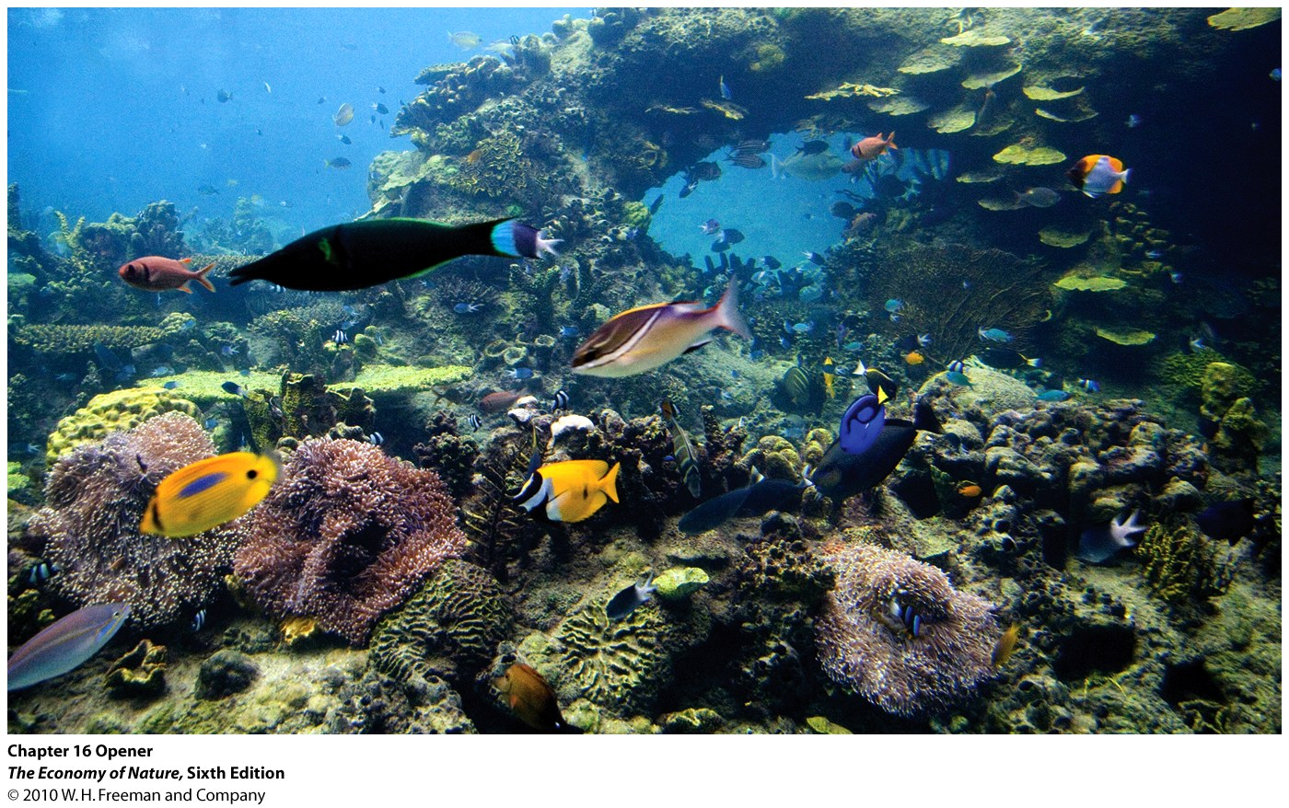
IV. Species Interactions
V. Dynamics of Consumer-Resource Interactions
VI. Competition
A. Overview
B. Empirical Studies
C. Modeling Competition

1. Intraspecifc Competition

2. Lotka-Volterra Interspecific Competition

3. Tilman Models (1982)
a. Competition by exploitation of resources
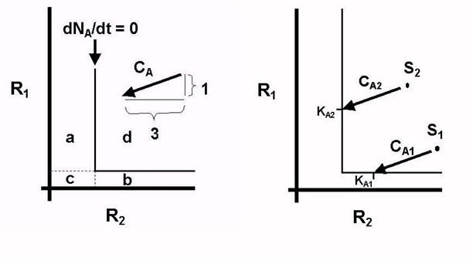
- Species in single-species treatments are monitored for the rate at which they reduce mineral nutrients, and the amount of nutrients they need to sustain population growth (isoclines).
- then, based on a combined analysis of two species’ isoclines, we should be able to predict the outcome of competitive interactions based on the ratio of resources in the environment, the rates at which the species consume these resources, and the minimum required amounts that each species needs for population growth.
- so, we don’t have to DO the competition experiment first to predict competitive outcomes, and we also KNOW what they are competing for (nutrients) and HOW (exploitation).

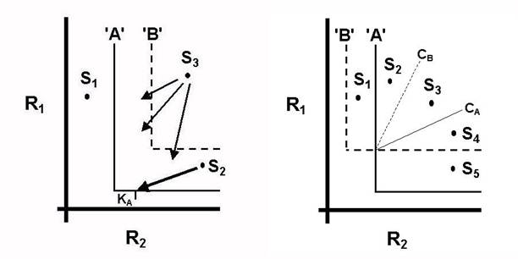
b. Isoclines and predictions
- species with high requirements will lose competitive contests – the winner will be those species that can continue to increase on the least amount of resource. (We might want to think about the relevance of this conclusion for humans, who may appear to be “winning” and growing now, but who require sooooo much that we will reach our limitations first… like when oil runs out, that no other organisms will be limited by.)
- if isoclines intersect, then coexistence is possible if the consumption curves drive the resource ratio to the equilibrium point. This will happen if both species rapidly consume the nutrient that THEY require the most of. In this case, each species will limit its own growth more than it limits the growth of the other species, and a stable coexistence will occur. Think of the Lotka-Volterra analog. However, since both resources are being consumed, a skewed initial ratio could lead to the extinction of one species or another (which differs from L-V).
- However, if each species rapidly consumes the resource that the OTHER species needs most of, then it is a race that will be determined by the initial resource ratio in almost every case and coexistence is almost impossible.
- So, the outcome of competition is dependent on the ratio of resources.

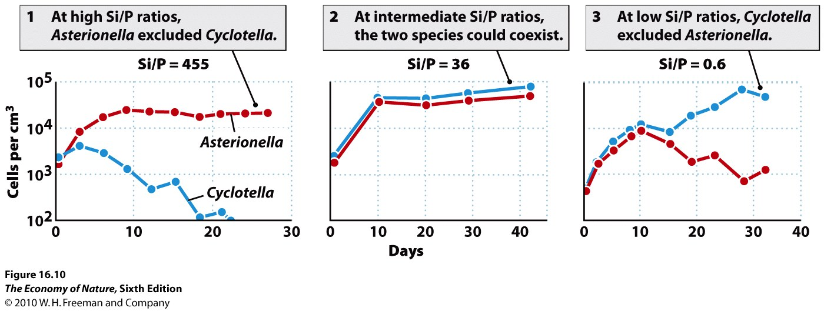
c. Experimental Validation
- Tilman has studied this in plankton and prairie grasses, and found that resource ratios were predictive.
- Experiments also confirm the “paradox of enrichment”, in which competitive outcomes change when nutrients are add… in fact, one species may come to dominate an initially diverse community. Think of fertilizing your lawn to promote the growth and competitive ability of grass over other weeds that persist under low nutrient levels.

3. Tilman Models (1982)
a. Competition by exploitation of resources
- Species in single-species treatments are monitored for the rate at which they reduce mineral nutrients, and the amount of nutrients they need to sustain population growth (isoclines).
- then, based on a combined analysis of two species’ isoclines, we should be able to predict the outcome of competitive interactions based on the ratio of resources in the environment, the rates at which the species consume these resources, and the minimum required amounts that each species needs for population growth.
- so, we don’t have to DO the competition experiment first to predict competitive outcomes, and we also KNOW what they are competing for (nutrients) and HOW (exploitation).

b. Isoclines and predictions
- species with high requirements will lose competitive contests – the winner will be those species that can continue to increase on the least amount of resource. (We might want to think about the relevance of this conclusion for humans, who may appear to be “winning” and growing now, but who require sooooo much that we will reach our limitations first… like when oil runs out, that no other organisms will be limited by.)
- if isoclines intersect, then coexistence is possible if the consumption curves drive the resource ratio to the equilibrium point. This will happen if both species rapidly consume the nutrient that THEY require the most of. In this case, each species will limit its own growth more than it limits the growth of the other species, and a stable coexistence will occur. Think of the Lotka-Volterra analog. However, since both resources are being consumed, a skewed initial ratio could lead to the extinction of one species or another (which differs from L-V).
- However, if each species rapidly consumes the resource that the OTHER species needs most of, then it is a race that will be determined by the initial resource ratio in almost every case and coexistence is almost impossible.
- So, the outcome of competition is dependent on the ratio of resources.

c. Experimental Validation
- Tilman has studied this in plankton and prairie grasses, and found that resource ratios were predictive.
- Experiments also confirm the “paradox of enrichment”, in which competitive outcomes change when nutrients are add… in fact, one species may come to dominate an initially diverse community. Think of fertilizing your lawn to promote the growth and competitive ability of grass over other weeds that persist under low nutrient levels.

Study Questions:
1) How does the Tilman model solve the shortcomings of the Lotka-Volterra models?
2) Explain what a consumption curve is, and explain how the relationships between two species’ consumption curves can determine whether stable coexistence is possible.
3) Distinguish between scramble and contest competition.
4) Why might one species win in one environment but another species win in another environment? Use a real example we discussed in class. What kinds of physiological trade-offs might be at work here?
5) Competition affects both species negatively. How might these negative effects be manifest?
6) How can competition be a selective pressure for evolutionary change and adaptation?

