Community Ecology

I. Introduction
II. Multi-species Interactions within a Trophic Level
III. Multi-species interactions across Trophic Levels
IV. Succession
A. Definitions
- succession: a change in community structure over time.
- sere: a typical sequence of successional stages that take place in a particular environment
- pioneer community: the first community to colonize a new or newly opened habitat.
- successional stage: a community between the pioneer and climax communities
- climax community: the last community in a sere – the community that replaces itself.

B. Classifying Vegetation Types
1. Focus on Climax
Clements believed that communities developed through time, reaching the most mature community type (climax) consisting of a particular (closed) set of species. He was a “lumper”, who recognized only nine community types in North America, and distinguished these based on climax endpoints. All other communities were just ‘transitional’, an in some senses unimportant. Following Gleason, Curtis and McIntosh recognized that the climax in an area is dependent on particular environmental conditions, and will have different ‘dominant’ species although they may have the same set of species. Whittaker suggested that to discriminate these different communities, we should separate them based on what the dominant species is.
2. Classification by Indicator Species
Braun-Blanquet took a ‘bottom-up’ approach, and recommended that classification be based on a whole floristic survey – sampling every species that is present and their relative abundances. Then, without regard to successional stage or climax trajectory, the community type is classified based on the presence of particular indicator species. These are unlikely the dominants – which are probably generalists that occur in lots of communities, and they are probably not the very rare species that might be limited based on geography and limited dispersal. Indicators will be ecological specialists, occurring at intermediate abundance where they occur. There is a very particular classification system, with a review board for establishing names and evaluating the legitimacy of a new classification.

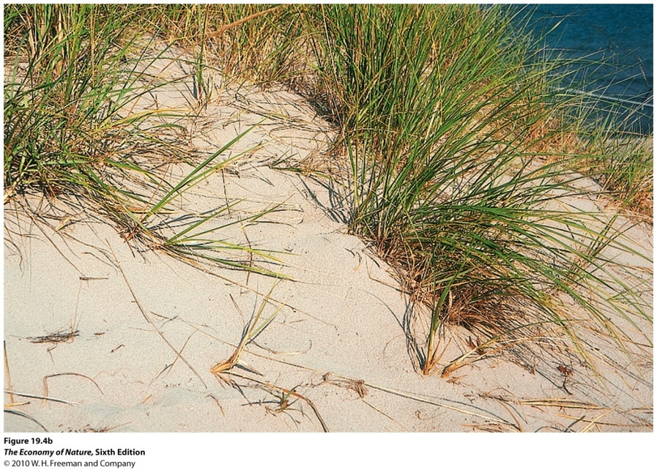
C. Types of Succession
1. Primary
The succession that occurs on a substrate that has no been previously vegetated… newly deposited sand, newly exposed rock, or newly formed rock (lava flow). Typically, the earliest colonists are wind or water dispersed and not animal dispersed, as animals have little reason to come to a place that has no food yet. Sometimes ‘bog succession’ is treated as a type of primary succession, as plants are ‘colonizing’ the open water habitat, and the mechanism is similar to other primary seres.
2. Secondary
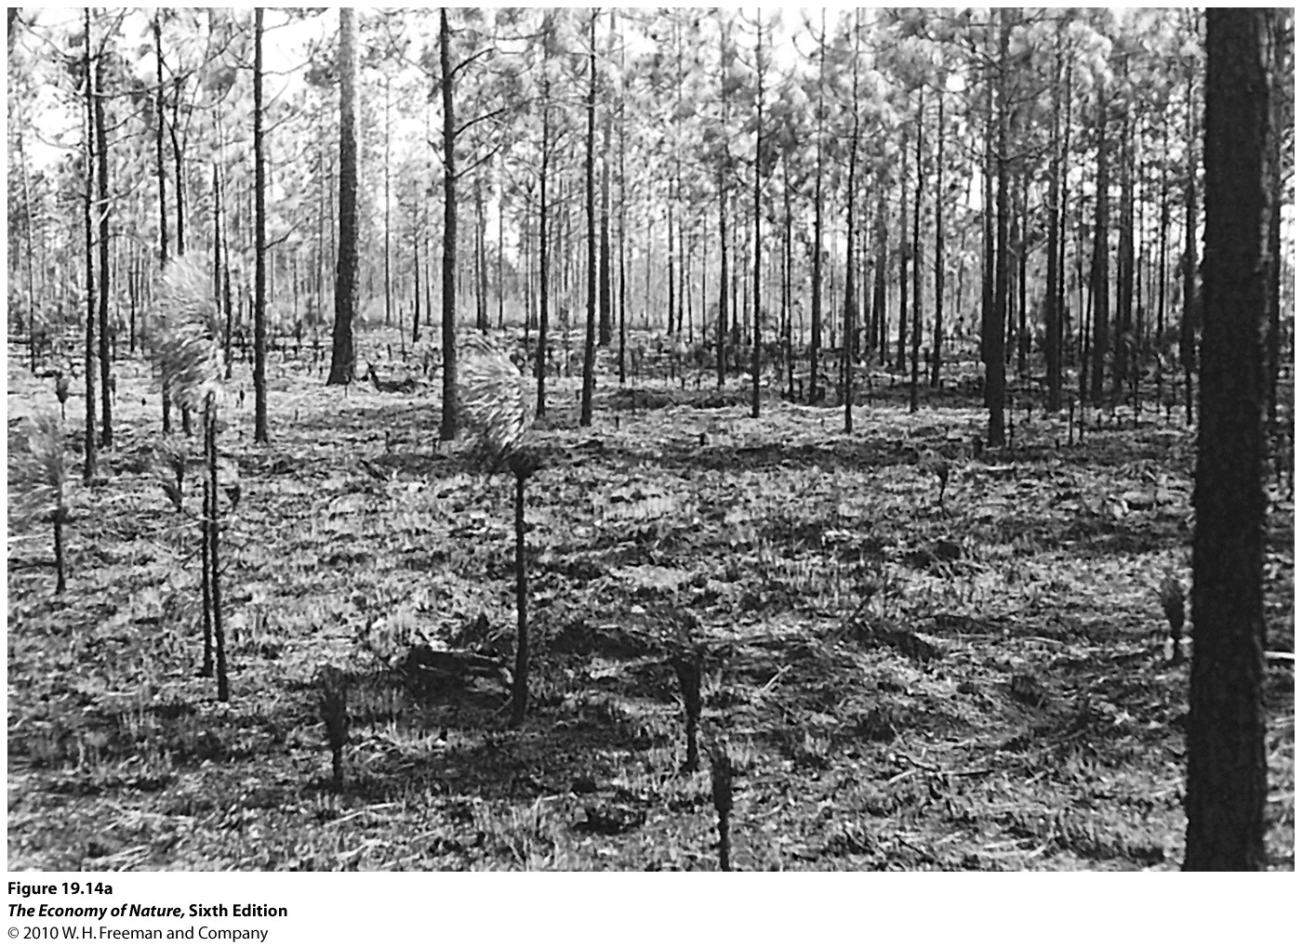
Succession that occurs on a previously vegetated substrate, initiated after a disturbance has removed the previous vegetation. In every habitat the patterns of community succession may differ. In the eastern deciduous forest, succession proceeds from a field of annual ‘weeds’, to perennial ‘weeds’ (herbs with non-woody tissue), to woody shrubs and fast-growing trees like red cedar and pines, to a climax of hardwoods that depend on the particular environmental conditions.
3. Disturbance-mediated Succession
Many communities have a successional process that is curtailed or maintained by frequent disturbance. ‘Fire-mediated’ succession is a classic example, like in the Sand Hills of SC or the Pine Barrens of NJ. Fires are so frequent (at least every 20 years) that slow-growing and fire-sensitive hardwoods can not come to dominate. So, the ‘endpoint’ of the successional sere is a ‘fire-mediated’ climax community of longleaf pine (SC) or pitch pine (NJ) that are adapted to high-frequency fires. Check the field trip handout for adaptations of both these species to high fire frequency.
In addition, the nature of successin and the variation in communities over the landscape will depend on the spatial and temporal pattern of disturbance. Weak disturbances may only set back the ‘successional clock’ to one stage earlier, allowing for rapid recovery. Strong disturbances may remove more biomass and set back the clock to a much earlier stage, requiring more time for recovery. Likewise, the size of the disturbance is criticl to the pace of recovery. Small areas are quickly recolonized from the surrounding matrix, whereas large areas recover more slowly, often by encroachment from the edge.
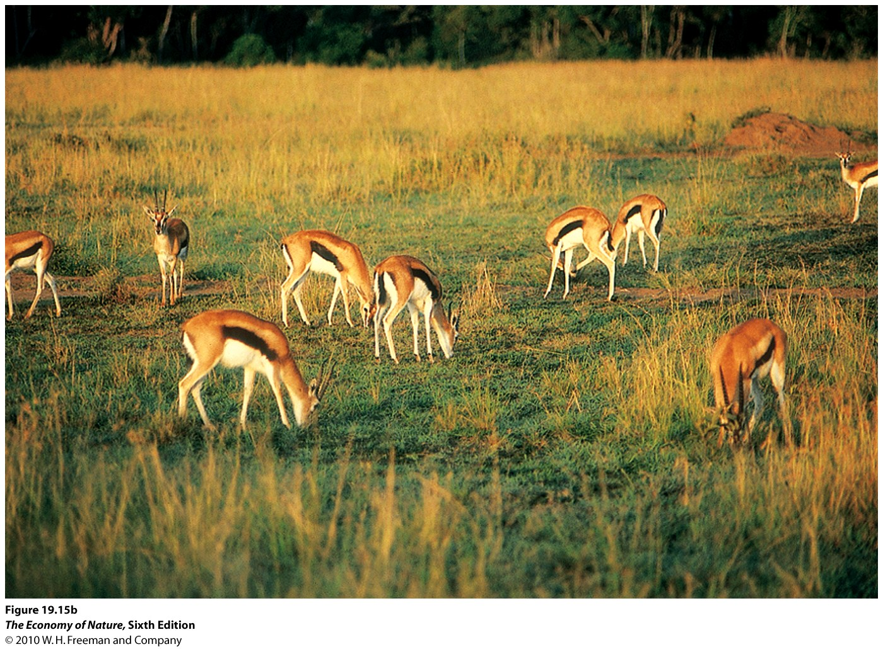
4. Heterotrophic Succession
These are regulr changes in the animal communities over time. It is most descriptive of changes that occur as a result of interactions between the animals, rather than as a passive response to changes in the plant community. So, for instance, carrion and corpses are often colonized by a fairly regular sequence of carrion-feeders. In fact, the regular sequence of beetle and fly species that colonize a corpse can be used to define the time of death (forensic entomology). There are also patterns in large grazer communities in African savannah. Smaller species like Thompson’s gazelles don’t like to forage in tall grass, and will only come into a habitat after the large grazers have been through and have eaten down the grass.
D. Mechanisms
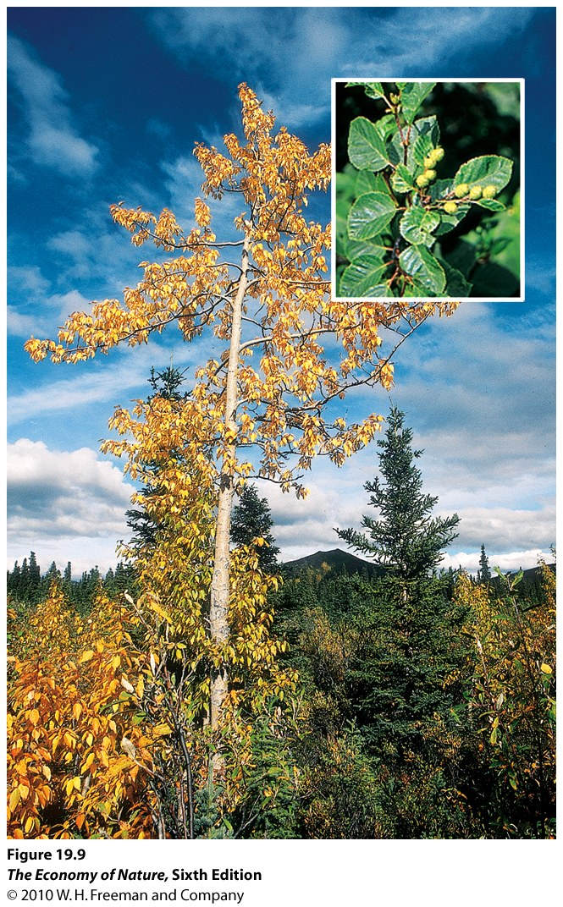
1. Facilitation
Pioneer species change the environment in a way that INCREASES the ability of other species to colonize. Indeed, later species can not colonize unless the pioneers have done so. Bare rock must be colonized by lichens and moss before enough soil is created to support vascular plants. Carrion beetles must open holes in a carcass before fly maggots can gain access. Sphagnum moss must extend over a bog before enough windblown soil and decaying detritus builds up to support vascular plants.
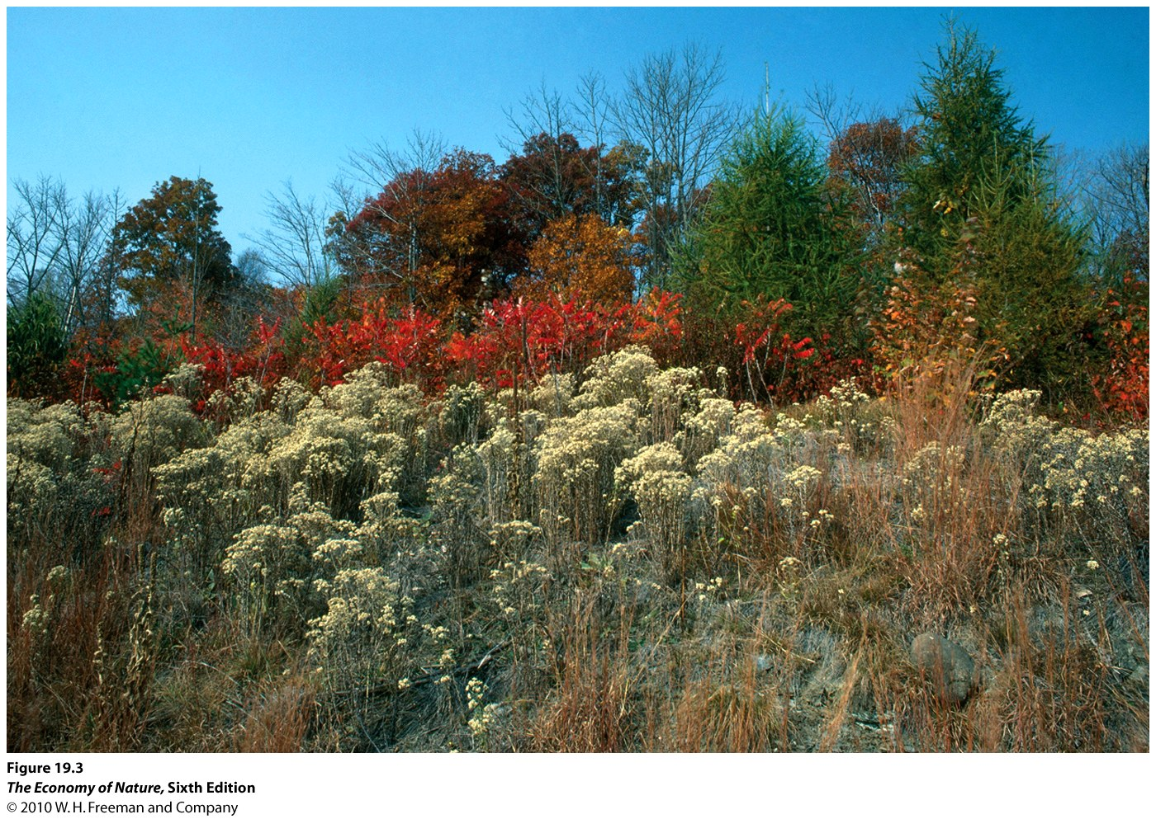
2. Tolerance
Here, late species tolerate the presence of early species but don’t ‘need’ them. Many secondary successional sequences seem to behave this way, where early species get in sooner and dominate, but don’t really affect the ability of later species (like trees) to colonize… in fact, they may all colonize at the same time, but since trees grow more slowly, the weeds dominatefor the first few years.

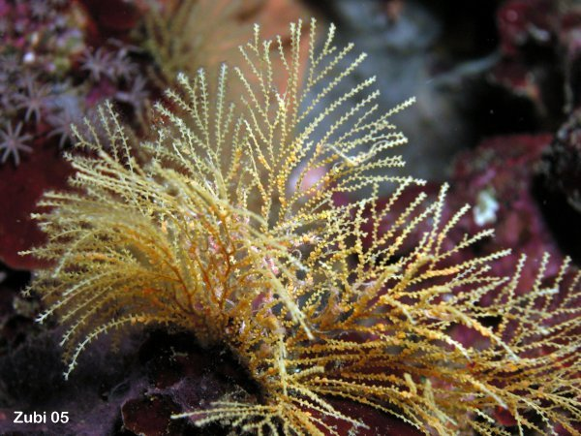
3. Inhibition
Early species inhibit the success of later colonists. This creates different seres, depending on who gets their first… this is called a ‘priority effect’, and it means that the structure of the community is dependent on the order of colonization. If bryozoans colonize reef substrate, tunicates and sponges can’t.

E. Invasive Species
“Invasive species” are facilitated or tolerated by neighbors, and subsequently inhibit them. Often they have escaped their predators or pathogens, and are ‘tolerated’ by native predators/pathogens…thus escaping limitation and increasing to densities where they compete with neighbors. They may be ‘exotic’ (from a different country) or ‘native’ but released by the removal of a predator or pathogen or disturbance.

D. Model (Tilman 1985)
Succession can be modeled by Tilman competition models, if the relative abundance of critical nutrients is inversely correlated. Then, we may get a sequence of predictable species colonizing, coexisting, and being outcompeted as one resource declines while another increases.

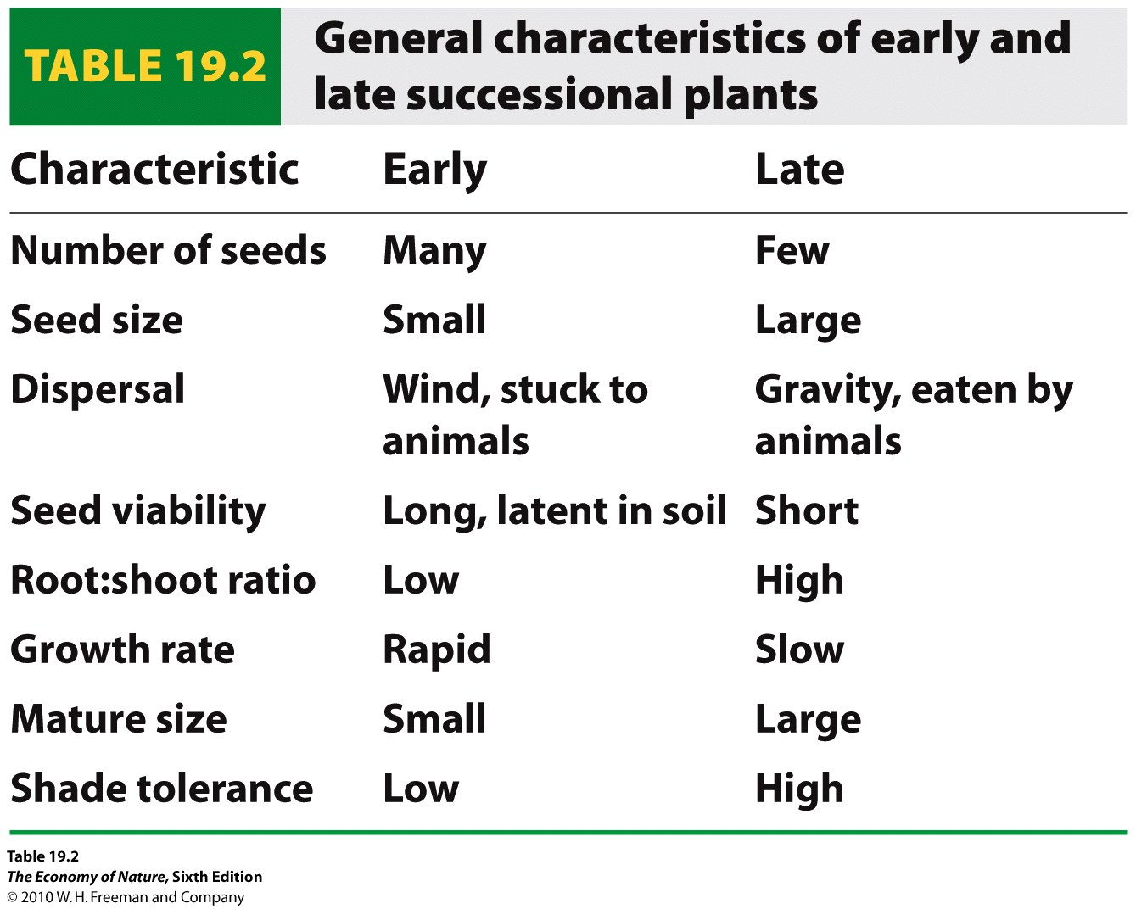
E. Community Patterns
- The characteristics of early and late successional communities change, from pioneer communities with open nutrient cycling, little competition, small generalist r-selected species in low diversity, linearly connected webs to late successional communities with closed nutrient cycles in competitive environments dominated by a lot of biomass of large specialized K-selected species linked in complex, highly connected complex webs.

Study Questions:
1. Define “succession”, “sere”, “pioneer community”, and “climax community”.
2. Distinguish between the Clements and Curtsi and McIntosh approaches.
3. Why would dominant or very rare species not be good community ‘indicators’?
4. Distinguish between primary and secondary succession, and give an example of each.
5. How does the size and frequency of disturbance influence successional rates, and why?
6. Distinguish between the facilitative, tolerance, and inhibitory models of succession, and give an example of each.
7. Under what conditions can the Tilman model of competition for resources explain a successional change in communities over time?
8. List six characteristics of early and late successional communities, and 4 characteristics of the life-history of the species that dominate these communities.

